**E-MINSU: A WEB-BASED HUMAN RESOURCE MANAGEMENT SYSTEM FOR MINDORO STATE UNIVERSITY WITH SMS NOTIFICATION**

A Research/Capstone Project

Presented to the Faculty of the

College of Computer Studies

**MINDORO STATE UNIVERSITY**

Calapan City Campus

Masipit, Calapan City, Oriental Mindoro

In Partial Fulfillment

of the Requirements for the Degree

**BACHELOR OF SCIENCE IN INFORMATION TECHNOLOGY**

by

**ROBIN M. ALMAREZ**

**JEREMIAH C. DELIZO**

**MHICA MAY J. JAVIER**

February 2023

**APPROVAL SHEET**

The Research/ Capstone Project Study entitled “**E-MINSU: A WEB-BASED HUMAN RESOURCE MANAGEMENT SYSTEM FOR MINDORO STATE UNIVERSITY WITH SMS NOTIFICATION”** prepared and submitted by **ROBIN M. ALMAREZ, JEREMIAH C. DELIZO,** and **MHICA MAY J. JAVIER** has been successfully presented and recommended for approval by the Advisory Committee in partial fulfillment of the requirements for the degree**, Bachelor of Science in Information Technology.**

**WILFRED V. PINE, *MSIT***

Adviser

# **PANEL OF EXAMINERS**

|  |  |
| --- | --- |
| JOHN EDGAR S. ANTHONY, MSIT  Chairperson  ________________  Date | |
| REGINE A. PONCE-MACHETE, *MIT* | **DEZZA MARIE M. MAGSINO, *MSIT*** |
| Technical Critic | Major Critic |
| ________________ | **________________** |
| Date | Date |
| ALICE R. RAMOS, *Ph. D.* | **LEONEL C. MENDOZA** |
| English Critic | Director of Research |
| ________________ | ________________ |
| Date | Date |

ACCEPTED and APPROVED in partial fulfillment of the requirements for the degree, **Bachelor of Science in Information Technology.**

# **JOHN EDGAR S. ANTHONY, *MSIT***

Dean, College of Computer Studies

__________________  
 Date

**ACKNOWLEDGEMENT**

The following people have provided unshakable support, assistance, and contributions to the completion of this project, and the proponents would like to convey their sincere gratitude to them.

First and foremost, they want to express our heartfelt gratitude to the Almighty God for His unending love and guidance in the decisions that the developers made while developing this capstone project.

Second, they would like to thank Mr. Wilfred V. Pine for his unwavering assistance and support in serving as our capstone project's adviser. The researchers highly value his encouragement, patience, advice, and knowledge; it was extremely helpful in the development and writing of this thesis. The researchers are happy to have such a mentor and adviser for this capstone project.

A very special thank you is also extended to Mr. John Edgar S. Anthony, Dean of the College of Computer Studies (CCS), for his immense patience and direction in helping to finish the project's manuscript. They also want to thank the entire faculty and staff at the College of Computer Studies (CCS) for their encouragement and motivational support.

Also, to be thanked are the beloved panels, Mrs. Dezza Marie M. Magsino, Mrs. Epie F. Custodio, and Mrs. Regine A. Ponce-Machete, for their encouragement, remarks, and inquiries during the pre-oral and final defenses. Together with their sincere gratitude to Dr. Alice V. Ramos, our English critic, for her grammar corrections, and to Mr. Leonel C. Mendoza, the research and development coordinator, for his time to review and correct the manuscript of the capstone project.

To the Human Resource Office of MinSU's Calapan City Campus, the client, to Mrs. Anabelle Q. Madrigal and staff, for believing in and accommodating the team during the research and development of this capstone project, for understanding and participating to complete the needs of this project. The researchers are indescribably grateful to them for their trust and cooperation.

And last but not the least, the researchers appreciate the assistance and encouragement from their parents, Mr. Binancio E. Almarez and Mrs. Rose M. Almarez, Mr. Javier M. Delizo and Mrs. Annaliza C. Delizo, Mr. Florante A. Javier and Mrs. Emelita J. Javier, who helped the researchers complete this capstone project. Together with gratitude to classmates and friends who assisted and inspired them in difficult times.

The proponents are always grateful for each and every one of you!

**R.M.A.**

**J.C.D.**

**M. M.J.J.**

**EXECUTIVE SUMMARY**

The goal of this study is to establish a web-based human resource management system that electronically records information like Personal Data Sheets (PDS), which will be used by both employees and human resources administrators. This website also integrates SMS notification for transactions updates. The employee may submit PDS, locator, and leave requests, and the administrator can manage transactions like leave, locator requests, service records, and NOSI. The website was created using an agile methodology, it was also used to meet customer requirements utilizing ISO 25010 standards. We used a questionnaire to collect the data for this study, with the eight (8) categories of research questions prepared by the authors. Fifty (50) respondents participated in the study, including IT experts, Human Resource Office officer, and MCC employees.

The evaluation's findings demonstrated the system's success in accordance with the suggested and proposed features. The Functional Suitability with overall mean of “4.52”, Performance Efficiency with “4.67, Compatibility with “4.6”, Usability with “4.68”, Reliability with “4.52”, Security with “4.65”, Portability with “4.55” and all describes as “strongly agree” while Maintainability with “4.4” and describes as “agree”.

The created system can manage the virtual operations of the human resource office, including managing PDS, leave, and locator requests, service records and pay slips, electronically storing data, and managing employee accounts. Employees can submit PDS, leave, and locator requests and receive SMS notifications when their transactions have updates. This website can simplify and virtualize the HR office procedure, reducing walk-in and paper transactions while also offering data storage. According to the many views of the proponents, this website might be made more valuable by incorporating additional HR office processes, the reports they generate, and other papers that must be kept electronically. These extra features could expand the system's functionality and make it more beneficial for the office.

|  |  |
| --- | --- |
| **TITLE** | **PAGE** |
| **TITLE PAGE** | I |
| **APPROVAL SHEET** | ii |
| **ACKNOWLEDGEMENT** | iii |
| **EXECUTIVE SUMMARY** | vi |
| **TABLE OF CONTENTS** | viii |
| **LIST OF FIGURES** | Xi |
| **LIST OF TABLES** | xiv |
| **LIST OF APPENDICIES** | xv |

**TABLE OF CONTENTS**

**CHAPTER**

1. **INTRODUCTION**

Project Context 1

Objectives of the Study 3

Scope and Limitation of the study 3

Significance of the Study 5

Conceptual Framework 6

Definition of Terms 7

1. **REVIEW OF RELATED LITERATURE/SYSTEM**

Related Literature/System 10

Synthesis 24

1. **METHODOLOGY**

Development Method 26

Gantt Chart 31

Requirements Specification 32

Functional Requirements 32

User Interface 33

Software Interface 35

Security Interface 35

Technical Background 36

Hardware Specifications 36

Software Specifications 37

System Analysis and Design 37

System Overview 38

System Architecture 38

Use Case Diagram 39

Activity Diagram 41

Data Flow Diagram (DFD) 42

Context Diagram 42

Diagram 0 43

Database Schema 44

Testing and Evaluation 45

Implementation Plan 47

1. **RESULTS AND DISCUSSION**

Presentation of System Output 49

Evaluation of System 69

Implementation Results 79

1. **SUMMARY, CONCLUSION, AND RECOMMENDATION**

Summary 81

Conclusions 83

Recommendations 84

**BIBLIOGRAPHY** 85

**APPENDICES**

**LIST OF FIGURES**

|  |  |  |
| --- | --- | --- |
| **Number** | **Title** | **Page** |
| 1 | Conceptual Framework | 6 |
| 2 | Agile Model | 26 |
| 3 | Admin Dashboard of the System | 34 |
| 4 | Employee Dashboard of the System | 34 |
| 5 | System Architecture | 39 |
| 6 | Use Case Diagram | 40 |
| 7 | Activity Diagram | 41 |
| 8 | Context Diagram | 42 |
| 9 | Diagram 0 | 43 |
| 10 | Database Schema | 44 |
| 11 | Admin Login Page | 50 |
| 12 | Admin Dashboard | 50 |
| 13 | Admin Profile | 51 |
| 14 | Registered Employee’s Page | 51 |
| 15 | Registered Employees Designation Page | 52 |
| 16 | User Roles Management Page | 52 |
| 17 | Employment Status Management Page | 53 |
| 18 | Designation Management Page | 53 |
| 19 | Department Management Page | 54 |
| 20 | Office Management Page | 54 |
| 21 | Deduction Management Page | 55 |
| 22 | Leave Credits Management Page | 55 |
| 23 | Salary Table Page | 56 |
| 24 | Employee’s Attendance Page | 56 |
| 25 | HR Leave Management Page | 57 |
| 26 | Service Record Page | 57 |
| 27 | Employees Service Record Page | 58 |
| 28 | Service Record Printing | 58 |
| 29 | Notice Of Salary Increment Page | 59 |
| 30 | NOSI Printing | 59 |
| 31 | List Of Eligible for Salary Increment | 60 |
| 32 | Employee Login Page | 60 |
| 33 | Employee’s Dashboard | 61 |
| 34 | Personal Data Sheet Page | 61 |
| 35 | PDS Personal Information Page | 62 |
| 36 | PDS Family Background Page | 62 |
| 37 | PDS Educational Background Page | 63 |
| 38 | PDS Civil Service Eligibility Page | 63 |
| 39 | PDS Work Experience Page | 64 |
| 40 | PDS Voluntary Work Page | 64 |
| 41 | PDS Learning and Development/Interventions/Training Programs Page | 65 |
| 42 | PDS Other Information Page | 65 |
| 43 | PDS Printing | 66 |
| 44 | Employees Leave Page | 66 |
| 45 | Employees Leave Form | 67 |
| 46 | Leave Printing | 67 |
| 47 | Employees Locator Page | 68 |
| 48 | Locator Printing | 68 |
| 49 | Employees Profile Page | 69 |

**LIST OF TABLES**

|  |  |  |
| --- | --- | --- |
| **Number** | **Title** | **Page** |
| 1 | Gantt Chart | 31 |
| 2 | Functional Requirements | 33 |
| 3 | Laptop Specifications of the system Development | 36 |
| 4 | Software Specifications of the system Development | 37 |
| 5 | Likert Scale | 47 |
| 6 | Implementation Activities 48 |  |
| 7 | Functionality and Suitability of the System | 70 |
| 8 | Performance Efficiency of the System | 71 |
| 9 | Compatibility of the System | 72 |
| 10 | Reliability of the System | 73 |
| 11 | Usability of the System | 74 |
| 12 | Security of the System | 75 |
| 13 | Maintainability of the System | 76 |
| 14 | Portability of the System | 77 |
| 15 | Summary Results of the System | 78 |
| 16 | Implementation result | 80 |

**LIST OF APPENDICES**

|  |  |  |
| --- | --- | --- |
| **Appendix** | **Title** | **Page** |
| A | Project Team Assignment Form | 90 |
| B | Capstone Project Topic Proposal Form | 91 |
| C | Notice of Title Acceptance | 102 |
| D | Endorsement for Final Defense | 103 |
| E | Grammarian Certificate | 104 |
| F | Certification of Originality | 105 |
| G | Program Listing | 106 |
| H | Data Elements / Dictionary | 171 |
| I | Capstone Evaluation Form | 191 |
| J | Pictures During Development | 195 |
| K | Pictures During Final Defense | 199 |
| L | Research/Capstone Project Waiver | 200 |
| M | Certificate of Oral Research Presentation | 201 |
| N | ACM Format | 202 |
| O | Curriculum Vitae | 211 |

**Chapter I**

**INTRODUCTION**

**Project Context**

In today’s world, the role of information is crucial and the ways that facilitate its processing are significant. There are concepts in economic designations about information civilization and information society (Kuś & Pypłacz, 2019).Setiyawati & Doktoralina (2019) discussed that utilizing information technology and applying good governance principles affects the quality of accounting information. Information Technology has been defined as the range of available technologies that benefit people and help them to be more efficient. It facilitates the exchange and delivery of data and information. Additionally, Zainab et al. (2018) implied that information technology systems have presented advantages as an essential tool for helping the country with the enhancement of the economy in both educational and industrial sectors.

Human Resource Management (HRM) and an organization’s digitalization is a combination of conceptual advancement. As a result, digital HRM represents a new evolutionary stage in the idea of technology-based HRM (Strohmeier, 2020). However, despite the evident advantages of implementing electronic

records management, some organizations still ignore the need to have one and stick with the manual ways of keeping the records, which could result in data loss. Information management is essential for the success of an organization while storing and keeping it is necessary so it will be accessible anytime it is needed. It is a difficult task to compile and traditionally keep records, so the researchers have come up with an idea to improve the current way of managing the records by implementing a web-based system that would allow an organization to store data and provide backup in times of unexpected phenomena.

This initiative known as E-MINSU was developed by the advocates to address the issue with the MinSU Calapan City Campus's human resources department. Since upon gathering the related studies, the researchers have discovered that the management of information is essential for the success of an organization. Storing and keeping the information is necessary so it will be accessible anytime it is needed. With the gathered problems from the previous related works, the researchers have come up with the decision to develop a web-based human resource management system with SMS notifications. The system will enable the mentioned organization to store and keep track of the records and information inside the workplace.

**Objectives of the Study**

The main objective of this project was to design and develop a web-based management system named E-MINSU: A Web-Based Human Resource Management System for Mindoro State University with SMS Notification.

Specifically, the study aimed to:

1. develop a web-based management system that creates reports for the human resources department and electronically secures employee data such as the personal data sheet (PDS);
2. establish a virtual workflow for operations including leave application, and locator requests, as well as producing service records for personnel and pay slips;
3. include a notification system that updates the employee on the status of their transaction via short messaging service (SMS); and
4. test and evaluate the system using ISO 25010.

**Scope and Limitation of the Study**

This study entitled,“E-MINSU:A Web-Based Human Resource

Management System for Mindoro State University with SMS Notification” is a system that will be developed to allow the organization to conveniently track and back-up information inside the workplace. The administration side of this web-based system will handle accounts, utility settings, leave request acceptance and rejection, service record, and NOSI. The employee side of the system will cater to PDS filing, leave, and locator applications, along with the integration of SMS notification which will be used to notify employees about the status of their requests. The study will cover the department of Human Resources Office in MinSU Calapan City Campus, the employees and employers will serve as the respondents. The target population for the project is the exact number of employees on the MinSU Calapan Campus.

This research study was developed exclusively for Mindoro State University Calapan City Campus and the said project is a web-based system only. The offices that cater to this project are the Human Resource Office and Campus Executive Director. This system was designed to generate documents such as Personal Data Sheet (PDS), locator, leave application, and pay slip, prints Notice of Salary Adjustment (NOSA), generate reports, and service record.

The study was conducted for 12 months from February 2022 – to February 2023. Visual Studio Code will be used as the text editor for the development of the website. Also, document reviews and interviews were used to gather the needed information for a better outcome to the system. The target participants gather the necessary data for the development of the system and will serve as the end-users.

**Significance of the Study**

This system is highly significant to the Human Resource Office and employees of MinSU Calapan City Campus.

**Human Resources Office.** This project is beneficial to the human resource office as the project aims to provide a platform that could store and manage the office’s records such as PDS, filed leaves, locator slip, service records, pay slips, and NOSI. This project will help the said department to enhance the management of records and lessen the papers that are needed to store in their office because this project aims to store them electronically, and this project will help the department to enhance the process of every request that the department is catering.

**Employees.** With the use of this project, the employees can track their attendance, request PDS updates, and file leaves online. This is beneficial on their part because they can access the system with the phone which can relieve the hassle of personal filling of their requests.

**Researchers.** This project is beneficial for the researchers to gain knowledge and experience about the research. This study will help them to enhance their learning and broaden their capabilities in developing a system.

**Future Researchers.** This project is substantial to future researchers as this could serve as their reference for their current or ongoing studies. Hence, they could further enhance or improve the gaps in this project.

**Conceptual Framework**

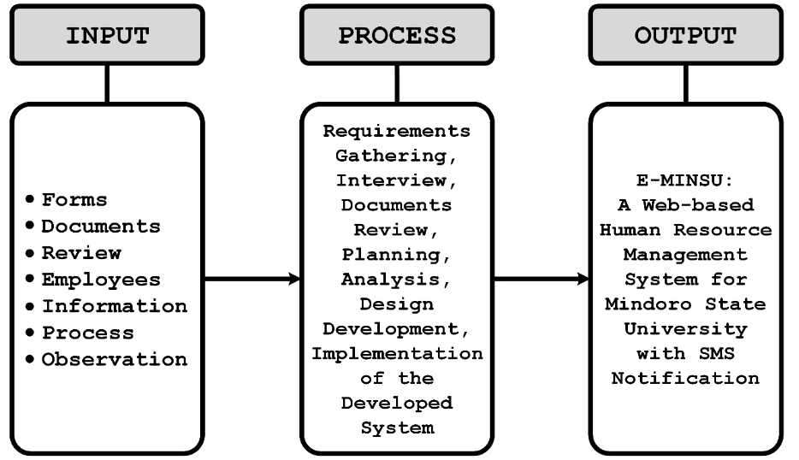The concept framework is an analytical tool that developers use to outline the input requirements and the steps necessary to complete the project.

**Figure 1. Conceptual Framework**

Figure 1 shows the Conceptual Framework of the Study. This framework includes Input, Process, and Input. The input frame contains all the information and resources required to construct the system. Data was gathered concerning the research on related literature, studies and system, employee information, document reviews of the document that circulates within the involved departments, and observation of the processes that took place in the involved departments. Different criteria were used to determine the level of acceptance, such as functionality, accuracy, reliability, user-friendliness, and security. The process frame refers to the actions that the system's proponents engage in while constructing the system. And lastly, the output frame is the outcome of “E-MINSU: A Web-based Human Resource Management System for Mindoro State University with SMS Notification” that aids in enhancing the current process of HR Office.

**Definition of Terms**

The terminologies below have both operational and conceptual definitions, to help you better comprehend the idea behind this system.

**API.** Application Programming Interface (API) used to connect two programs, this will act as a link for data sharing and extraction. Data sharing within and between businesses is easy with the usage of APIs.

**E-MINSU.** A developing project for the human resource office of Mindoro State University (MinSU) Calapan City Campus which aims to digitalize the storing of information and process of the office.

**Electronic Documents**. The files generated by the system or the system files, these are the files stored in the computer (softcopy files).

**Leave Request.** A formal document that notifies your manager and employers that you intend to miss work for an approved reason, making your absence legal.

**Locator Slip**. A document that the employees use, if they have some chores, need to do during their work hours outside their workplace.

**Notice of Step Increment (NOSI).** The rise in pay from one salary grade to the next for a position.

**Pay Slip.** Arecord that is provided to an employee each pay period. It indicates their entire amount earned, less deductions for things like tax.

**Personal Data Sheet** **(PDS).** A personal data sheet contains all the employee information that is used by Human Resources to know and identify every employee in their institution.

**Service Records**. A collection of either electronic or printed material which provides a history of a person's activities and accomplishments while serving as a member of a given organization.

**Visual Studio Code**. One of the editors used to build either a mobile application or a web application.

**Web-Based**. It is any system that we access via the internet, and it can be either peer-to-peer or client-server.

**Chapter II**

**REVIEW OF RELATED LITERATURE / SYSTEM**

A review of related literature is presented in this chapter gathered from reliable data gathering sites to ensure the authenticity of every piece of information collected. This will help the researcher to understand more about their capstone project and serve as a guide to develop their capstone project according to the objective of their study.

**Related Literature / System**

The internet has grown to become the world's largest data repository. Overload of information is information explosion has made it more difficult for information retrieval systems to organize and retrieve information for the ordinary user efficiently and effectively (Luzon et al. 2022).

According to Grepon et al. (2022) automating school management data information system can help with effort reduction, time management, and the generation of timely and high-quality reports. To carry out their administrative and managerial duties correctly and efficiently, school administrators employ a variety of ICT tools and systems. Many people prefer to utilize technology to manage data and information since it is more trustworthy and efficient.

Every institution and organization relies on information. Brombuela et al. (2021) claims that modern institution like universities have grown large and complex information needs that every institution must pay close attention to how information is gathered, stored, disseminated, and utilized. With the aid of modern technology, an institution can utilize using a system supporting them in handling the information within their institution. Information systems alleviate uncertainties and provide quicker support and almost automated decisions.

While according to Garcia et al. (2021), web technology has a rapid growth which also affects the educational system, he stated that the study about web-based learning has grown in importance because the portable devices such as cellphones, laptops, and personal digital assistants now have rapid access to web-based applications and learning environments thank to the internet. As a result, the needed

information can be easily obtained via the internet. Furthermore, time and spatial constraints can be addressed to facilitate self-directed learning.

Additionally Buhain and Pulmano (2021) stated that managing, authorizing, and recording leave requests is generally the responsibility of the university's human resource development office and higher authorities. The university's human resource development office has been experiencing problems in their manual operations, such as difficulties in handling information due to traditional storage of information, and transparency issues because employees do not have direct access to their leave records, with an increasing number of employees earning leave and leave applications being filed monthly.

And Anwar and Abdullah (2021) discussed that planning, strategic recruiting, employee training, growth pay management, efficiency, worker relations, health care, employee satisfaction, and supply of employee services are all duties that fall under the umbrella of human resource management (HRM). Together with the rules and procedures designed to boost organizational efficiency, employee engagement, and job quality. The HRM’s practices such as revenue return, benefit, competitiveness, and market share will improve if the office practices good management.

Suwita et al. (2021) also mentioned that web-based software’s simple to use and create nowadays, they are also usable in the business industry, businesses use web applications to carry out typical business planning, analysis, and techniques for data collection for the promotional effectiveness. The web also employed activities that are widely used by numerous firms as well as business problems to attract customers, and vendors and earn money.

The leave management and monitoring system automates the leave request process, making it easier for employees and managers to track and award leave Buhain & Pulmano, (2021). While Pengaruh PMA, PMDN, TK, (2020) stated that most institution uses the conventional method of requesting and managing leave. In this method, an employee is required to write and submit a leave application to the designated personnel such as the Head of the Department. The request is forwarded to the officer in charge of approving and rejecting leave. The current method is at risk of making an error, requires a lot of paperwork, tedious to manage, and consumes a lot of time.

Paderna et al. (2020)and Valencia-Inarda (2020) both mentioned that human resources have an essential position and important role in the success of an organization. Paderna et al. (2020)whoconducted the research entitled “Improving Employee Experience in a Medium-sized Retail Chain through Quality Human Resource Management Practices: Does Bifurcation Bias in Family Firms Moderate the Nexus?” tackled that Human Resource Management (HRM) is an organizational function that focuses on the recruitment, management, and direction of a company's most asset. This functional area provides an organization with the essential information, tools, training, administrative services, coaching, legal and management counsel, and talent management oversight to maximize performance quality. Employees are then given a set of goals to achieve using their talents and knowledge because of these resources. Human resource managers must be able to identify and meet employee needs through successful recruitment and selection, training and development, compensation administration, and employee-employer relations, in addition to what type of employment best suits an employee's skill set.

On the other hand, human resources are substantially related to organizational commitment based on the study by Valencia-Inarda (2020)**,** the analysis of her study which is conducted in the Philippines highlighted four core areas of the human resource system and its relationship with the organizational commitment in the context of public organization. Human resource initiatives have been implemented at many levels in terms of RSP, L&D, PM, and R&R. People believe they have given all candidates an equal chance under the law. Even though L & D operations are carried out, this research does not focus on their effectiveness. On PM, primary sources suggested that data recording and storage may be improved. Personnel has been given R&R based on their excellent performance and achievements.

As stated by Jayoma et al. (2020), the process of converting paper-based data into a digital format, such as computer-generated electronic documents or digital images created by scanning or photography, is known as digitization. Data that has been digitized will be easier to preserve, access, and manage. Digitized data is stored and managed through a system such as a record management system. However, there are still some who still stick to the traditional way of keeping and managing their records which are stored in cabinets, filers, and folders.

In the teaching-learning process, a teacher's attendance is critical. The presence of teachers has a major impact on student learning, according to a study. When compared to their counterparts, teachers who had fewer absenteeism had kids who scored higher on achievement tests Naive, (2020).

On the other hand, Strohmeier (2020) who studied Digital Human Resource Management: A conceptual clarification said that there is a possibility that the digital HRM can be developed based on the general research that he conducted regarding the digital organization, terminology, and typology of digital HRM. The findings point to a perspective on technology based HRM that is not fundamentally different from earlier perspectives, but that embraces and expands on them.

Gonapinuwala (2020) discussed that in today's world, there are only manual procedures for dealing with teacher leaves, which are more time consuming due to the numerous paper works, such as filling out applications. Because the clearance process involves multiple types of employees, it takes longer to acquire approval for some special leaves, such as study leaves and foreign leaves. All records of leave taken by an employee in accordance with the company's leave policy are kept by leave management. In a large firm, having an effective leave management system is critical. And Afsana, 2018 further explained that a leave management system is an automated online stage that tracks all forms of leave applications and requests, as well as a method to track different types of leaves. This system can be used to automate the process of submitting and accepting leave applications. It is a simple and easy to use technology that eliminates paperwork and saves time and money.

Most institutional authorities are bothered by the inconvenient method of manually tracking their employees' attendance. The manual process of signing on a piece of paper is time-consuming and insecure. At such locations, an effective attendance monitoring system must be implemented. (Setiyawati & Doktoralina, 2019)

According to Reddy et al. (2019), the monitoring of attendance in all organizations for checking the performance of students is a challenging task. It is time-consuming to call the names of students to see whether they are present or not. In businesses, calling the registered numbers or names of the employees is also a prolonged task. Attendance is manually taken in all organizations by calling their register numbers or names and recorded in attendance registers issued by department heads as proof, and in some organizations, students want to sign in these sheets, which are stored for future reference. This technique is repetitive, complex work that leads to errors because few pupils sign for their students or tell surrogate attendance of the missing students regularly. This method is also able to track all the students' attendance more difficult, as well as monitoring individual student attendance in a large classroom setting. An attendance Monitoring System needs to be implemented to make the task easier and effortless.

As explained by Balbino J. et al. (2019), filing for leave is exhausting because it requires going through various departments or employees to get approval, just like filing for reimbursement expenses. While Plata & Calpito, (2020) discussed that leave management is one of the simplest yet crucial HR activities that often consumes a significant portion of the HR personnel’s time. Organizations must recognize the need for employees not to report from their work, taking time away to consider and fulfill personal, family, social obligations, and other necessities thus may file different leave privileges. Taking annual leave is a right of an employee but subject to the right of the head of the office to schedule the time at which leave may be made. While a leave of absence is a right granted to employees not to report to work with or without pay, leave policies must be complied with or provided by the law. The HR personnel must see to it that there are always available sufficient workers and that employees are satisfied with the working environment.

Kuliah and Kuliah (2019), elaborated on the role of information management and cluster to innovate the development of regions and operational management. It plays a vital role in addressing significant issues and structural entities. Through it, the level of life of most of most population is being raised and news products and services are being created.

Information is significant in today's economic realities; it is fundamental to recognize that 21st-century society can be considered a mass data community in which information is very valuable and needed as a determinant of action. Information allows people to act and enhance the current state. Furthermore, in the view of an organization, accessing the right information at the right time is much more necessary to its people than any large assets and revenue (Kuś & Pypłacz, 2019).

According to Aladejebi and Oladimeji (2019), in business management meticulous record keeping are required. Identification, classification, summarizing, storage, protection, communication, retention, and disposal of records for the creation of financial statements are all part of record keeping. Policies, systems, procedures, operations, and individuals all play a role in record keeping. A record of financial inflows and outflows in connection to the respective asset, liability, income, and expense is called an account. The importance of reliable financial information being available to owners and managers for performance measurement cannot be overstated. Owners of businesses, the government, creditors, potential investors, and others are all users of accounts.

While according to Mukred et al. (2019), records management improves the quality of public service delivery, and it also assists organizations to acquire quality certification. Records management has a direct relationship with transparency, productivity, and accountability inside an organization. However, as perceived from the professional aspect, there are still some who don’t understand the importance of this program.

Human resources are an organization's most precious asset. A company's Human Resources department performs an important function. It has the ability to manage an organization's most important and valuable assets. Without a properly operating human resources department, a firm will struggle to achieve high levels of efficiency and labor management. Recruitment and selection, salary management, performance management, organization development, employee engagement, and employee leave management are all responsibilities of Human Resource Management (HRM) (Afsana, 2018).

World Wide Web’s (www) growth and evolution has grown rapidly in the previous 10 years, owing primarily to factors such as social media and mobile technology. This expansion, which necessitates the pleasure of millions of users accessing Web applications with sufficient service quality, necessitates ongoing infrastructure upgrades to improve user experience or meet new needs (Curiel & Pont, 2018).

Web-based applications allow the gathered information to be accessed and processed remotely. And this kind of software is created to ensure secure and real-time access to the data, the backend is programmed via PHP Hypertext Pre-Processor while the user-interactive front-end is written or programmed using Javascript to generate Dynamic HTML together with the stored and maintained data in a MySQL database (Capraro et al., 2018).

This paper aimed to demonstrate how policy can facilitate the incorporation of disclosure requirements into the project life cycle of documentation (transparency by design) to prevent the occurrence of any corruption risk associated with the management of information created by a public administration (missing or disappearance of information, lack of evidence, modification of documents, etc.) It has been shown that organizing information can facilitate the occurrences inside an organization (Casadesús et al., 2018).

Aziz and Yusof (2018), conducted a study regarding Electronic Document and Records Management System (EDRMS), which is a system that is responsible for managing digital information. It could merge both document management and records management to increase the efficacy of a business and attain better accountability. The study has revealed that some organizations are not ready to implement EDRMS in their workplace. The required knowledge and skills, as well as the lack of policy and procedure in place, are contributing factors to this. In the findings of the study, it is shown that developing proper policies and procedures while taking appropriate actions could help to resolve the issue of implementing a records management system in the workplace.

Mukred and Yusof (2018), stated that records are key to organizing the goals and attaining knowledge for the process of decision-making and problem-solving. Businesses rely on information and communications technology to run and conduct operations which has resulted in the generation of e-records in large volumes. Therefore, it is important to retain the records and keep evidence that a certain activity has been carried out.

Furthermore, Zainab et al. (2018), several government organizations, as well as educational institutions, still depend on manually checking attendance in a paper-based approach. The said approach has presented disadvantages such as wastage of environmental resources and is a time-consuming task. There is a must change these traditional and old methods of recording attendance and replace them with more productive ones. A system must be implemented to disclose those disadvantages and achieve a much more effective approach.

As stated by Khim (2018), there is waste of time while the leave process approval is being processed and records are being retrieved. The existing manual system has several shortcomings. Because the entire system is maintained by hand, the process of storing, maintaining, and retrieving information is time-consuming and labor-intensive.

**Synthesis**

The different related literature above discussed the meaning of web-based system, human resource management, information system, leave management, and records management. The said studies open the importance of Human Resource Management in an organization, not only for universities but also for companies, firms and other large organizations who needs huge manpower. Nowadays Human Resource Management Offices are adopting the technology to lessen the long process which causes time, money and effort, the manual process of recruiting workers is now converting into technology-based procedure which is also beneficial for storing data. And as the internet evolves the web-based systems become more valuable for the said industry, the process of filling leave, registering, managing and updating the PDS can be online. As well as the information system and record management which is helpful for the organization to lessen the manual process and store the data electronically for security purposes.

The importance of human resource management in the organization, the difficulties they are facing because of the manual process of handling paperwork. It was clear that the related literature and systems show that the gap is the manual process of record management and processing leaves consumes a lot of time and exploits a lot of vulnerabilities. The main reason is the conventional way of managing and processing records. Keeping the records in this way exposes different risks such as the effect of natural phenomena. Processing leaves can take several steps that add a burden to the employee. This is supported by the sought related literature and systems that shows the lack of a specific system that provides an enhancement to the conventional way of managing and keeping a record.

**Chapter III**

**METHODOLOGY**

This chapter discusses the methods and strategies used by the researchers to develop the Web-Based Human Resource Management Information System that matches its objectives. The system’s structural model is further explained together with the data gathering techniques which justify the research methodology of this system.

**Development Method**

This project was developed using the agile model. This model starts at the planning stage and enables the developers to repeat the cycle depending on the system to be developed based on the user’s feedback. Additionally, bugs that may arise on the prototype can be fixed on the next iteration.

There are six phases in this model which are defined below.

**Figure 2. Agile Model**

**Requirements**

The requirement for creating a web-based application to assist the office in electronic data storage and virtual employee and transaction management became apparent when the developers identified the issue with the manual procedure of the human resource office.

To acquire the information required, interviews with designated personnel were conducted. Certain documents and forms that are used to create the system are also viewed. The developers formulated a development strategy for the system using the data that has been gathered.

The developers then started to plan for the manpower, equipment, and time required to complete the project after accumulating such data.

**Design**

In the second phase, known as design, developers created several diagrams, including context diagrams, use case diagrams, database schema, and others that aid in project execution.

The developers used the data they collected from the HR office of MinSU Calapan City Campus to construct various wireframes for the admin panel and employee panel to imagine a potential user interface for the project.

**Development**

The phase of development is when the developers put all the data they have acquired to use and create the suggested system.

The HR module of the planned system was first developed, followed by the employee module. The system is built using HTML, CSS, JS, and the Lavalust framework, and the developers incorporate the data they obtained into it.

**Testing**

Throughout the testing phase, the produced system went through many tests to find defects and problems.

The developed project was put through unit testing by the programmers; the HR module was tested first, followed by the employee module. When the developers tested the system in the HR office, they ran into a variety of faults and errors that they fixed afterwards.

**Deployment**

The produced system was installed on the client

workspace during the deployment phase. To determine whether the system satisfies the need, the client must utilize and test the system.

The created system was implemented in the Calapan City Campus Human Resource Office. The HR and campus personnel were involved in the deployment. The HR department made use of the system's admin panel to manage employee records as well as staff management and transactions. The employee used the employee panel to track the status of their transactions as well as submit leave and locator requests.

**Review**

The evaluation of the system's user feedback took place at this point. These comments were applied to the system's ongoing improvement. The system needed to be improved by the developer considering the review.

The system was evaluated by the developers at the MinSU Calapan City Campus to see if it had satisfied the users. The developers' conclusions and system improvements were made possible by their responses.

The system was examined by the MinSU HR Office, which also included an MCC employee, an IT expert, and a human

resource officer.

**Gantt Chart**

The Gantt chart, which is frequently used in project management, is helpful in outlining the tasks that developers must complete while working on a project. This chart’s left side lists the various activities, including requirement phase, analysis and design, development, testing, deployment, and review, while the top shows the relative timing of each activity. A bar is used to symbolize each activity, and the position and length of the bar indicate the activity's beginning, middle, and end months. This could be a wise move as the project develops up to its completion. It shows how the programmers allocated their time.

The order in which things happened while the website was being developed is shown in Table 1. This Gantt chart illustrates the sequence of events and plans involved in creating the system and assigning daily tasks for better project execution and advancement. Each stage of the development process contains a sub-process that exemplifies the thorough work the developers did to carry out the project's development process.

The developers used the Gantt chart to track the

The developers used the Gantt chart to track the project's progress from the requirement phase to the system evaluation.

**Table 1. Gantt Chart**

**Legend**:

**Done**

The table above demonstrates how the researchers planned the project's progress while using the phases of the agile approach. The model's phases were adopted, and each phase comprises subphases that outline the work that the researchers will undertake in relation to that phase of the model. Also, the agile approach distributes each phase according to how much time it took to finish it.

**Requirements Specifications**

To maximize the use of the developing website, the users must understand, meet, and be well-oriented regarding the system’s software interface, hardware interface, functional requirements, user interface and security requirements.

**Functional Requirements**

The web application was developed to come up with

“E-MINSU: A Web-Based Human Resource Management System for Mindoro State University with SMS Notification”.

The initial focus of the system's designers was on its intended users. They made certain that there would be an advantage. The system would be created in accordance with its goal and the way the client desires the system to be created.

**Table 2. Functional Requirements**

|  |  |
| --- | --- |
| **Modules** | **Description** |
|  |  |
| Admin (HR) Panel | Manages records like PDS, NOSI, and Service Records,  Approves and disapproves of PDS updates and application of leave.  Manages the creation of the accounts of the employees.  Manages the admin account.  Validate and evaluate every transaction of the employees such as PDS updates, Locator application and Leave application.  Monitors the attendance and application such as leave and PDS updates of the employees.  Prints the service records of a specific employee. |
| Employee Panel | Create a request for PDS update, file Leave and Locator request.  Check the status of his/her request for PDS update, filed Leave and Locator.  View his/her compensation details. |

**User Interface**

User interface is an essential part of the project because it links the interactions of the user and the program. At this system the developers use user-friendly interface so that the user can easily understand the icons and representation that includes in the system.

The developed system's real user interface, which will be visible and usable online, is contained in it.

**Figure 3. Admin Dashboard of the System**

The system's admin interface, where personnel administration takes place, is seen in the image above. Here, the administrative staff handles a variety of

employee activities, including the administration of utilities, employee accounts, and others.

**Figure 4. Employee Dashboard of the System**

The system's employee panel is seen in the image above, where users may monitor their transactions, edit their PDS, and submit leave or locator requests.

**Software Interface**

The researcher uses PHP programming language for coding to create the website for E-MINSU: A Web-Based Human Resource Management System for Mindoro State University with SMS Notification, XAMMP server for creating MySQL databases, together with PHP spreadsheet for PDS exportation, ITEXMO as SMS API for notification of the system and the created system must be uploaded and tested at Hostinger as website host. The admin of the Human Resource Office that serves as authorized personnel can manage the transactions and data of the system.

**Security Requirements**

The security requirements of this system ensure that the security properties of the system are satisfied. The developers use login system that specifies and automatically identify the role of the user depending on the filtering method that the developers use, this is an important part of security of the said system because of some stored data that needs more privacy security. This system can only be accessed by the authorized offices and personnel of HR. The system also implements the security module of LavaLust framework.

**Technical Background**

The technical background gives important information regarding technical aspects of the project which makes it easier to define what is required in easy-to-understand words for developers. The next sections go over hardware and software specifications.

**Hardware Specifications**

E-MINSU: A Web-Based Human Resource Management System for Mindoro State University with SMS Notification was designed and developed using the following hardware specifications.

**Table 3. Laptop Specification for System Development**

|  |  |  |
| --- | --- | --- |
| **Hardware Components** | **Minimum Specifications** | **Recommended Specifications** |
| Windows Operating System | Windows 7 | Windows 11 |
| System Memory (RAM) | 2GB | 4GB |
| CPU | Intel Celeron | Core i9 11th generation |
| Free Storage Space | 256GB | 1TB |
| Internet | 5mbps | 10mbps - up |

Table 3 shows the detailed hardware specifications consists of windows operating system, system memory of windows operating system, system memory (RAM), CPU, free storage space, and internet.

**Software Specifications**

E-MINSU: A Web-Based Human Resource Management System for Mindoro State University with SMS Notification was designed and developed using the following software specification.

**Table 4. Software Specification for System Development**

|  |  |  |
| --- | --- | --- |
| Software Components | Minimum Specifications | Recommended Specifications |
| Web-Browser | Chrome web-browser ver. 100.0.4896 | Chrome web-browser ver. 113.0 |
| XAMMP Server | Version 8.0.3 | Version 8.0.3 |
| Visual Code | Version 1.67.2 | Version 1.67.2 |
| PHP | Version 8.0.3 | Version 8.0.3 |
| PHP Spreadsheet | Version 7.3 | Version 7.3 |

Table 4 illustrates the detailed software specification consists of minimum and recommended specifications of operating system, database, editor, and programming language.

**System Analysis and Design**

System analysis and design are concerned with the planning and development of information systems by understanding and specifying in detail what a system should perform as well as how the system's components should be implemented and work together**.** The developers are unsure that the process of the developmental model is implemented to create the website according to the process needed.

**System Overview**

E-MINSU: A Web-Based Human Resource Management System for Mindoro State University with SMS Notification is a web application that lets the employees of MINSU Calapan access some transactions between the employee and the Human Resource such as leave application and updating their PDS. Users can track the status of certain transactions and notify them via SMS whenever there is progress. The system is used for processing the employee’s modules and issuing pay slips to the employees.

**System Architecture**

In this section of the study, the organization of the research is shown in depth, along with how tasks must be carried out for the system to operate properly.

“E-MINSU: A Web-Based Human Resource Management System for Mindoro State University with SMS Notification” is made up of several elements, including a database, the internet, and web-based applications.

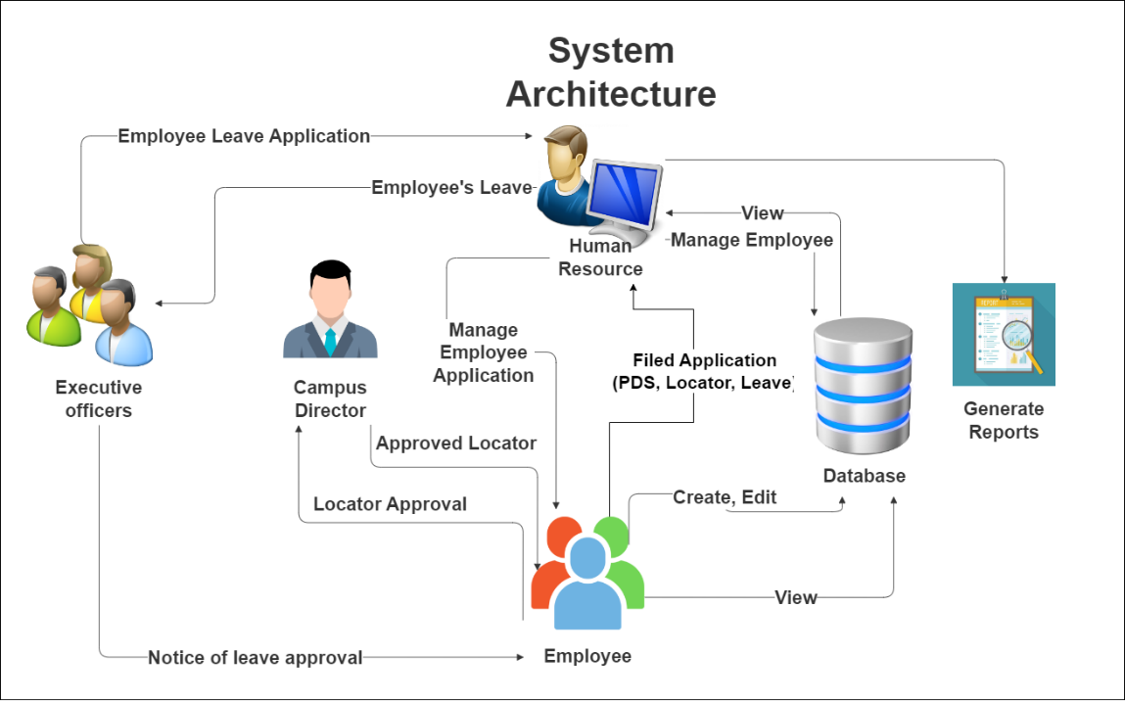**Figure 5. System Architecture**

Figure 5 above shows the system architecture of the proposed project. The main features mainly revolve between the employee and the HR. The HR mainly manages the essential document with concern to the employees such as PDS. The modules are restricted to the designated users.

**Use Case Diagram**

The use case diagram for "E-MINSU: A Web-based Human Resource Management System for Mindoro State University with SMS Notification" is shown below. It illustrates the system's usability and how the user and administrator interact with 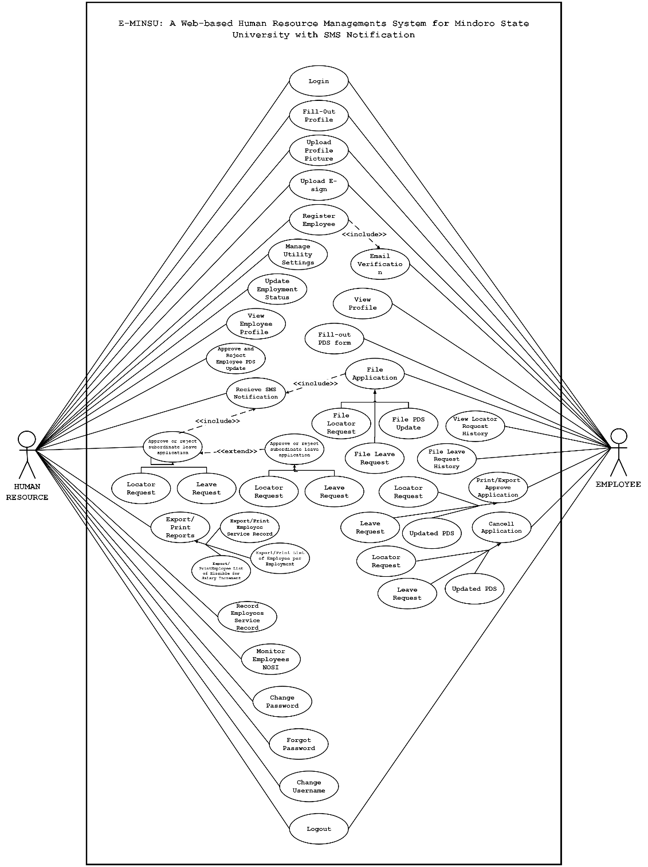it.

**Figure 6. Use Case Diagram**

In this figure 6 below, the case diagram shows the connection of the system between the actors. Human Resource is mainly the one who manages almost all the transactions on the system especially approval or rejection of Personal Data Sheet (PDS) updates, leave, locator applications and manages other documents related to the employees.

Employees also have their own module which they have the functionalities to interact with other modules mainly with the Human resource module. An employee can apply for leave using the system, request PDS updates, and fill up a locator slip.

**Activity Diagram**

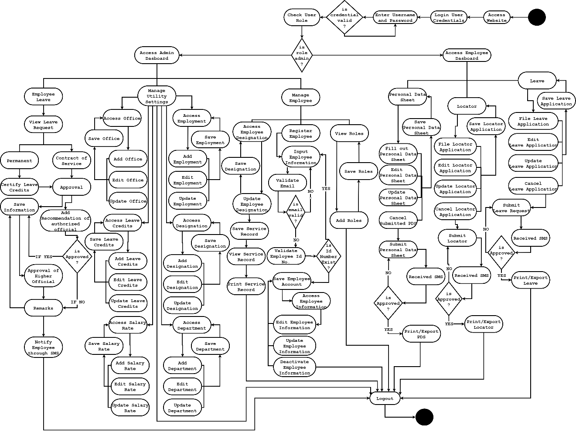The figures below show the activity diagram of the activities and transactions that took place in the system.

**Figure 7. Activity Diagram**

The figure above shows the whole activity of the system starting from the admin panel to the employee panel of the system.

**Data Flow Diagram (DFD)**

The developers studied the different processes and diagrams of the developing system to determine the improvement needed of the system. The following figures below show how the information flows or different transactions on the proposed system.

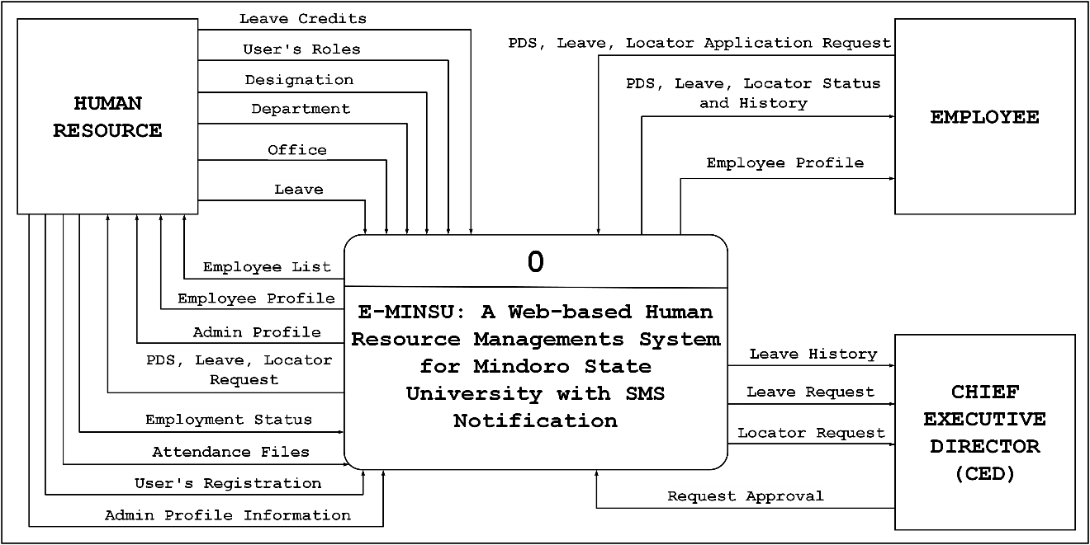 **Context Diagram**

**Figure 8. Context Diagram**

Figure 8 above demonstrates the mechanism by which the suggested system will operate and perform in the specific contexts for which it is intended.

**Diagram 0**

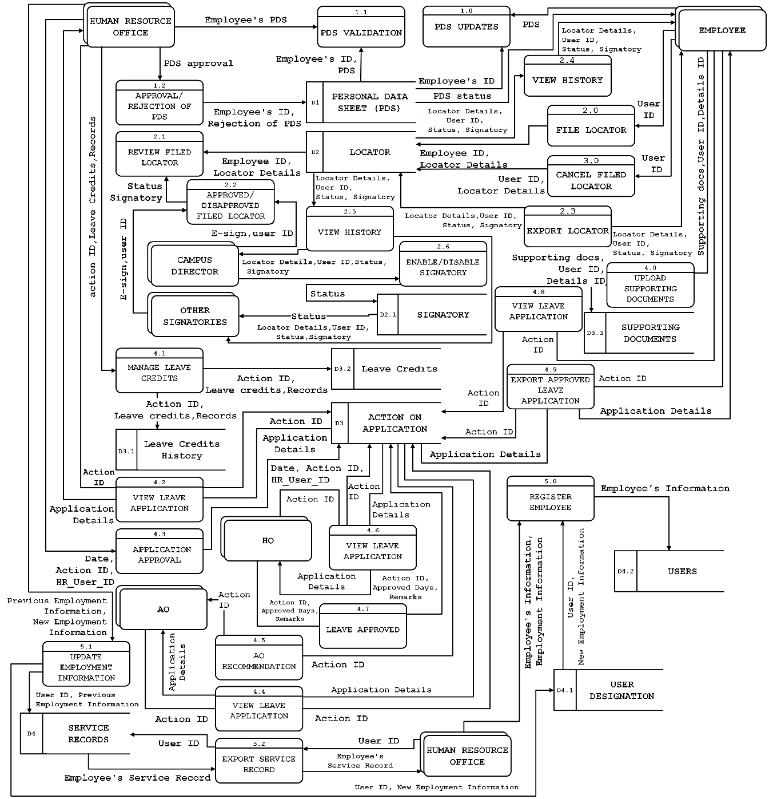Diagram 0 of E-MINSU: A Web-Based Human Resource Management System for Mindoro State University with SMS Notification shows all the process and functions that are happening in the system.

**Figure 9. Diagram 0**

The system's data for the project system is shown in the diagram 0 above, which also demonstrates how it interacts with the entities.

**Database Schema**

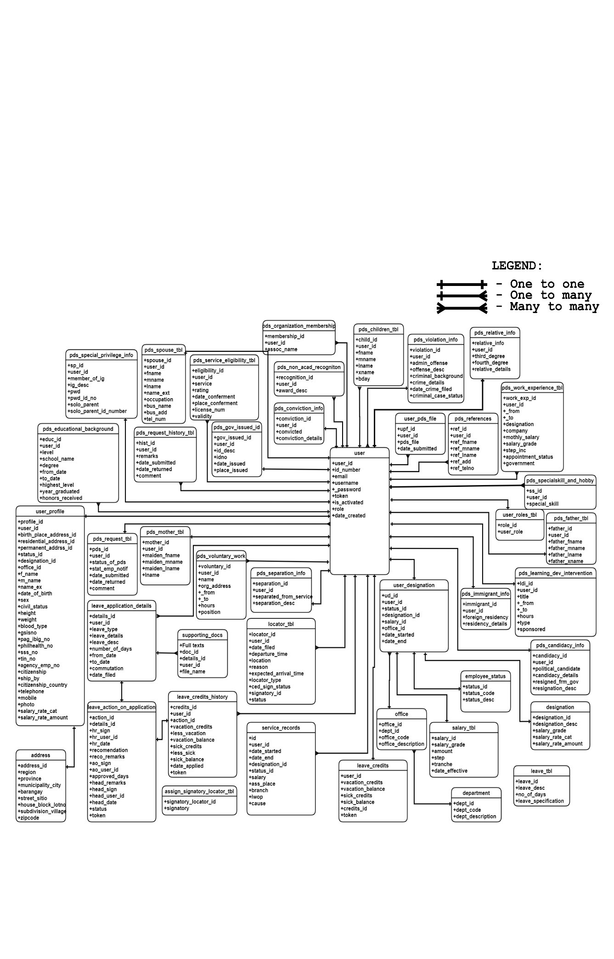 The system's database schema displays the name of the table and the data that it contains, along with where the system's information will be saved.

**Figure 10. Database Schema**

The system's database schema is depicted in the above diagram. This displays the information table that users of the web-based application that is utilized by the administrator and the employee can enter data too. The databases that the programmers utilized are displayed in the tables above. The user table, which is also connected to tables for PDS, locator, leave, designation, and other data, is the system's principal table. Each of these tables is connected to the others, and the system uses each piece of information.

**Testing and Evaluation**

The researchers used web hosting to share the website for testing. With this, the researchers checked if the system is malfunctioning and look for any faults once the entire system is in use. The website's capabilities, including the ability to fill out employee PDS forms, use a locator, and request leave, as well as the admin side functionality of the created website application, was tested. It also examined the usability, user experience, system design, and SMS notification features of the system. The researchers created a system and used ISO 25010 as a foundation to assess the system's effectiveness and results.

**Functional Suitability.** This refers to how well the system or product performs and can carry out the tasks it was designed to.

**Performance Efficiency.** This refers to how well a system performs given the number of resources it has utilized.

**Compatibility.** Refers to the ability of a system, product, or component to exchange information and carry out its necessary duties in the presence of a shared hardware or software environment.

**Usability.** This relates to how effectively, efficiently, and successfully a product or system may be utilized to achieve specific goals.

**Reliability.** This relates to how effectively, efficiently, and successfully a product or system may be leveraged to fulfill specified goals.

**Security.** This refers to how successfully a product or system protects information and data against security issues.

**Maintainability.** Refers to the degree to which a system or product may be altered to meet requirements or to improve,

adjust, or adapt to environmental changes.

**Portability.** This refers to the ability of a system, product, or component to transfer to a new environment.

**Likert Scale**

The study participants responded to questionnaires provided by the researchers. The data received from the questionnaires were used to verify the data required for the website. To collect information from the respondents, the researchers employed a rating scale questionnaire as their tool.

**Table 5. Likert Scale**

|  |  |  |
| --- | --- | --- |
| **Scale** | **Statistical Limit** | **Verbal Interpretation** |
| 5 | 4.50-5.00 | Strongly Agree |
| 4 | 3.50-4.49 | Agree |
| 3 | 2.50-3.49 | Moderately Agree |
| 2 | 1.50-2.49 | Disagree |
| 1 | 1.00-1.49 | Strongly Disagree |

Table 5 presents the Likert Scale that was used to evaluate the system. It is made up of five (5) scales, with the highest value being five (5) and the lowest value being one (1). Each scale signifies a verbal interpretation from Very Acceptable to Very Not Acceptable.

**Implementation Plan**

Following the system's development and implementation by the researchers, they began to evaluate the system's performance and using the information acquired they began to enhance the web-based application's functions. They test the system's modules using unit testing, identifying the system's capabilities and deficiencies in the process. After that, they make sure that the system is free of bugs and errors before deploying it to their chosen customer.

The web application was polished before being deployed in an actual working environment by the researchers. The proponents visited the Human Resource Office of the MinSU Calapan City Campus, which will be the system's user.

|  |  |  |
| --- | --- | --- |
| **Activities** | **Target Dates** | **Progress Notes** |
| Discussion with user | July 11, 2022 | Accomplished |
| Deployment Letter | November 14, 2022 | Accomplished |
| System Deployment and Monitoring Period | December 16, 2022 – December 16, 2023 | Few Patches |
| Training for User | December 16, 2022 | In progress |
| System Evaluation | January 09, 2023 | Accomplished |

**Table 6. Implementation Activities**

Table 6 demonstrates the project’s implementation plan for the system’s adaptation. It illustrates the dates of the activities to be performed.

**Chapter IV**

**RESULTS AND DISCUSSION**

The development of the system's design is discussed in this chapter. The administrative and staff interfaces, as well as the implementation strategy, will be included in the system’s design. This chapter may provide a discussion of the system's development and results.

**Presentation of System Output**

The presentation of the finished website, from the user interface to the actual system evaluation, is included in this section.

User interface (UI) is the public face of a system. When creating this component of a project, it is important to consider how well users will comprehend the elements we want to utilize to interact with our website. The illustrations below display the admin and user interfaces. The figures offer descriptions to aid in a clearer understanding of the interface and project visualization.

The user interface for the system's user side and the admin interface for the system's admin side are depicted in the figures below. The system's interfaces vary depending on the role.

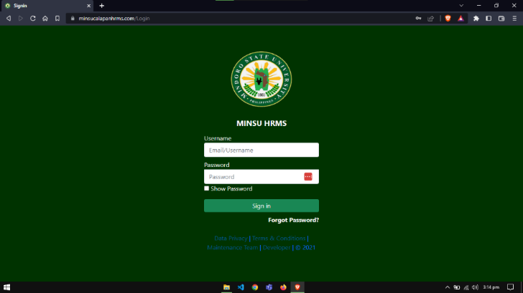**Admin Interface**

**Figure 11. Admin Login Page**

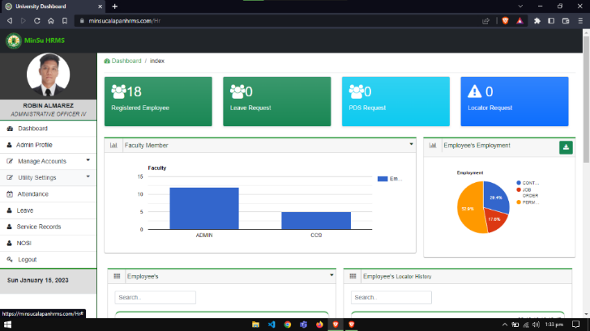Figure 11 shows the login page for the HR module. This indicates that the HR can access the using of their designated username or email address and the corresponding password to carry out their desired action.

**Figure 12. Admin Dashboard**

Figure 12 shows the dashboard for the HR. The bar graph shows the number of employees in each department while the pie graph shows the number of employees in each employment status. The dashboard shows the list of employees registered 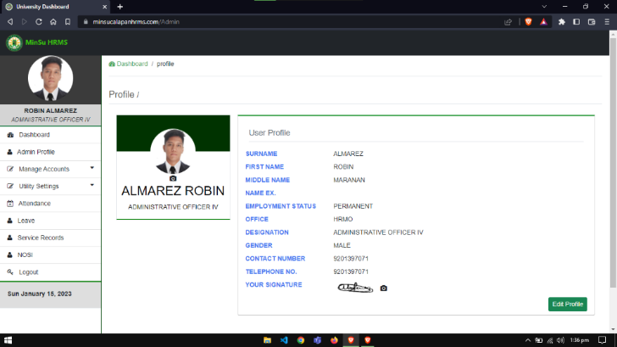along with their respect profiles and the locator history.

**Figure 13. Admin Profile**

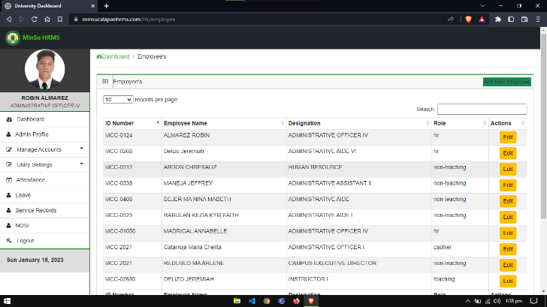Figure 13 shows the profile for the HR. This is used whenever the HR is a signatory for a process within the system such as the Leave request and Locator request.

**Figure 14. Registered Employee’s Page**

Figure 14 shows the list of the registered employees in the system. This is where the HR can enroll new employees as well as edit their information in case there are some errors that occurred upon enrollment.

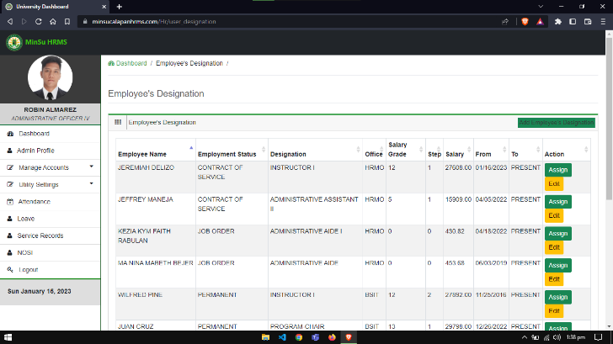**Figure 15. Registered Employees Designation Page**

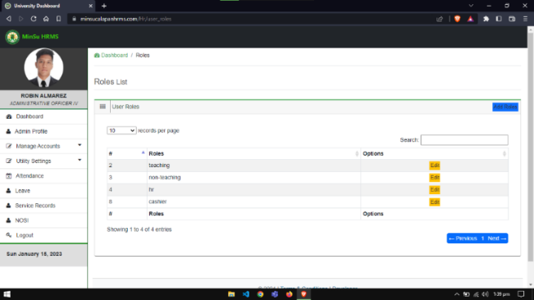Figure 15 shows the list of the employee’s respective employment information. The HR can perform assignment of new employment information such as updating the salary information for salary increment and assignment of new designation in case the employee got promoted into a new designation. The HR can also edit the current employment status in case there is an error on his enrollment.

**Figure 16. User Roles Management Page**

Figure 16 shows the list of user roles that exist within the system. HR can perform the addition of user role and the selected user role.

**Figure 17. Employment Status Management Page**

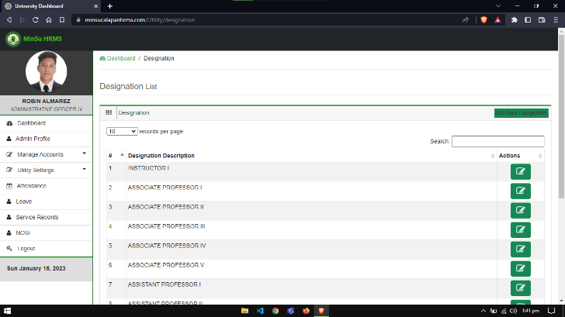Figure 17 shows the list of employment status within the system. The HR can also perform the addition of employment status and the updating of employment status that is being selected.

**Figure 18. Designation Management Page**

Figure 18 shows the designation within the system. HR is also capable of adding designations and altering employment status if there are some errors that need to be fixed.

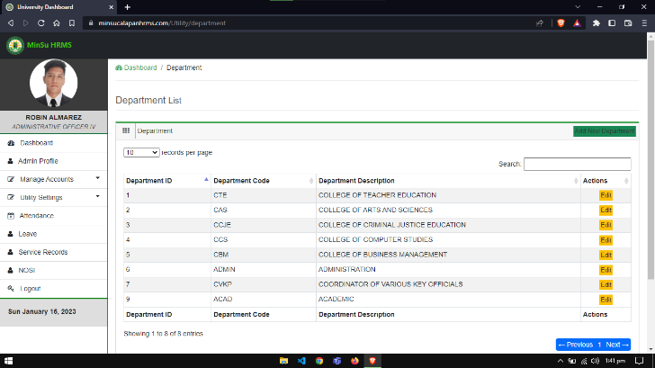Figure 18 shows the designation within the system. HR is also capable of adding designations and altering employment status if there are some errors that need to be fixed.

**Figure 19. Department Management Page**

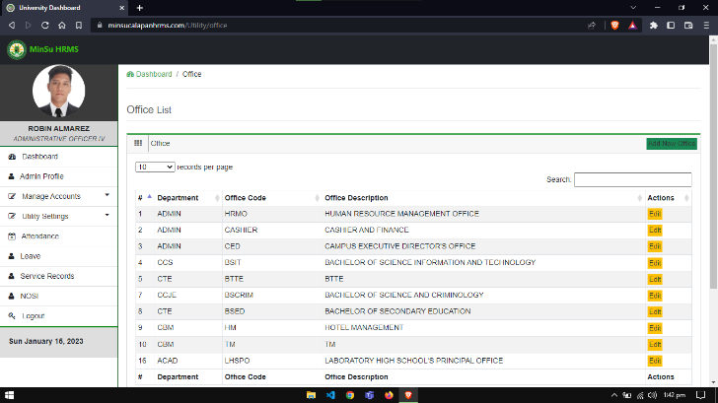Figure 19 shows the department within the system. Additionally, HR has the capability to change and add departments.

**Figure 20. Office Management Page**

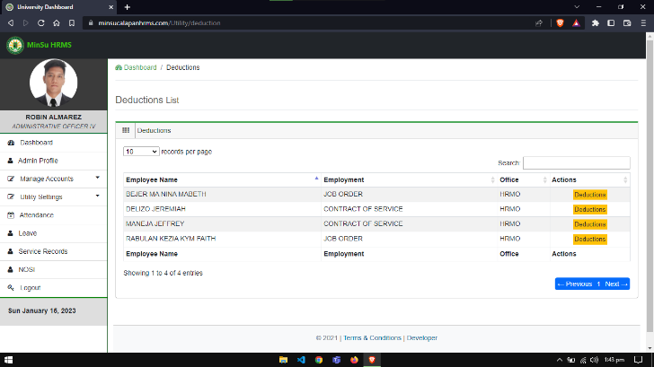Figure 20 shows the list of offices that exist within the MinSU Calapan Campus. The HR officer can add a new office and update the selected existing office in case there is a need to do so.

**Figure 21. Deduction Management Page**

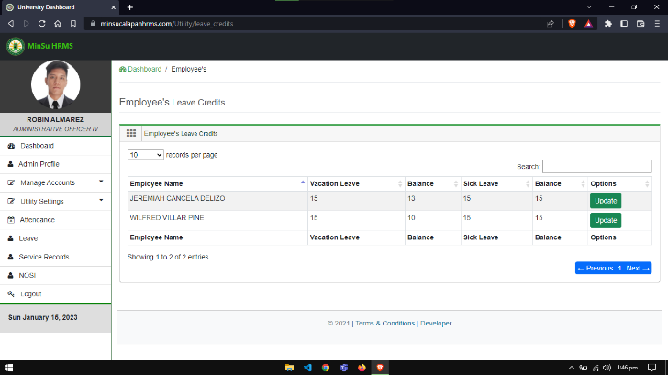Figure 21 shows the list of employees that have the voluntary contributions. The HR officer can select the corresponding deduction that an employee wants to deduct on their salary.

**Figure 22. Leave Credits Management Page**

Figure 22 shows the list of employees along with their respective leave credits. The HR officer can update the respective leave credits of an employee when they earn a service credit. The deducted leave credits from the 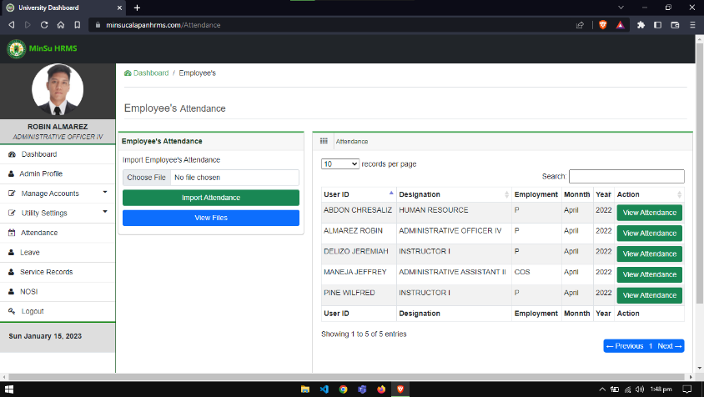employee’s leave request can also be notice here.

**Figure 23. Salary Table Page**

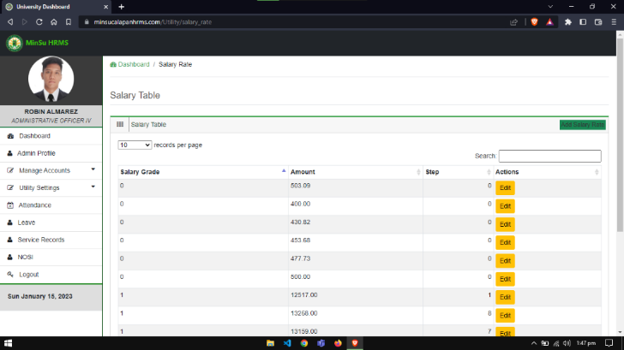Figure 23 shows the salary table for the permanent employees and for the employees that has the JOB ORDER employment status. HR have the capability to of adding new salary rate and updating the existing once in case they need to alter the information.

**Figure 24. Employee’s Attendance Page**

Figure 24 shows the interface where the HR can upload the attendance files of the employee in Excel Workbook file that is exported from the biometric system of the institution. The HR also has the capability of viewing and downloading the upload attendance files for backup purposes. The HR also can Graphical user interface, text, application, email
view the individual attendance of the selected employee.

**Figure 25. HR Leave Management Page**

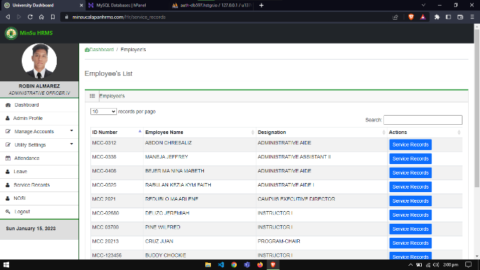Figure 25 shows the tables where the leave request of the employees goes when they submitted their application. The “Permanent” tab is where the leave request from the permanent employees goes. The “Contract of Service” is from the contract of service employees. The “Under Authorization” is where the leave request of the employees that comes from the office of HR after their request is certified by the HR officer. Lastly, the “Application Approval” tab is from permanent employees whose application is approved by their respective VPs.

**Figure 26. Service Record Page**

Figure 26 shows the list of employees along with the option to view their service records.

**Figure 27. Employees Service Record Page**

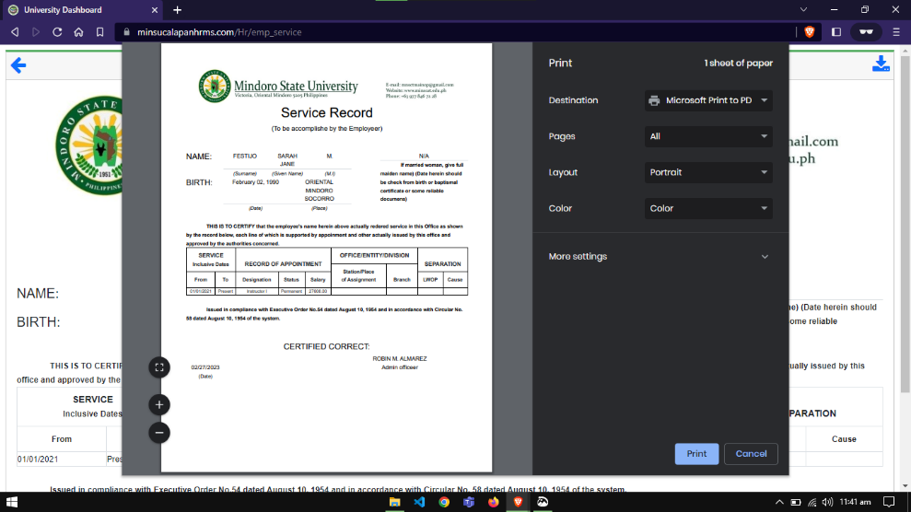Figure 27 shows the service record of the selected employee. The HR officer has the capacity to edit the rendered service of an employee to supply the missing information if there is one. The HR officer can also export the employee’s service records if the employee requested the copy of their service records.

**Figure 28. Service Record Printing**

Figure 28 depicts the service record printing. The print option would be selected, and the printing of the relevant papers would be initiated if the admin wanted to print the service record.

**Figure 29. Notice Of Salary Increment Page**

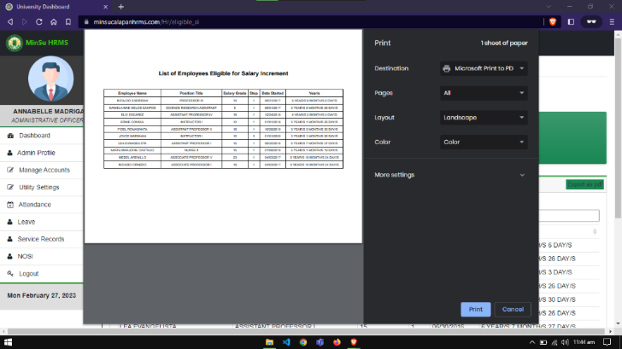Figure 29 shows the list of employees that are eligible for salary increment. The table shows the current salary grade and step which the employee currently has along with the respective duration that the employee has already rendered within that salary grade and step. The card on the upper right can be used to export the list of employees eligible for salary increment.

**Figure 30. NOSI Printing**

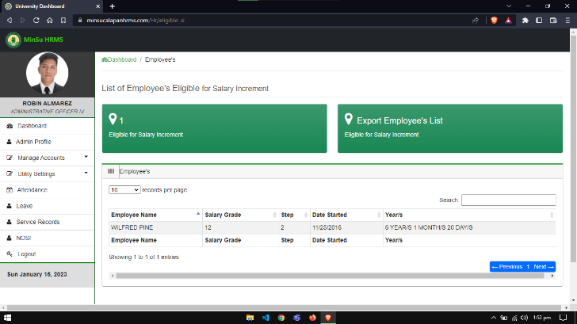Figure 30 depicts the NOSI printing. The print option would be selected, and the printing of the relevant papers would be initiated if the admin wanted to print the NOSI report.

**Figure 31. List Of Eligible for Salary Increment**

Figure 31 shows the list of employees that are already eligible for salary increment along with the duration that the employee rendered within the said salary grade and step.

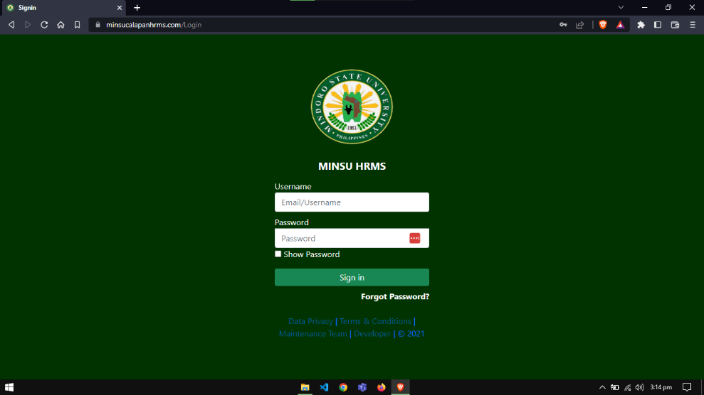**Employee Interface**

**Figure 32. Employee Login Page**

Figure 32 shows the login page for employees. This indicates that the employees can access the system through this page using their designated username or email address 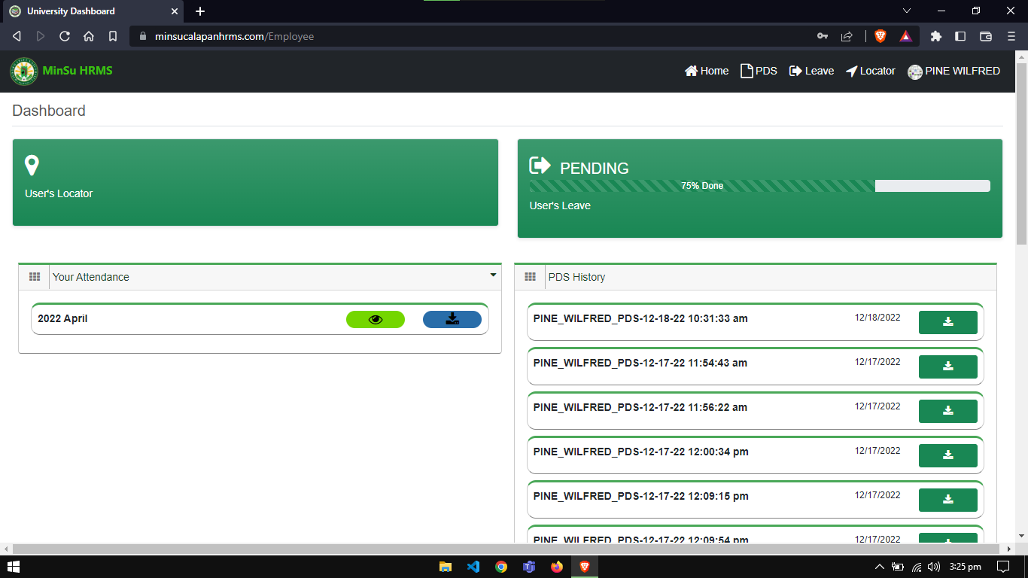and password. For them to perform their desired task.

**Figure 33. Employee’s Dashboard**

Figure 33 shows the employee’s dashboard upon successful login. The dashboard shows the PDS History of the employees that they can download, the progress bar of the existing leave request, the employee’s attendance if there is a record for

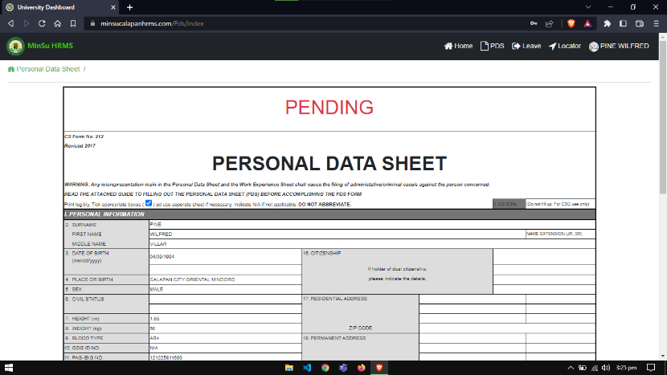that specific employee. Lastly, the card on the upper right is used to go directly to where the employees submit a locator request.

**Figure 34. Personal Data Sheet Page**

Figure 34 shows the Personal Data Sheet of the employee along with their information if they’re done filling out the forms that corresponds with the PDS.

**Figure 35. PDS Personal Information Page**

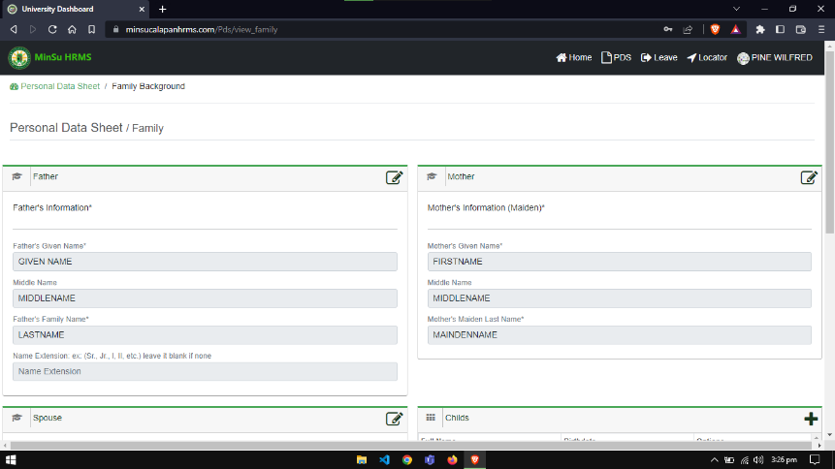Figure 35 shows the personal information form where the employee fills out their complete personal information to accomplish this page.

**Figure 36. PDS Family Background Page**

Figure 36 shows the tables where the employee can see and fill out the information about their family. The first

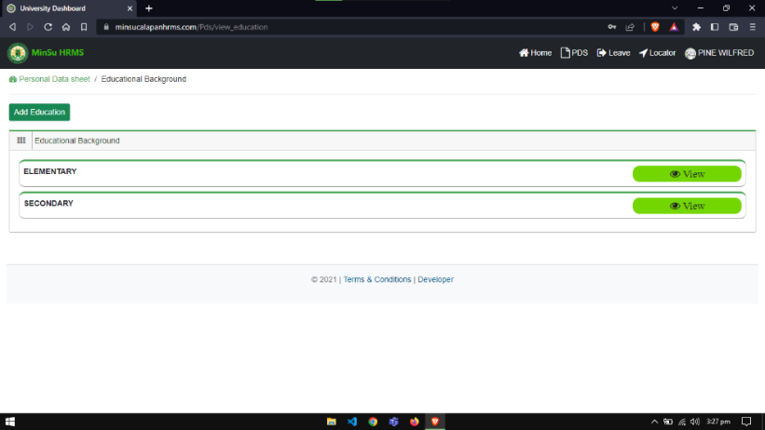form is for the information of the employee’s father, the second is for the employee’s mother, the form below the father’s form is for the spouse information and the last is for the employee’s child.

**Figure 37. PDS Educational Background Page**

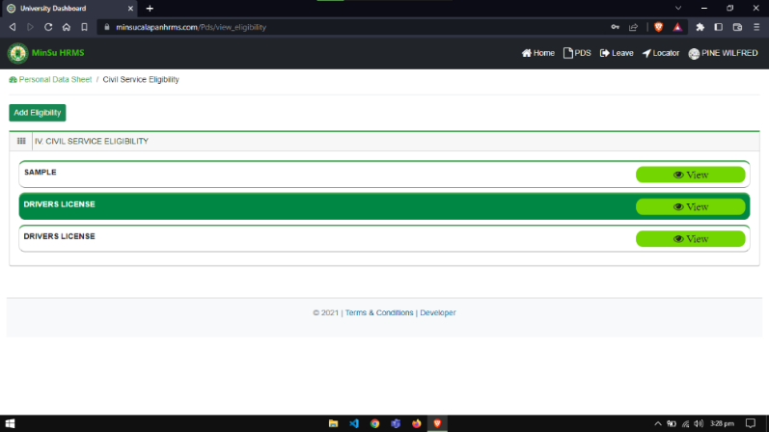 Figure 37 shows the page where the employee can add them educational background through the button on the upper left corner. They can also update their selected educational record upon viewing the selected record which the button for updating will be shown.

**Figure 38.** **PDS Civil Service Eligibility Page**

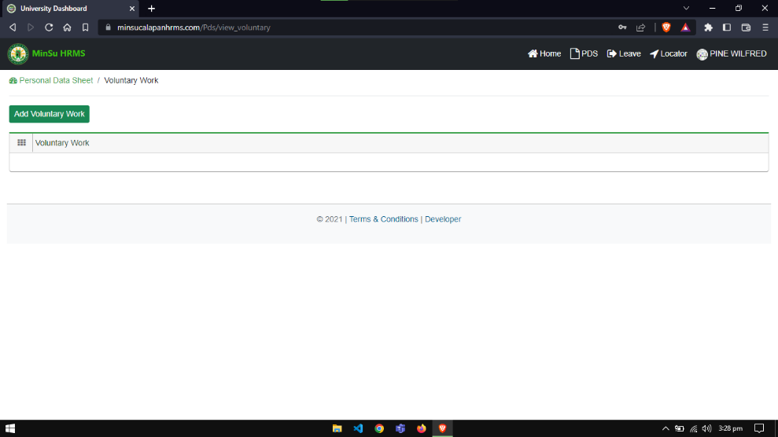Figure 38 shows the page for the employee where they can add using the button on the upper left corner and edit their respective eligibility upon viewing the selected record.

**Figure 39. PDS Work Experience Page**

Figure 39 shows the page where the employee’s record of

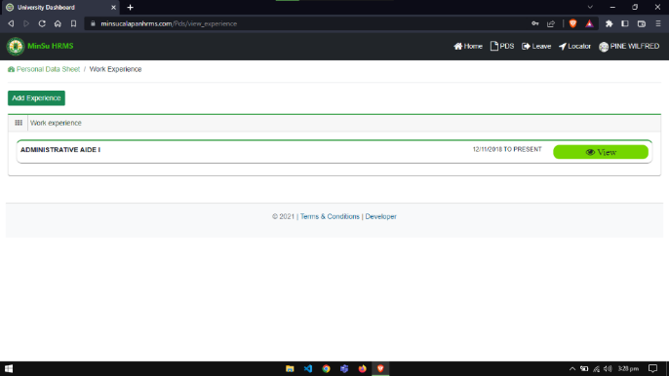their recent and past work experiences can be viewed. Using the button on the upper left corner they add their past work experience while the view button shows the selected record and the button for updating the record will be revealed.

**Figure 40. PDS Voluntary Work Page**

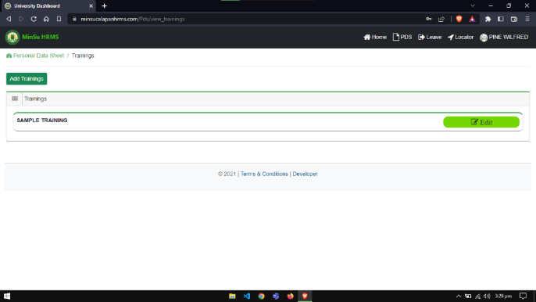Figure 40 displays the page where a record of the employee's current and previous volunteer activities can be accessed. While the view button displays the selected record and the button for updating the record is hidden, users of the button in the top left corner of the screen can add their previous volunteer activities.

**Figure 41. PDS Learning and Development/Interventions/Training Programs Page**

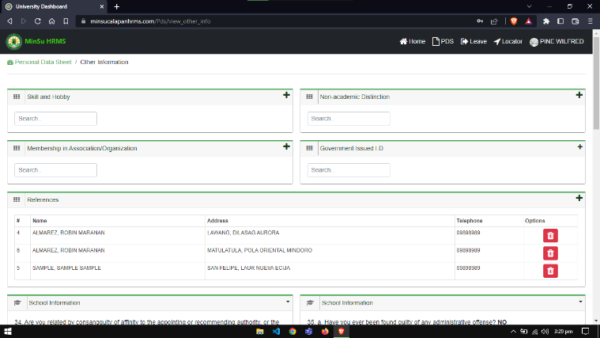Figure 41 displays the page where the employee can locate the list of their training attended. Using the button upper left corner, they can add training and the edit button gives them the capability to edit or update their selected record.

**Figure 42. PDS Other Information Page**

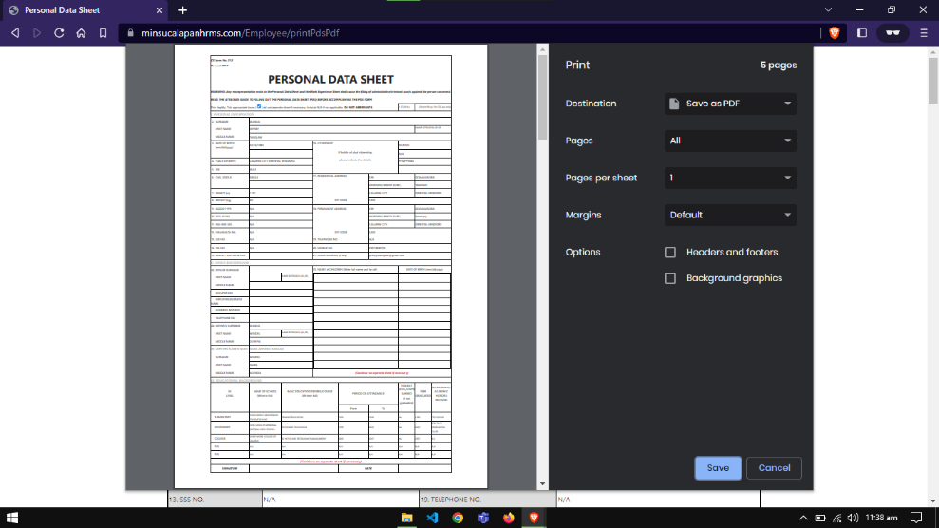Figure 42 shows the page where the employee can fill out the data for the other information section of the PDS.

**Figure 43. PDS Printing**

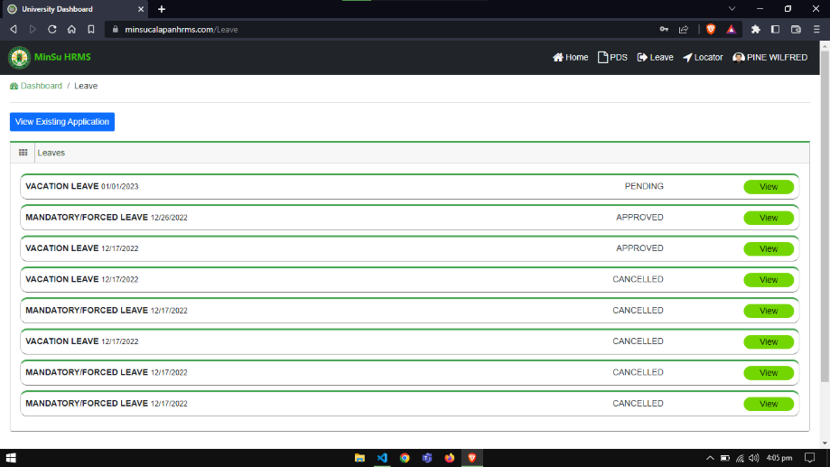Figure 43 depicts the leave printing. The print option would be selected, and the printing of the relevant papers would be initiated if the admin wanted to print the leave records.

**Figure 44. Employees Leave Page**

Figure 44 shows the page where the employee can file a leave request. The table also shows the past leave requests

of the employee along with its status. The view button shows the selected leave form while the view existing application button will show the current or pending request of the employee if they have one.

**Figure 45. Employees Leave Form**

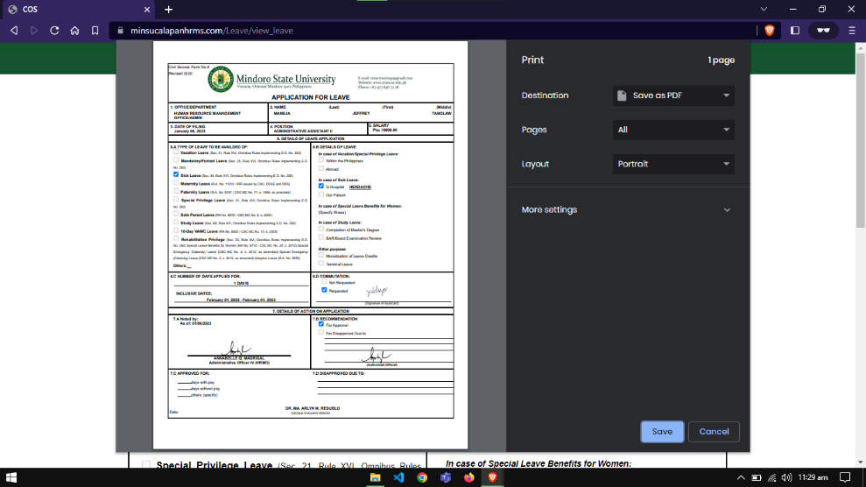Figure 45 shows the page where the selected leave formis displayed. This lets the employee track the status of the request and indicates that they can export it if it is approved by the respective signatories.

**Figure 46. Leave Printing**

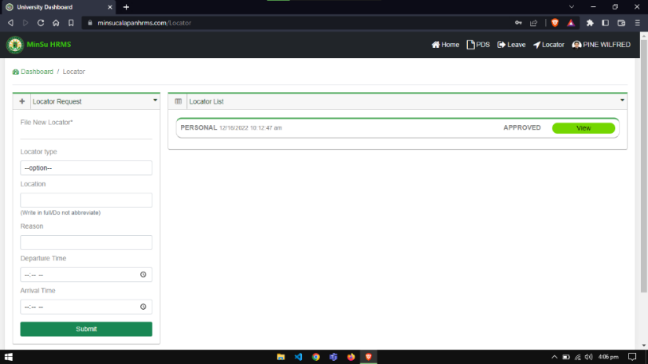Figure 46 depicts the leave printing. The print option would be selected, and the printing of the relevant papers would be initiated if the admin wanted to print the leave records.

**Figure 47. Employees Locator Page**

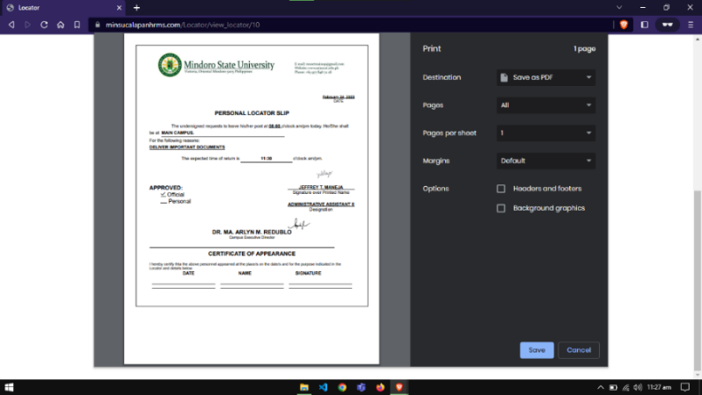Figure 47 shows the page where the employee can file a locator request. The form on the left side enables the employee to fill out a request. While the table on the right shows the previous locators they already used, the view button enables them to view more details about the selected locator records.

**Figure 48. Locator Printing**

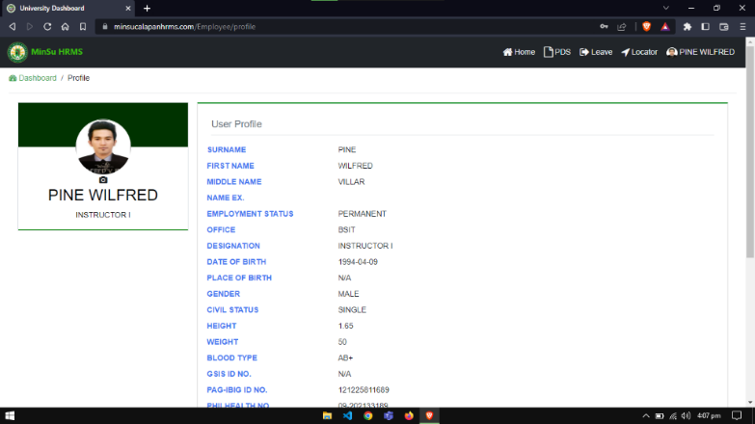Figure 48 depicts the locator printing. The print option would be selected, and the printing of the relevant papers would be initiated if the admin wanted to print the locator reports.

**Figure 49. Employees Profile Page**

Figure 49 shows the page where the employee can view their profile. This page displays the primary or the most important information about the employee.

**Evaluation of the System**

An evaluation of the established system was carried out as part of the implementation plan, the system was assessed using ISO 25010 to determine how well it met the requirements for functional suitability, performance efficiency, compatibility, usability, reliability, security, maintainability, and portability. And the Mindoro State University Calapan City Campus's human resource staff, IT experts, and other employees served as the evaluators.

|  |  |  |  |
| --- | --- | --- | --- |
| **Functional Suitability** | **Mean** | **Rank** | **Verbal Interpretation** |
| 1.1. The system covers all specified tasks and user objectives. | 4.41 | 3 | Strongly Agree |
| 1.2. The system provides the correct results with the needed degree of precision. | 4.34 | 4 | Strongly Agree |
| 1.3. The system can accomplish specified tasks and objectives. | 4.49 | 1 | Strongly Agree |
| 1.4. As a whole. | 4.46 | 2 | Strongly Agree |
| **Overall Mean** | **4.43** |  | **Strongly Agree** |

**Table 7. Functionality Suitability of the System**

Table 7 illustrates the result of the evaluation in terms of functional suitability of the website. As shown in the table above, the overall mean of the website’s functional suitability is “4.43” with the verbal interpretation of “strongly agree” and “the system can accomplish specified tasks and objectives” as rank 1 while “the system provides the correct results with the needed degree of precision” as rank 4. The human resource staff, IT experts and other MinSU Calapan Campus employees are the evaluators.

The result states that the developed website provides the correct output and functions for the intended users. It encompasses that the website responds with completeness, correctness, and appropriateness. This shows that the website delivers its results in compliance with its user requirements. The table shows that according to the users the website is functional and performing exactly as intended without any problems.

**Table 8. Performance Efficiency of the System**

|  |  |  |  |
| --- | --- | --- | --- |
| **Performance Efficiency** | **Mean** | **Rank** | **Verbal Interpretation** |
| 2.1 The amounts and types of resources used by a system, when performing its functions, meet requirements. | 4.52 | 1 | Strongly Agree |
| 2.2 The response and processing times and throughout rates of a system, when performing its functions, meet requirements. | 4.26 | 4 | Strongly Agree |
| 2.3 The maximum limits of the system parameter, meet requirements. | 4.45 | 3 | Strongly Agree |
| 2.4 As a whole. | 4.46 | 2 | Strongly Agree |
| **Overall Mean** | **4.42** |  | **Strongly Agree** |

Table 8 illustrates the result of the evaluation in terms of performance efficiency of the website. As shown in the table above, the overall mean of the website’s performance efficiency is “4.42” with the verbal interpretation of “strongly agree” and “the amounts and types of resources used by a system, when performing its functions, meet requirements as rank 1 while “the response and processing times and throughout rates of a system, when performing its functions, meet requirements” as rank 4. The human resource staff, IT experts and other MinSU Calapan Campus employees are the evaluators. This means that the website can deliver the expected output of the users and delivers the resources needed by the users efficiently.

**Table 9. Compatibility of the System**

|  |  |  |  |
| --- | --- | --- | --- |
| **Compatibility** | **Mean** | **Rank** | **Verbal Interpretation** |
| 3.1. The system performs its required functions efficiently while sharing a common environment and resources with other products, without negative impact on any other product. | 4.50 | 2.5 | Strongly Agree |
| 3.2. The system can exchange information and use the information that has been exchanged. | 4.51 | 1 | Strongly Agree |
| 3.3. As a whole. | 4.50 | 2.5 | Strongly Agree |
| **Overall Mean** | **4.50** |  | **Strongly Agree** |

Table 9 illustrates the result of the evaluation in terms of compatibility of the website. As shown in the table above, the overall mean of the website’s performance efficiency is “4.50” with the verbal interpretation of “strongly agree” and “the system can exchange information and use the information that has been exchanged” as rank 1 while “the system performs its required functions efficiently while sharing a common environment and resources with other products, without negative impact on any other product” as rank 2.5. The human resource staff, IT experts and other MinSU Calapan Campus employees are the evaluators.

|  |  |  |  |
| --- | --- | --- | --- |
| **Reliability** | **Mean** | **Rank** | **Verbal Interpretation** |
| 5.1. A system meets for reliability under normal operation. | 4.52 | 3 | Strongly Agree |
| 5.2. The system is operational and accessible. | 4.62 | 1 | Strongly Agree |
| 5.3. The system operates despite hardware and/or software faults. | 4.40 | 4 | Agree |
| 5.4. The system can recover data in the event of an interruption or failure. | 3.89 | 5 | Agree |
| 5.5. As a whole. | 4.56 | 2 | Strongly Agree |
| **Overall Mean** | **4.40** |  | **Agree** |

The compatibility of the website meets its requirements when it comes to shared hardware and software environments. **Table 10. Reliability of the System**

Table 10 illustrates the result of the evaluation in terms of reliability of the website. As shown in the table above, the overall mean of the website’s reliability is “4.40” with the verbal interpretation of “agree” and “the system is operational and accessible” as rank 1 while “the system can recover data in the event of an interruption or failure” as rank 5. The human resource staff, IT experts and other MinSU Calapan Campus employees are the evaluators. This means that the website delivers its designated functions and fulfills the intended requirements of the users.

|  |  |  |  |
| --- | --- | --- | --- |
| **Usability** | **Mean** | **Rank** | **Verbal Interpretation** |
| 4.1. Users can recognize whether a system is appropriate for them needs. | 4.63 | 1 | Strongly Agree |
| 4.2. A system enables the user to learn how to use it with effectiveness, efficiency in emergencies. | 4.47 | 4 | Agree |
| 4.3. A system is easy to operate, control and appropriate to use. | 4.57 | 2 | Strongly Agree |
| 4.4. A system protects users against making errors. | 4.24 | 7 | Agree |
| 4.5. A user interface enables pleasing and satisfying interactions for the user. | 4.35 | 6 | Agree |
| 4.6. A system can be used with the widest range of characteristics and capabilities. | 4.49 | 3 | Agree |
| 4.7. As a whole | 4.44 | 5 | Agree |
| **Overall Mean** | **4.46** |  | **Agree** |

**Table 11. Usability of the System**

Table 11 illustrates the result of the evaluation in terms of usability of the website. As shown in the table above, the overall mean of the website’s usability is “4.46” with the verbal interpretation of “agree” and “users can recognize whether a system is appropriate for them needs” as rank 1 while “a user interface enables pleasing and satisfying interactions for the user” as rank 6. The human resource staff, IT experts and other MinSU Calapan Campus employees are the evaluators. This shows that the website is user friendly and can be use easily, the controls can be manipulated with ease, and can be understood without the necessity to have exerting additional technical knowledge when it comes to different users to maximize the capabilities of the website.

**Table 12. Security of the System**

|  |  |  |  |
| --- | --- | --- | --- |
| **Security** | **Mean** | **Rank** | **Verbal Interpretation** |
| 6.1. The system ensures that data are accessible only to those authorized to have access. | 4.67 | 1 | Strongly Agree |
| 6.2. The system can prevent unauthorized access to, or modification of computer programs or data. | 4.65 | 2 | Strongly Agree |
| 6.3. Actions or events of the system can be proven to have taken place. | 4.30 | 5 | Agree |
| 6.4. Unauthorized users can be traced back to them. | 4.25 | 6 | Agree |
| 6.5. The identity of a subject or resources can be proved. | 4.32 | 4 | Agree |
| 6.6. As a whole | 4.49 | 3 | Strongly Agree |
| **Overall Mean** | **4.45** |  | **Agree** |

Table 12 illustrates the result of the evaluation in terms of security of the website. As shown in the table above, the overall mean of the website’s security is “4.45” with the verbal interpretation of “agree” and “the system ensures that data are accessible only to those authorized to have access” as rank 1 while “unauthorized users can be traced back to them” as rank 6. The human resource staff, IT experts and other MinSU Calapan Campus employees are the evaluators.

This means that the website can secure the users information and can only be accessed by the authorized user. This indicates that the website’s security is in a good state.

|  |  |  |  |
| --- | --- | --- | --- |
| **Maintainability** | **Mean** | **Rank** | **Verbal Interpretation** |
| 7.1. The components of a system or the program can be changed with minimal impact on other components. | 4.29 | 3 | Agree |
| 7.2. An asset can be used in more than one system. | 4.41 | 1 | Agree |
| 7.3. The diagnosis of deficiencies or causes of failures, or to identify parts to be modified is helpful. | 4.19 | 5.5 | Agree |
| 7.4. A system can be effectively and efficiently modified without introducing defects or degrading existing product quality. | 4.19 | 5.5 | Agree |
| 7.5. Test criteria can be established for a system to determine whether those criteria have been met. | 4.39 | 2 | Agree |
| 7.6. As a whole | 4.28 | 4 | Agree |
| **Overall Mean** | **4.29** |  | **Agree** |

**Table 13. Maintainability of the System**

Table 13 illustrates the result of the evaluation in terms of maintainability of the website. As shown in the table above, the overall mean of the website’s maintainability is “4.29” with the verbal interpretation of “agree” and “an asset can be used in more than one system” as rank 1 while “a system can be effectively and efficiently modified without introducing defects or degrading existing product quality” as rank 5.5. The human resource staff, IT experts and other MinSU Calapan Campus employees are the evaluators.

This shows that the website responds to modifications, or it is adaptive to changes without having a major impact on the system’s components. This indicates that the system can be modified or improved without having any trouble.

**Table 14. Portability of the System**

|  |  |  |  |
| --- | --- | --- | --- |
| **Portability** | **Mean** | **Rank** | **Verbal Interpretation** |
| 8.1. A system can effectively and efficiently be adapted for different or evolving hardware, software or other operational or usage environments. | 4.42 | 3.5 | Agree |
| 8.2. The system provides login and logout. | 4.67 | 1 | Strongly Agree |
| 8.3. A system can replace another specified software product for the same purpose in the same environment. | 4.42 | 3.5 | Agree |
| 8.4. As a whole. | 4.56 | 2 | Strongly Agree |
| **Overall Mean** | **4.52** |  | **Strongly Agree** |

Table 14 illustrates the result of the evaluation in terms of portability of the website. As shown in the table above, the overall mean of the website’s portability is “4.52” with the verbal interpretation of “strongly agree”, “the system provides login and logout” as rank 1 while “a system can replace another specified software product for the same purpose in the same environment” as rank 3.5. The human resource staff, IT experts and other MinSU Calapan Campus employees are the evaluators.

This indicates that the website's portability is effective because it allows for the effortless transfer of data into a different device. This implies that the website is always available.

**Table 15. Summary Results of the System**

|  |  |  |  |  |
| --- | --- | --- | --- | --- |
| **Items** | **Mean** |  | **Rank** | **Verbal Interpretation** |
| Functional Suitability | 4.43 |  | 5 | Agree |
| Performance Efficiency | 4.42 |  | 6 | Agree |
| Compatibility | 4.50 |  | 2 | Strongly Agree |
| Usability | 4.45 |  | 3.5 | Agree |
| Reliability | 4.40 |  | 7 | Agree |
| Security | 4.45 |  | 3.5 | Agree |
| Maintainability | 4.29 |  | 8 | Agree |
| Portability | 4.52 |  | 1 | Strongly Agree |
| **Overall Mean** | **4.42** |  |  | **Agree** |

Table 15 shows the results of the implementation results of the website ISO 25010. Table 14 shows that the website has Functional Suitable of (A=4. 43) as “Agree”, Performance Efficiency (A=4.42) as “Agree”, Compatibility (A=4.50) as “Strongly Agree”, Usability (A=4.45) as “Agree”, Reliability (A=4.40) as “Agree”, Security (A=4.45) as “Agree”, Maintainability (A=4.29) as “Agree”, and Portability (A=4.52) as “Strongly Agree”, which has the general average of “4.42” as “Agree” with Portability as rank 1 and Maintainability as rank 8.

It implies that the website is more approachable in terms of its ability to be maintained by IT experts and staff because they have more access to and expertise in this area.

**Implementation Results**

The researchers deployed their system to the Human Resource Office of the MinSU Calapan City Campus after evaluating it and repairing any flaws or faults the developers discovered in the built system (MCC). The system was created in accordance with the processes that the creators wished to digitize. After the implementation, the following recommendations emerged: the system must contain data from the human resource office and integrate SMS notification, and the printing of the reports must be automatically directed to the printing process.

Employees at MCC, particularly those working in the human resources department, reviewed the system, and it came out that, based on their evaluation scores, the system receives a Strongly Agree rating.

|  |  |  |  |  |
| --- | --- | --- | --- | --- |
| **Activities** | **Target Dates** | **Progress Notes** | **Outcomes** | **Remarks** |
| Discussion with user | July 11, 2022 | Accomplished | Required information’s for the project were gathered. | Some formulations are change and some functions have added. |
| Deployment Letter | November 14, 2022 | Accomplished | Deployment letters were signed. | None. |
| System Deployment and Monitoring Period | December 16, 2022 – December 16, 2023 | Few Patches | Errors and bugs of the system were fixed. | Some bugs appear and need to be fixed. |
| Training for User | December 16, 2022 | In progress | The users successfully use the system. | None. |
| System Evaluation | January 09, 2023 | Accomplished | Add and remove some features of the system. | None. |

**Table 16. Implementation Result**

Table 16 shows the implementation result of the project based on the implementation plan, which shows that the project's growth and development were successful. The researchers were successful in implementing the project specifications and testing techniques needed of the system.

**Chapter V**

**SUMMARY, CONCLUSION AND RECOMMENDATION**

This chapter includes an elaborate summary, conclusion, and recommendation. Based on the data collection that was done, the proponents' observations and interpretations were evaluated, assessed, and analyzed.

**Summary**

The primary goal of this study is to create a web-based human resource management system with SMS notification that will electronically store organizational data. The system administrator can control the transactions, and users or employees can submit PDS, leave and locator requests. The study concentrated on creating a user-friendly environment so that users can easily engage with the website and on the features that the user requires to manage a human resource. Additionally, the technical operation of the entire system was tested during the construction of this system using ISO 25010.

Going by the evaluated data from the respondents, the functional suitability is effectively checked and according to the gathered data, “4.43” is the overall mean which describes as “strongly agree”, performance efficiency with

overall mean of “4.42” and describes as “strongly agree”, compatibility with overall mean of “4.50” and describes as “strongly agree”, usability with overall mean of “4.45” and describes as “strongly agree”, reliability with overall mean of “4.40” and describes as “strongly agree”, security with overall mean of “4.45” and describes as “strongly agree”, maintainability with overall mean of “4.29” and describes as “strongly agree” and portability with overall mean of “4.52” and describes as “strongly agree”. The system completes stated tasks and objectives without exhibiting any errors and operates in accordance with user requirements. Overall, the system is functional, beneficial for the office's data management, and convenient for the staff, which shows that it can run flawlessly in accordance with its goals.

Additionally, that was supported by the information acquired and system usage where the Mindoro State University (MinSU) Calapan City Campus personnel successfully registered and submitted PDS, leave, and locator requests. The admin, who works in the human resources department at the MinSU Calapan City Campus, effectively managed the system's other features as well as the requests to approve and deny employees' accounts.

**Conclusions**

As the proponents complete the development and study of E-MINSU: Mindoro State University’s Web-Based Human Resource Management System with SMS Notification, the researchers have come to several conclusions and observations. These are the following:

1. The web-based system functions to store the employee’s data securely and can generate different reports for human resource office needs.
2. The system allows the employees to file their leave and locator request virtually, produce service records, and pay slips.
3. The system integrates SMS notification to notify employees about the progress of their request.
4. The system meets the user requirements in terms of Functional Suitability, Performance Efficiency, Compatibility, Useability, Reliability, Security, Maintainability and Portability as the respondents gave a high rating performance; and
5. The system is fully implemented by Mindoro State University – Human Resource Office.

**Recommendations**

The researchers make the following recommendations basedon the data presented in this study which are obtained during deployment period:

1. Future researchers and web developers may include additional offices as users for the website’s human resource management system to be complete.
2. Future web developers may include the other documents that human resources need to process.
3. Future developers may improve the user interface (UI) and user experience (UX) of the system.
4. Future researchers may look for additional functions that are necessary for human resources to fully convert their operations to electronic ones.
5. Future developers may improve the system's interactivity and responsiveness to mobile devices.
6. Future researchers may continue to make upgrades and advances to keep up with developing technologies.

**BIBLIOGRAPHY**

Ab Aziz, A., Mohammad Yusof, Z., Mokhtar, U. A., & Jambari, D. I. (2018). Electronic document and records management system implementation in Malaysia: A preliminary study of issues embracing the initiative. In Lecture Notes in Computer Science (including subseries Lecture Notes in Artificial Intelligence and Lecture Notes in Bioinformatics): Vol. 10766 LNCS. Springer International Publishing. https://doi.org/10.1007/978-3-319-78105-1_65

Afsana, H. (2018). Employee leave Management System in MetLife Bangladesh. 38. http://hdl.handle.net/10361/9854

Aladejebi, D. O., & Oladimeji, D. J. A. (2019). The Impact of Record Keeping On the Performance of Selected Small and Medium Enterprises in Lagos Metropolis. Journal of Small Business and Entrepreneurship Development, 7(1). https://doi.org/10.15640/jsbed.v7n1a3

Amora, E. N. O., Romero, K. V, & Romero, A. M. J. (2021). Digital Attendance and Accomplishment Report Monitoring System (Digiatt). Ioer International Multidisciplinary Research Journal, 3(2), 123–133.

Anwar, G., & Abdullah, N. N. (2021). The impact of Human resource management practice on Organizational performance. International Journal of Engineering, Business and Management, 5(1), 35–47. https://doi.org/10.22161/ijebm.5.1.4

Brombuela, G. B., Estacio, A. D. L., Jingco, F. G. A., & Cabrera, W. (2021). The Impact of Management Information System on Teachers of an HEI in City of The Impact of Management Information System on Teachers of an HEI in City of Malolos , Bulacan , Philippines Abstract : September.

Buhain, J.-A. C., & Pulmano, C. E. (2021). Development of a Leave Management and Monitoring System for the Cavite State University Campus Network. International Journal of Business and Technology Management, 3(3), 124–135. https://myjms.mohe.gov.my/index.php/ijbtm/article/view/16022

Capraro, F., Tosetti, S., Rossomando, F., Mut, V., & Serman, F. V. (2018). Web-based system for the remote monitoring and management of precision irrigation: A case study in an arid region of Argentina. Sensors (Switzerland), 18(11). https://doi.org/10.3390/s18113847

Casadesús, A., Mingo, D., & Cerrillo-i-martínez, A. (2018). International Journal of Information Management Improving records management to promote transparency and prevent corruption. International Journal of Information Management, 38(1), 256–261. https://doi.org/10.1016/j.ijinfomgt.2017.09.005

Curiel, M., & Pont, A. (2018). Workload Generators for Web-Based Systems: Characteristics, Current Status, and Challenges. IEEE Communications Surveys and Tutorials, 20(2), 1526–1546. https://doi.org/10.1109/COMST.2018.2798641

Garcia, J. G., Gangan, M. G. T., Tolentino, M. N., Ligas, M., Moraga, S. D., & Pasilan, A. A. (2021). Canvas Adoption Assessment and Acceptance of the Learning Management System on a Web-Based Platform. ArXiv: Computers and Society, 12(1), 24–38. https://128.84.21.199/abs/2101.12344

Gonapinuwala, D. S. D. (2020). Leave Management System for Sri Lanka Teachers’ Service. http://dl.ucsc.cmb.ac.lk/jspui/handle/123456789/4488

Grepon, B. G., Baran, N., Gumonan, K. M. V., Martinez, A. L., & Lacsa, M. L. (2022). Designing and Implementing e-School Systems: An Information Systems Approach to School Management of a Community College in Northern Mindanao, Philippines. International Journal of Computing Sciences Research, 6, 792–808. https://doi.org/10.25147/ijcsr.2017.001.1.74

Jayoma, J. M., Moyon, E. S., & Morales, E. M. O. (2020). OCR Based Document Archiving and Indexing Using PyTesseract: A Record Management System for DSWD Caraga, Philippines. 2020 IEEE 12th International Conference on Humanoid, Nanotechnology, Information Technology, Communication and Control, Environment, and Management, HNICEM 2020. https://doi.org/10.1109/HNICEM51456.2020.9400000

Khim, C. Y. (2018). Leave Management System (LMS).

Kuś, A., & Pypłacz, P. (2019). The importance of information management in the context of Industry 4.0: Evidence from the Kuyavian-Pomeranian Forbes Diamonds. Social Sciences, 8(6), 1–13. https://doi.org/10.3390/socsci8060169

Luzon, C., Lacatan, L., Bangalisan, H., & Osapdin, J. (2022). Web-Based File Clustering and Indexing for Mindoro State University. International Journal of Computing Sciences Research, 6, 951–961. https://doi.org/10.25147/ijcsr.2017.001.1.82

Mukred, M., Yusof, Z. M., & Alotaibi, F. M. (2019). Ensuring the productivity of higher learning institutions through electronic records management system (ERMS). IEEE Access, 7, 97343–97364. https://doi.org/10.1109/ACCESS.2019.2927614

Naive, A. F. E. (2020). Design and implementation of faculty class attendance monitoring system using BLE beacons. Indian Journal of Science and Technology, 13(40), 4234–4243. https://doi.org/10.17485/ijst/v13i40.1527

Paderna, R. D., Guiveses, M. L., Ong, S. J., & Tsai, J. L. (2020). Improving Employee Experience in a Medium-sized Retail Chain through Quality Human Resource Management Practices: Does Bifurcation Bias in Family Firms Moderate the Nexus? Review of Integrative Business and Economics Research, 9(1), 62–79. http://buscompress.com/journal-home.html

Pengaruh PMA, PMDN, TK, dan I. (2020). EMPLOYEE LEAVE MANAGEMENT SYSTEM. 2507(February), 1–9.

Plata, I. T., & Calpito, J. L. (2020). Application of time-based one time password (TOTP) algorithm for human resource e-leave tracking web app. International Journal of Scientific and Technology Research, 9(3), 4070–4077.

Praveen. T, Vetrivel. HM, & Arumugasamy. B. (2020). Online Leave Management System. International Journal of Advanced Science and Technology, 29(7), 2785–2791. http://sersc.org/journals/index.php/IJAST/article/view/18155

Reddy, K. P. N., Alekhya, T., T, S. M., & Rashmi, K. (2019). AI-Based Attendance Monitoring System. International Journal of Innovative Technology and Exploring Engineering, 9(2S), 592–597. https://doi.org/10.35940/ijitee.b1057.1292s19

Satria, D., Zulfan, Z., Munawir, M., & Mulyati, D. (2019). Final Project Consultation Information System Integrated Notification System Based on Sms Gateway. Cyberspace: Jurnal Pendidikan Teknologi Informasi, 2(2), 135. https://doi.org/10.22373/cj.v2i2.4002

Setiyawati, H., & Doktoralina, C. M. (2019). The importance of quality accounting information management in regional governments in Indonesia. Management Science Letters, 9(12), 2083–2092. https://doi.org/10.5267/j.msl.2019.6.025

Strohmeier, S. (2020). Digital human resource management: A conceptual clarification. German Journal of Human Resource Management, 34(3), 345–365. https://doi.org/10.1177/2397002220921131

Suwita, F. S., Sholihat, S. A., & Dewi, N. P. (2021). Web-based information system sales. Journal of Physics: Conference Series, 1764(1). https://doi.org/10.1088/1742-6596/1764/1/012189

Valencia-Inarda, A. (2020). Exploring Prime-Human Resource Management and Organizational Commitment: A Perspective. PalArch’s Journal of Archaeology of Egypt …, 17(2), 501–517. https://www.archives.palarch.nl/index.php/jae/article/view/2534

Zainab Hussein Arif, Nabeel Salih Ali, Nurul Azma Zakaria, M. N. A.-M. (2018). Attendance Management System for Educational Sector: Critical Review . International Journal of Computer Science and Mobile Computing, 7(8), 60–66.

**Appendix A**

**Project Team Assignment’s Form**

|  |  |
| --- | --- |
| Team Alias | E-MINSU |

|  |  |  |
| --- | --- | --- |
| **Name and Signature** | **Project Role** | **Email address/mobile number** |
| ROBIN M. ALMAREZ | Lead Programmer | [almarezrobin24662@gmail.com](mailto:almarezrobin24662@gmail.com)  09950063183 |
| JEREMIAH C. DELIZO | P Programmer  R Researcher | [jcdelizo14@gmail.com](mailto:jcdelizo14@gmail.com)  09300005339 |
| MHICA MAY J. JAVIER | Technical Writer | [javiermhicamay18@gmail.com](mailto:javiermhicamay18@gmail.com)  09510112108 |

**Appendix B**

**Capstone Project Topic Proposal Form**

|  |  |
| --- | --- |
| **CAPSTONE/RESEARCH PROJECT TOPIC PROPOSAL**  **Final Title Proposal** | |
| **Proposed Title** | **A Web-Based Human Resource Management Information System for Mindoro State University Calapan City Campus** |
| **Name of Student/**  **Course, Year & Section** | **Almarez, Robin Delizo, Jeremiah**  BSIT III-F5 BSIT III-F5  **Javier, Mhica May**  BSIT III-F5 |
| **Introduction** | Information is crucial in every field. It helps individuals to come up with an objective decision and attain awareness regarding the things they ought to know. It is important to manage information for future references. Recording the information and maintaining them can help businesses to function effectively and productively for they can access the data they need at any time. This study is about developing a web-based human resource management information system that aims to keep track of the records of information and details inside an organization.  According to Mukred et al., (2019) recorded information is a valuable resource that is needed to be handled, managed and administered in a systematic and organized way to prepare it for timely access and be a guide for the process of decision-making. Records management is a core for most organization because it is required for daily business operations; it provides information that is vital for the growth of a business. However, despite the evident advantages of implementing records management, there are still organizations that are ignoring the need to have one and stick with the manual ways of keeping the records which could result in data loss.  Aziz & Yusof (2018), conducted a study about Electronic Document and Records Management System (EDRMS), it is a system which helps to maintain the documents of both paper and electronic format that is greatly effective to have an efficient organization workflow and processes. The deployment of such system evidently improve the effectiveness of reducing costs as well as keeping information secure and safe and managing the records inside an organization. It improves service delivery and generally contributes to the enhancement of business processes.  Nguyen et al., (2017) added that ERMS is a system that enables businesses to assign a specific life cycle to the created data as records. It has the feature to access, receive, use maintain and manage electronic records rather than manually managing paper-based records and analogs. In order for an ERMS to properly function, it is necessary for information technology (IT) and records managers to collaborate and work together.  Based on the study conducted by Casadesús et al., (2018), there is need to guarantee proper records management, the lack of specific policy that provides transparency by design represents the limitation on the role of records management. Implementing records management to maintain and keep information is a contributing factor to prevent and fight corruption in an organization. Legislators often ignore the importance of records management, but there is a need to manage the legislation on archives with regards in accessing information, accountability and transparency  Information management, as a discipline, governs how people and organizations often use information. It includes studying the practicalities of how to handle information as well as the ethical considerations of managing it, especially the private and personal information. Information management is the duty of an organization and it must be counted not only by senior levels of managements but also by employees and staffs. (Edology, 2021)  In today’s world, the role of information is crucial and the ways that facilitate its processing is significant. There are concepts in economic designations about information civilization and information society. It has been proven that information leads to commercial breakthrough including the success of an enterprise on the intellectual capital. People have agreed that a well-functioning enterprise information system that is used to facilitate and make decisions in an organization improves internal communication. (Kuś & Pypłacz, 2019)  The study conducted by Setiyawati & Doktoralina, (2019), shows that the utilization of information technology and the application of good governance principles has an effect on the quality of accounting information. Information Technology has been defined as the range of available technologies that benefits people and help them to be more efficient. It facilitates the exchanges and deliveries of data and information.  Additionally, Avgerou & Walsham (2017) stated that making decisions are objective with the use of information technology. It benefits different fields such as accounting in a way that it makes the work comfortable and increase the productivity in a workplace while improving the work performance.  Records management have made the mechanism of recording the attendance effortless and quicker. A system that is designed for monitoring attendance to be used at different educational institutions, government offices and corporate offices is useful for organizations. (Setiyawati & Doktoralina, 2019)  Zainab et al., (2018) implied that information technology systems have presented advantages as an essential tool for helping the country with the enhancement of economy in both educational and industrial sectors. Furthermore, attendance recording and monitoring is significant in today’s world. Attendance is considered as one of the work ethics by employers, but most organizations still used the traditional way of managing attendance so there is a critical need for changing it and adopting the attendance management system for the growth of organizations.  Upon gathering the related studies, the researchers have discovered that management of information is essential for the success of an organization. Storing and keeping the information is necessary so it will be accessible anytime it is needed. Also, the researchers have found out that the monitoring of attendance is an important value for every employer, and it is a must to gather the daily attendance of the employees.  With the gathered problems from the previous related works, the researchers have come up with the decision to develop a web-based human resource management information system particularly for Human Resource Office in Mindoro State University Calapan City Campus. The system will enable the mentioned organization to keep track of records and information inside the workplace. |
| **Statement of the Problem** | The management of information is essential for the success of an organization. Storing and keeping the information is necessary so it will be accessible anytime it is needed. However, it is a difficult task to compile and keep the records in a traditional way, so the researchers have come up with an idea to improve the current way of managing the records by implementing an electronic system that would allow an organization to store data and provide backup in times of unexpected phenomena. |
| **Objectives of the Study** | The main objective of this project is to design a web-based human resource management information system for human resource department that could allow the organization to keep track of data of every employee.  Specifically, the study aims:   * To collect the updated personal data sheet of an employee and maintain the records. * To design an online platform that could allow the employees to file his leave. * To manage and monitor the attendance of every employees. * To integrate a website that could process and print payroll reports. |
| **Scope and Limitation of the Study** | The study entitled “A Web-Based Human Resource Management Information System for Mindoro State University Calapan City Campus” is a system that will be developed in order to allow the organization to conveniently track information inside the workplace. Also, it will monitor the attendance of every employee and process their payrolls. The study will cover the department of Human Resource in MinSU, the employees and employers will serve as the respondents. The target population for the project is 50 participants. The research will take place at MinSU, Calapan City Oriental Mindoro. The target respondents of this research are the employees working inside the organization, as well as the employers.  The research aims to collect the updated Personal Data Sheet (PDS) of the employees. It will enable the employees to update their own PDS so the head of the department will be aware of the up-to-date data. The record will be maintained in the system and the authorized users can access it anytime.  Also, the study has the objective to design an online platform that could allow the employee to file his leave. Employees are eligible to register an account in the system. It will enable them the opportunity to file leave online instead of doing it personally. The employee can also update his employer about his whereabouts and update him about the progress of the task assigned to him. However, the employers need to approve the leave first, so just like the traditional way, the employee needs to wait until the supervisor approves his leave  Moreover, one of the objectives of the system is to manage and monitor the attendance of every employee. The general purpose of this objective is to organize the attendance of the employees and keep it in a secured system. It will also generate the attendance reports and will be available to get printed anytime.  The research also aims to integrate a website that could process and print payroll reports. The employee may access the change and updates on his salary and the payroll reports can also be printed. Also, the system has the function to trace the records of the employee’s loans and compensation. The security of every data is guaranteed on this system and the organization can manage the information of the employee’s activity that is relevant to the department.  The study will be conducted for **12 months from February 2022 – January 2023**. Visual Studio Code will be used as the IDE for the development of the website. Also, document review and interview will be used to gather the needed information for the better outcome of the system. The target participants to gather the necessary data for the development of the system will serve as the end-users. |
| **Review of Related Literatures and System** | The researchers have gathered the following related works regarding the proposed research topic.  **Records Management**  According to Mukred et al., (2019), records management improves the quality of public service delivery and it also assists organization to acquire the quality certification. Evidently, records management has a direct relationship with transparency, productivity and accountability inside an organization. However, as perceive from the professional aspect, there are still some who doesn’t understand the importance of this program.  Aziz & Yusof (2018), conducted a study regarding Electronic Document and Records Management System (EDRMS), it is a system that is responsible for managing digital information. It could merge both document management and records management to increase the efficacy of a business and attain better accountability. The study has revealed that some organization is not ready to implement EDRMS in their workplace. The required knowledge and skills, as well as the lack of policy and procedure in place are contributing factor for this. In the findings of the study, it is shown that developing proper policies and procedures while taking appropriate actions could help to resolve the issue on implementing records management system in the workplace.  Mukred & Yusof (2018), stated that records are key to organizing the goals and attaining knowledge for the process of decision-making and problem solving. Businesses rely on information and communications technology to run and conduct operations which resulted to the generation of e-records in large volumes. Therefore, it is important to retain the records and keep evidences that a certain activity has been carried out.  **Information Management**  This paper aims to demonstrate how policy can facilitate the incorporation of disclosure requirements into the project life cycle of a documentation (transparency by design) in order to prevent the occurrence of any corruption risk associated with the management of information created by a public administration (missing or disappearance of information, lack of evidence, modification of documents, etc.) It has been shown that organizing information can facilitate the occurrences inside an organization. (Casadesús et al., 2018)  Kuliah & Kuliah (2019), elaborated the role of information management and cluster to innovate development of regions and operational management. It plays a vital role in addressing significant issues and structural entities. Through it, the level of life of most population is being raised and news products and services are being created.  Information is significant in today's economic realities, it is fundamental to recognize that the 21st century society can be considered as a mass data community in which information is very valuable and needed as a determinant of action. Information allows people to take action and enhance the current state. Furthermore, in the view of an organization, accessing the right information at the right time is much necessary to its people than any large assets and revenue. (Kuś & Pypłacz, 2019)  **Attendance Monitoring**  The majority of institutional authorities are bothered by the inconvenient method of manually tracking their employees' attendance. The manual process of signing on a piece of paper is time-consuming and insecure. At such locations, an effective attendance monitoring system must be implemented. (Setiyawati & Doktoralina, 2019)  According to Reddy et al., (2019), the monitoring of attendance in all organizations for checking the performance of students is a challenging task. It is time consuming to call the names of students to see whether they are present or not. In businesses, calling the registered numbers or names of the employees is also a prolonged task. Attendance is manually taken in all organizations by calling their register numbers or names and recorded in attendance registers issued by department heads as proof, and in some organizations, students want to sign in these sheets, which are stored for future reference. This technique is repetitive, complex work that leads to errors because few pupils sign for their individual students or tell surrogate attendance of the missing students on a regular basis. This method also makes able to track all of the students' attendance more difficult, as well as monitoring individual student attendance in a large classroom setting. Attendance Monitoring System needs to be implemented in order to make the task easier and effortless.  Furthermore, Zainab et al., (2018), several government organizations as well as educational institutions still depend on the manually checking of attendance in a paper-based approach. The said approach has evidently presented disadvantages such as wastage of environmental resources and being a time-consuming task. There is a must to change these traditional and old methods of recording attendance and change it with more productive ones. A system must be implemented in order to disclose those disadvantages and achieve much effective approach. |
| **Methodology** | The agile model will be used in this research, which will cover the activities of requirements gathering, design, development, testing, deployment and review. HTML, CSS, PHP, and the MySQL database will be used to create a Human Resource Information Management System. Data will also be gathered through an interview of the staffs of the offices involved in the study as well as document review of the documents that corresponds most on the system’s functionalities. The employees and staff would be the target respondents and end-users of the system. The created system's testers and evaluators will be the respondents. Questionnaires will be sent once the designed system has been tested and evaluated in order to get the employee’s and staff’s feedback or early impressions. |
| **References** | Aziz, A. A., & Yusof, Z. M. (n.d.). *Electronic Document and Records Management System Implementation in Malaysia : A Preliminary Study of Issues Embracing the Initiative*. Springer International Publishing. https://doi.org/10.1007/978-3-319-78105-1  Avgerou, C., & Walsham, G. (2017). *Introduction: IT in developing countries. In Information technology in context (pp. 1-8)*. Routledge.  Casadesús, A., Mingo, D., & Cerrillo-i-martínez, A. (2018). International Journal of Information Management Improving records management to promote transparency and prevent corruption. *International Journal of Information Management*, *38*(1), 256–261. https://doi.org/10.1016/j.ijinfomgt.2017.09.005  How important is information management? | Edology. (n.d.). Retrieved January 22, 2022, from https://www.edology.com/blog/computing-it/how-important-is-information-management/  Kuliah, M., & Kuliah, M. (2019). *No Title*. *April*, 33–35.  Kuś, A., & Pypłacz, P. (2019). The importance of information management in the context of Industry 4.0: Evidence from the Kuyavian-Pomeranian Forbes Diamonds. *Social Sciences*, *8*(6), 1–13. https://doi.org/10.3390/socsci8060169  Mukred, M., Yusof, Z. M., & Alotaibi, F. M. (2019). *Ensuring the Productivity of Higher Learning Institutions Through Electronic Records Management System ( ERMS )*.  Reddy, K. P. N., Alekhya, T., T, S. M., & Rashmi, K. (2019). AI-Based Attendance Monitoring System. *International Journal of Innovative Technology and Exploring Engineering*, *9*(2S), 592–597. https://doi.org/10.35940/ijitee.b1057.1292s19  Setiyawati, H., & Doktoralina, C. M. (2019). The importance of quality accounting information management in regional governments in Indonesia. *Management Science Letters*, *9*(12), 2083–2092. https://doi.org/10.5267/j.msl.2019.6.025  Zainab Hussein Arif, Nabeel Salih Ali, Nurul Azma Zakaria, M. N. A.-M. (2018). Attendance Management System for Educational Sector: Critical Review . *International Journal of Computer Science and Mobile Computing*, *7*(8), 60–66. |

**Prepared by:**

|  |  |  |
| --- | --- | --- |
| **ROBIN ALMAREZ** | **JEREMIAH DELIZO** | **MHICA MAY JAVIER** |
| BSIT III-F5 | BSIT III-F5 | BSIT III-F5 |

**APPENDIX C**

**Notice of Title Acceptance**

**C E R T I FI C A T I O N**

|  |
| --- |
| **REGINE A. PONCE-MACHETE, *MIT*** |
| Capstone Project Course Facilitator |
| **WILFRED V. PINE, *MSIT*** |
| Research Adviser |
| **DEZZA MARIE M. MAGSINO, *MSIT*** |
| Subject Specialist |
| **EPIE F. CUSTODIO, *MIT*** |
| Program Chairperson |
| **LEONEL C. MENDOZA** |
| Research and Development Coordinator |
| **JOHN EDGAR S. ANTHONY, *MSIT*** |
| College Dean |

The undersigned members comprising the panel for oral examination hereby approve the Research Project entitled **E-MINSU: A WEB-BASED HUMAN RESOURCE MANAGEMENT SYSTEM FOR MINDORO STATE UNIVERSITY WITH SMS NOTIFICATION** including its team members composed of Robin M. Almarez, Jeremiah C. Delizo, Mhica May J. Javier.

**APPENDIX D**

**Endorsement for Final Defense**

**CAPSTONE PROJECT FINAL DEFENSE ENDORSEMENT**

This Research/ Capstone Project entitled **“E-MINSU: A WEB-BASED HUMAN RESOURCE MANAGEMENT SYSTEM FOR MINDORO STATE UNIVERSITY WITH SMS NOTIFICATION”** prepared and submitted by: ROBIN M. ALMAREZ, JEREMIAH C. DELIZO, and MHICA MAY J. JAVIER as a partial fulfillment of the requirement for the degree Bachelor of Science in Information Technology is hereby accepted and recommended for FINAL ORAL DEFENSE by me as their Capstone Project Adviser after thorough review of their manuscript and system output. Their oral presentation may be scheduled on November 26, 2021.

**REGINE A. PONCE-MACHETE, *MIT***

Capstone Project Course Facilitator

**WILFRED V. PINE, *MSIT***

Capstone Project Adviser

Noted:

**EPIE F. CUSTODIO, *MIT***

Program Chairperson, BSIT

**JOHN EDGAR S. ANTHONY, *MSIT***

Dean, College of Computer Studies

**APPENDIX E**

**Grammarian’s Certificate**

Date: February 28, 2023

***GRAMMARIAN’S CERTIFICATE***

This is to certify that the undersigned has reviewed the grammatical construction and the text organization of this Research/ Capstone Project entitled **“E-MINSU: A WEB-BASED HUMAN RESOURCE MANAGEMENT SYSTEM FOR MINDORO STATE UNIVERSITY WITH SMS NOTIFICATION."**

Signed:

**ALICE R. RAMOS, *Ph.D.***

Grammarian

Conformed:

**ROBIN M. ALMAREZ**

Project Manager

**APPENDIX F**

**Certification of Originality**

**CERTIFICATION OF ORIGINALITY**

|  |
| --- |
| **ROBIN M. ALMAREZ** |
| Researcher |
| **JEREMIAH C. DELIZO** |
| Researcher |
| **MHICA MAY J. JAVIER** |
| Researcher |

This is to certify that the research work presented in this Research/Capstone Project, **E-MINSU: A WEB-BASED HUMAN RESOURCE MANAGEMENT SYSTEM FOR MINDORO STATE UNIVERSITY WITH SMS NOTIFICATION** for the degree **Bachelor of Science in Information and Technology** at the Mindoro State University embodies the result of original and scholarly work carried out by the undersigned. This Research/Capstone Project does not contain words or ideas taken from published sources or written works that have been accepted as basis for the award of a degree from any other higher education institution, except where proper referencing and acknowledgment were made.

**APPENDIX G**

**Program Listing**

**Controllers**

**Admin.php**

<?php

defined('PREVENT_DIRECT_ACCESS') OR exit('No direct script access allowed');

class Admin extends Controller {

public function __construct()

{ parent::__construct();

is_logged_in() ?? redirect('Login');

if ($this->session->userdata('role') !== 'hr' && $this->session->userdata('role') !== 'admin' && $this->session->userdata('role') !== 'cashier') {

redirect('Login');}}

public function index(){

$data = ['admin_profile' => $this->Admin_model->admin_profile(),];

$this->call->view('human_resource/profile',$data); }

public function add_admin_profile(){

// if ($this->form_validation->submitted()) {

// $this->form->validation->namesssssss;

if($this->form_validation->run()){

$this->Admin_model->add_admin_profile(

$this->io->post('fname'),

$this->io->post('mname'),

$this->io->post('lname'),

$this->io->post('xname'),

$this->io->post('gender'),

$this->io->post('contact-number'),

$this->io->post('tel-number'));

redirect('Admin');}// }}

public function update_admin_profile(){

if ($this->form_validation->submitted()) {

if($this->form_validation->run()){

$this->Admin_model->update_admin_profile(

$this->io->post('fname'),

$this->io->post('mname'),

$this->io->post('lname'),

$this->io->post('xname'),

$this->io->post('gender'),

$this->io->post('contact-number'),

$this->io->post('tel-number'));

redirect('Admin');}}}

#region uploading of signature and profile picture rma

public function upload_signature(){

if ($_POST) { $target_dir = "uploads/signatures/";

$target_file = $target_dir . basename($_FILES["fileToUploadSign"]["name"]);

$uploadOk = 1;

$imageFileType = strtolower(pathinfo($target_file,PATHINFO_EXTENSION));

// Check if image file is a actual image or fake image

if(isset($_POST["submit"]))

{ $check = getimagesize($_FILES["fileToUploadSign"]["tmp_name"]);

if($check !== false)

{ echo "File is an image - " . $check["mime"] . ".";$uploadOk = 1; }

else { echo "File is not an image."; $uploadOk = 0;}}

// Check if file already exists

if (file_exists($target_file))

{ echo "Sorry, file already exists.";$uploadOk = 0; }

// Check file size

if ($_FILES["fileToUploadSign"]["size"] > 5000000)

{ echo "<script>window.alert('Sorry, your file is too large.'); window.location='http://localhost/hrmis-v2/Admin'; </script>"; $uploadOk = 0; }

// Allow certain file formats

if($imageFileType != "jpg" && $imageFileType != "png" && $imageFileType != "jpeg"

&& $imageFileType != "gif" )

{ echo "Sorry, only JPG, JPEG, PNG & GIF files are allowed."; $uploadOk = 0; }

// Check if $uploadOk is set to 0 by an error

if ($uploadOk == 0)

{ echo "Sorry, your file was not uploaded.";

// if everything is ok, try to upload file }

else { if (move_uploaded_file($_FILES["fileToUploadSign"]["tmp_name"], $target_file))

{ $this->Employee_model->uploadsignature(basename( $_FILES["fileToUploadSign"]["name"]));

// echo "The file ". htmlspecialchars( basename( $_FILES["fileToUploadSign"]["name"])). " has been uploaded.";

// echo "<script>window.alert('Your Signature Successfully Uploaded.');

// window.location='http://localhost/hrmis-v2/Admin';

// </script>";

redirect('Admin');}

else {// echo "<script>window.alert('Sorry, there was an error uploading your file.'); //window.location='http://localhost/hrmis-v2/Admin';//</script>";

redirect('Admin');}}}}

public function upload_profile(){

if ($_POST) {

$target_dir = "uploads/profiles/";

$target_file = $target_dir . basename($_FILES["fileToUpload"]["name"]);

$uploadOk = 1;

$imageFileType = strtolower(pathinfo($target_file,PATHINFO_EXTENSION));

// Check if image file is a actual image or fake image

if(isset($_POST["submit"]))

{$check = getimagesize($_FILES["fileToUpload"]["tmp_name"]);

if($check !== false)

{echo "File is an image - " . $check["mime"] . ".";$uploadOk = 1;}

else {echo "File is not an image.";$uploadOk = 0;}}

// Check if file already exists

if (file_exists($target_file))

{echo "Sorry, file already exists.";$uploadOk = 0;}

// Check file size

if ($_FILES["fileToUpload"]["size"] > 1000000)

{echo "Sorry, your file is too large.";$uploadOk = 0;}

// Allow certain file formats

if($imageFileType != "jpg" && $imageFileType != "png" && $imageFileType != "jpeg"

&& $imageFileType != "gif" )

{echo "Sorry, only JPG, JPEG, PNG & GIF files are allowed.";$uploadOk = 0;}

// Check if $uploadOk is set to 0 by an error

if ($uploadOk == 0)

{echo "Sorry, your file was not uploaded.";// if everything is ok, try to upload file}

else{if (move_uploaded_file($_FILES["fileToUpload"]["tmp_name"], $target_file))

{$this->Employee_model->uploadprofile(basename( $_FILES["fileToUpload"]["name"]));

echo "The file ". htmlspecialchars( basename( $_FILES["fileToUpload"]["name"])). " has been uploaded.";

redirect('Admin');}

else {echo "Sorry, there was an error uploading your file.";}}}}

#endregion

public function change_password(){

if($this->form_validation->submitted()){

$password = trim($this->io->post('current_password'));

$newpass = trim($this->io->post('new_password'));

$chkpass = $this->Employee_model->chechpassword($password);

if (empty($chkpass)) {

echo "<script>window.alert('Your current password is incorrect.');

window.location = '/LavaLust/Employee';

</script>";}

else{$this->Employee_model->update_password($newpass);

redirect('Login');}}}}?>

**Employee.php**

<?php

defined('PREVENT_DIRECT_ACCESS') OR exit('No direct script access allowed');

use PhpOffice\PhpSpreadsheet\IOFactory;

use PhpOffice\PhpSpreadsheet\Worksheet\Drawing;

use PhpOffice\PhpSpreadsheet\Style\Alignment;

use PhpOffice\PhpSpreadsheet\Worksheet\PageSetup;

class Employee extends Controller {

public function __construct() {

parent::__construct();

$this->call->model('Login_model', 'Log_mod');

is_logged_in() ?? redirect('Login');

if($this->session->userdata('role') != 'teaching' && $this->session->userdata('role') != 'non-teaching') {

redirect('Login');}}

public function index(){

$data = ['emp_profile' => $this->Employee_model->emp_profile(),

'pending_locator'=>$this->Locator_model->pending_locator(),

/* end change 2ndprog jcd August 22, 2022 */

'get_pending_leave' =>$this->Leave_model->get_pending_leave(),

'leave_type'=>$this->Leave_model->leave_type(),

'count_locator_request'=>$this->Locator_model->count_locator_request(),

'count_pending_leave_ao'=>$this->Leave_model->count_pending_leave_ao(),

'count_pending_leave_ao_key'=>$this->Leave_model->count_pending_leave_ao_key(),

'count_pending_cos'=>$this->Leave_model->count_pending_cos(),

'my_attendance'=>$this->Employee_model->my_attendance(),

'select_pds_name' => $this->Pds_model->select_pds_name(),];

/* start change 2ndprog jcd August 22, 2022 */

// echo '<pre>';

// var_dump($data['count_pending_leave_ao_key']);

// echo '</pre>';

// exit;

/* end change 2ndprog jcd August 22, 2022 */

$this->call->view('employee/index',$data);}

public function profile(){

$data = [ 'emp_profile' => $this->Employee_model->emp_profile($this->session->userdata('user_id')),

/* start change 2ndprog jcd August 22, 2022 */

// 'birth_add' => $this->Address_model->birth_add($this->session->userdata('user_id')),

// 'residential_add' => $this->Address_model->residential_add($this->session->userdata('user_id')),

// 'permanent_add' => $this->Address_model->permanent_add($this->session->userdata('user_id')),

/* end change 2ndprog jcd August 22, 2022 */];

$this->call->view('employee/profile',$data);}

public function change_password(){

if($this->form_validation->submitted()){

$password = trim($this->io->post('current_password'));

$newpass = trim($this->io->post('new_password'));

$chkpass = $this->Employee_model->chechpassword($password);

if (empty($chkpass)) {

echo "<script>window.alert('Your current password is incorrect.');

window.location = '/LavaLust/Employee';

</script>";}

else{$this->Employee_model->update_password($newpass);

redirect('Login');}}}

#region uploading of signature and profile picture rma 4/8/2022 n

public function upload_signature(){

if ($_POST) {

$target_dir = "uploads/signatures/";

$target_file = $target_dir . basename($_FILES["fileToUploadSign"]["name"]);

$uploadOk = 1;

$imageFileType = strtolower(pathinfo($target_file,PATHINFO_EXTENSION));

// Check if image file is a actual image or fake image

if(isset($_POST["submit"]))

{ $check = getimagesize($_FILES["fileToUploadSign"]["tmp_name"]);

if($check !== false)

{ echo "File is an image - " . $check["mime"] . ".";

$uploadOk = 1;}

else { echo "File is not an image.";

$uploadOk = 0; }}

// Check if file already exists

if (file_exists($target_file))

{ echo "Sorry, file already exists.";

$uploadOk = 0; }

// Check file size

if ($_FILES["fileToUploadSign"]["size"] > 1000000)

{ echo "Sorry, your file is too large.";

$uploadOk = 0;}

// Allow certain file formats

if($imageFileType != "jpg" && $imageFileType != "png" && $imageFileType != "jpeg"

&& $imageFileType != "gif" && $imageFileType != "webp")

{ echo "Sorry, only JPG, JPEG, PNG & GIF files are allowed.";

$uploadOk = 0;}

// Check if $uploadOk is set to 0 by an error

if ($uploadOk == 0)

{echo "Sorry, your file was not uploaded.";

// if everything is ok, try to upload file}

else

{ if (move_uploaded_file($_FILES["fileToUploadSign"]["tmp_name"], $target_file))

{ $this->Employee_model->uploadsignature(basename( $_FILES["fileToUploadSign"]["name"]));

echo "The file ". htmlspecialchars( basename( $_FILES["fileToUploadSign"]["name"])). " has been uploaded.";

redirect('Employee/profile');}

else {echo "Sorry, there was an error uploading your file.";}}}

// $data = ['emp_profile' => $this->Employee_model->emp_profile($this->session->userdata('user_id')), 'emp_notif_forpds' => $this->Employee_model->emp_notif_forpds()] ;

// $this->call->view('emp/emp_profile/uploadsignature',$data);}

public function upload_profile(){

if ($_POST) {

$target_dir = "uploads/profiles/";

$target_file = $target_dir . basename($_FILES["fileToUpload"]["name"]);

$uploadOk = 1;

$imageFileType = strtolower(pathinfo($target_file,PATHINFO_EXTENSION));

// Check if image file is a actual image or fake image

if(isset($_POST["submit"]))

{$check = getimagesize($_FILES["fileToUpload"]["tmp_name"]);

if($check !== false)

{echo "File is an image - " . $check["mime"] . ".";

$uploadOk = 1;}

else { echo "File is not an image.";

$uploadOk = 0;}}

// Check if file already exists

if (file_exists($target_file))

{echo "Sorry, file already exists.";

$uploadOk = 0;}

// Check file size

if ($_FILES["fileToUpload"]["size"] > 10000000){

echo "Sorry, your file is too large.";

$uploadOk = 0;}

// Allow certain file formats

if($imageFileType != "jpg" && $imageFileType != "png" && $imageFileType != "jpeg"

&& $imageFileType != "gif" ){

echo "Sorry, only JPG, JPEG, PNG & GIF files are allowed.";

$uploadOk = 0;}

// Check if $uploadOk is set to 0 by an error

if ($uploadOk == 0) { echo "Sorry, your file was not uploaded.";

// if everything is ok, try to upload file}

else{if (move_uploaded_file($_FILES["fileToUpload"]["tmp_name"], $target_file)){

$this->Employee_model->uploadprofile(basename( $_FILES["fileToUpload"]["name"]));

redirect('Employee/profile');}

else{echo "Sorry, there was an error uploading your file.";}}}}

#endregion

#region Attedance

public function attendance(){

$data=['emp_profile' => $this->Employee_model->emp_profile(),'my_attendance'=>$this->Employee_model->my_attendance(),];

$this->call->view('employee/attendance/index',$data);}

public function month_attendance(){

// attendance ng bawat emplooyee

$employee_attendances = $this->Employee_model->month_attendance($this->io->post('year'),$this->io->post('month'));

$employee_information = $this->Employee_model->emp_profile();

$data=[

'emp_profile' =>$employee_information,

'month_attendance'=>$employee_attendances,

'year' =>$this->io->post('year'),

'month' =>$this->io->post('month'),

'wholeMonth' => wholeMonth($this->session->userdata('user_id'),$this->io->post('year'),$this->io->post('month'))];

$this->call->view('employee/attendance/view_attendance',$data);}

public function employeePayslip(){

$user_id = $this->session->userdata('user_id');

$payslip = $this->io->post('payslip');

$year = $this->io->post('year');

$month = $this->io->post('month');

$employee_information = $this->Cashier_model->employee_information($user_id);

if($employee_information['status_code'] == 'P'){

permanent($user_id, $payslip, $year, $month,$employee_information);}

else if($employee_information['status_code'] == 'COS'){

cosP($user_id, $payslip, $year, $month,$employee_information);}

else if($employee_information['status_code'] == 'JO'){

jo($user_id, $payslip, $year, $month,$employee_information);

}}

#endregion

public function Pds(){

$data = ['emp_profile' => $this->Pds2_model->emp_profile($this->session->userdata('user_id')), /* change jcd June 13, 2022 */

'get_spouse_info'=> $this->Pds_model->get_spouse_info(),

'get_father_info'=> $this->Pds_model->get_father_info(),

'get_mother_info' =>$this->Pds_model->get_mother_info(),

'get_all_child' => $this->Pds2_model->get_all_child(),

/* start change jcd June 13, 2022 */

'get_educational' => $this->Pds_model->get_educational(),

'residential_address' => $this->Address_model->residential_add($this->session->userdata('user_id')),

'permanent_address' => $this->Address_model->permanent_add($this->session->userdata('user_id')),

'get_eligibility' => $this->Pds2_model->get_eligibility(),

'get_experience' => $this->Pds2_model->get_experience(),

'get_voluntary' => $this->Pds2_model->get_voluntary(),

'get_trainings' => $this->Pds2_model->get_trainings(),

'get_skills' => $this->Pds_model->get_skills(),

'get_distinctions' => $this->Pds_model->get_distinctions(),

'get_membership' => $this->Pds_model->get_membership(),

'get_references' => $this->Pds_model->get_references(),

'get_id' => $this->Pds2_model->get_id(),

/* end change jcd June 13, 2022 */

'get_rel_info'=>$this->Pds_model->get_rel_info(),

'get_violation_info'=>$this->Pds_model->get_violation_info(),

'get_conviction_info'=>$this->Pds_model->get_conviction_info(),

'get_separation_info'=>$this->Pds_model->get_separation_info(),

'get_candidacy_info'=>$this->Pds_model->get_candidacy_info(),

'get_immigrant_info'=>$this->Pds_model->get_immigrant_info(),

'get_previlage_info'=>$this->Pds_model->get_previlage_info(),

'get_pds_status'=> $this->Pds_model->get_pds_status(), //status of pds if pending, approved or rejected.

'pdsRemarks' => $this->Pds_model->get_pds_history(),];

$this->call->view('employee/pds/printPds',$data);}

#region for exportation of DTR in Employee Side

public function export_DTR(){

$reader = IOFactory::createReader('Xlsx');

$spreadsheet = $reader->load(ROOT_DIR . PUBLIC_DIR . '/export_payroll/DTR.xlsx');

$year = $this->io->post('year');

$month = $this->io->post('month');

$this->dtr_info($spreadsheet, $year, $month);

$this->set_printer_options($spreadsheet);

$this->export($spreadsheet);}

private function dtr_info($spreadsheet,$year, $month){

$attendance = $this->Employee_model->month_attendance($year, $month);

$employee_information = $this->Employee_model->emp_profile();

$spreadsheet->setActiveSheetIndex(0);

$activeSheet = $spreadsheet->getActiveSheet();

$activeSheet->setCellValue('C4', $employee_information['l_name'] .' '. $employee_information['f_name']);

#region

// for ($i=0; $i < count($attendance); $i++) {

// if ($i >=14) {

// $activeSheet->setCellValue('D8', $attendance[$i]['month'] .' '. $attendance[$i]['year']);

// $activeSheet->setCellValue('B'.$i , $attendance[$i]['date']);

// $activeSheet->setCellValue('C'.$i , $attendance[$i]['inam']);

// $activeSheet->setCellValue('D'.$i , $attendance[$i]['outam']);

// $activeSheet->setCellValue('E'.$i , $attendance[$i]['inpm']);

// $activeSheet->setCellValue('F'.$i , $attendance[$i]['outpm']);

// $activeSheet->setCellValue('G'.$i , $attendance[$i]['inot']);

// $activeSheet->setCellValue('H'.$i , $attendance[$i]['outot']);// }// }

#endregion

$i = 15;

foreach($attendance as $dtr){

$activeSheet->setCellValue('D8', $dtr['month'] .' '. $dtr['year']);

$activeSheet->setCellValue('B'.$i , $dtr['date']);

$activeSheet->setCellValue('C'.$i , $dtr['inam']);

$activeSheet->setCellValue('D'.$i , $dtr['outam']);

$activeSheet->setCellValue('E'.$i , $dtr['inpm']);

$activeSheet->setCellValue('F'.$i , $dtr['outpm']);

$activeSheet->setCellValue('G'.$i , $dtr['inot']);

$activeSheet->setCellValue('H'.$i , $dtr['outot']);

$i++;}}

private function set_printer_options($spreadsheet){

$spreadsheet->getActiveSheet()->getPageSetup()

->setOrientation(PageSetup::ORIENTATION_PORTRAIT)

->setPaperSize(PageSetup::PAPERSIZE_A4)

->setScale(100)

->setHorizontalCentered(true);}

private function export($spreadsheet){

header('Content-Type: application/vnd.openxmlformats-officedocument.spreadsheetml.sheet');

header('Content-Disposition: attachment;filename=DTR.xlsx');

$writer = IOFactory::createWriter($spreadsheet, 'Xlsx');

ob_end_clean();

$writer->save('php://output');

redirect('Employee');}

#endregion}?>

**Hr.php**

<?php

defined('PREVENT_DIRECT_ACCESS') or exit('No direct script access allowed');

class Hr extends Controller

{ public function __construct(){

parent::__construct();

is_logged_in() ?? redirect('Login');

if ($this->session->userdata('role') != 'hr' && $this->session->userdata('role') != 'admin') {

redirect('Login');}}

public function test(){

$send = $this->sms->itexmo("test from itext mo.", "09300005339");

// $num = trim_number(get_number(57));

var_dump($send);}

public function index(){

$data=['admin_profile' => $this->Admin_model->admin_profile(),

'count_registered_employee'=>$this->Hr_model->count_registered_employee(),

'get_user_profile'=>$this->Hr_model->get_user_profile(),

'signatoryStatus' => $this->Ced_model->signatoryStat(),

'get_all_locator' =>$this->Locator_model->get_all_locator(), //para sa locator

'count_locator_request' => $this->Locator_model->count_locator_request(), //count locator request and display it in card

'count_pds_request' =>$this->Pds_model->count_pds_request(),

'count_pending_leave_hr' => $this->Leave_model->count_pending_leave_hr(),

//for visualization

'employments' => $this->Visualization_model->allEmployment(),

'roles' =>$this->Hr_model->get_all_roles(),

'facultyMembers' =>$this->Visualization_model->employeeFaculty(),];

$this->call->view('human_resource/index',$data);}

public function user_roles(){

$data = ['admin_profile' => $this->Admin_model->admin_profile(),

'count_registered_employee' => $this->Hr_model->count_registered_employee(),

'get_user_profile' => $this->Hr_model->get_user_profile(),

'signatoryStatus' => $this->Ced_model->signatoryStat(),

'get_all_locator' => $this->Locator_model->get_all_locator(), //para sa locator

'count_locator_request' => $this->Locator_model->count_locator_request(), //count locator request and display it in card

'count_pds_request' => $this->Pds_model->count_pds_request(),

'count_pending_leave_hr' => $this->Leave_model->count_pending_leave_hr(),

'get_all_roles' => $this->Hr_model->get_all_roles(),

//'all_leave_history' => $this->Leave_model->all_leave_history(),];

$this->call->view('human_resource/employee/roles', $data)}

// public function user_roles()

// {$data = ['admin_profile' => $this->Admin_model->admin_profile(),

// 'get_all_roles' => $this->Hr_model->get_all_roles(),];

// $this->call->view('human_resource/employee/roles', $data);}

public function add_role(){

$this->Hr_model->add_role($this->io->post('role'));

redirect('Hr/user_roles');}

public function update_role(){

$this->Hr_model->update_role($this->io->post('role_id'), $this->io->post('role'));

redirect('Hr/user_roles');}

#region for managing employee's account

public function employee(){

$data = ['role_des' => $this->Hr_model->role_des(),

'admin_profile' => $this->Admin_model->admin_profile(),

'get_all_users' => $this->Hr_model->get_all_users(),

'get_all_roles' => $this->Hr_model->get_all_roles(),

'employment_stat' => $this->Utility_model->employment_stat(),

'designation' => $this->Utility_model->designation(),

'office' => $this->Utility_model->office(),

'deductions' => $this->Deduction_model->get_all_deductions(),

/* start change 2ndprog jcd November 1, 2022 */

'sg_step1' => $this->Utility_model->sg_step1(),

// 'salary_step1' => $this->Utility_model->salary_step1(),

/* end change 2ndprog jcd November 1, 2022 */];

// echo '<pre>';

// var_dump($data['role_des']);

// echo '</pre>';

// exit;

$this->call->view('human_resource/employee/index', $data);}

public function select_designation(){

$role_id = html_escape($this->io->post('role_id'));

if (!empty($role_id)) {$des = $this->Utility_model->emp_des($role_id);

if ($des) {$response = ['des' => $des,

'message' => 'Designation selected successfully',

'code' => 200,];

echo json_encode($response);}}}

public function add_employee(){

if ($this->form_validation->submitted()) { $this->form_validation

->name('emp_idnumber')->required()

->name('emp_email')->required()

->name('emp_username')->required()

->name('emp_password')->required()

->name('emp_status')->required()

->name('emp_designation')->required()

->name('emp_office')->required()

->name('date_started')->required()

->name('emp_salary')->required()

->name('emp_role')->required();

if ($this->form_validation->run()) {

// $this->call->model('auth/emp_model');

$id_number = html_escape($this->io->post('emp_idnumber'));

$email = html_escape($this->io->post('emp_email'));

$username = html_escape($this->io->post('emp_username'));

$password = html_escape($this->io->post('emp_password'));

$role = html_escape(strtolower($this->io->post('emp_role')));

$token = mt_rand(111111, 999999);

$status = html_escape($this->io->post('emp_status'));

$designation = html_escape($this->io->post('emp_designation'));

$office = html_escape($this->io->post('emp_office'));

$salary = html_escape($this->io->post('emp_salary'));

$date = html_escape($this->io->post('date_started'));

// $is_idnumber_exist = $this->Verification_model->IdNumber_exist($id_number);

// $is_email_exist = $this->Verification_model->email_exist($email);

// if ($is_email_exist == true) {

// $res = ['status' => 'email_exist','message' => 'Email already exist!'];

// echo json_encode($res);

// return;}

// if ($is_idnumber_exist == true) {

// $res = ['status' => 'idnumber_exist',

// 'message' => 'Employee Id number already exist!'];

// echo json_encode($res);

// return;

// } else {$data = $this->Employee_model->register($id_number, $email, $username, $password, $role, $token);

$mail = $this->send_email($email, $username, $token);

if (!empty($data)) {$date_end = null;$this->Hr_model->insert_user_designation($data, $status, $designation, $salary, $office, $date);

// !deprecated tingin ko ay dina to kailangan kasi may current service naman from user designation.

// !deprecated $this->Hr_model->insert_service_record($data, $status, $designation, $salary, $date, $date_end);

$res = ['status' => 200,'message' => 'Employee Added Succesfully!'];

echo json_encode($res);

return;}// }// redirect('Hr/employee');}}}

public function select_employee(){

$id = $this->io->post('user_id');

if (!empty($id)) {single_select($id, 'Employee_model', 'select_emp', 'user_id', 'Employee');}}

public function update_employee(){

if ($this->form_validation->submitted()) {$this->form_validation

->name('emp_idnumber')

->required('Id Number must not be empty.')

->name('emp_email')

->required('Email address must not be empty.')

->name('emp_username')

->required('User name must not be empty.')

->name('emp_role')

->required('Must select one employee role.');

if ($this->form_validation->run()) {

$idNum = html_escape($this->io->post('emp_idnumber'));

$email = html_escape($this->io->post('emp_email'));

$username = html_escape($this->io->post('emp_username'));

$role = html_escape($this->io->post('emp_role'));

$id = $this->session->userdata('data_id');

$token = mt_rand(111111, 999999);

// $is_idnumber_exist = $this->Verification_model->IdNumber_exist($idNum);

// $is_email_exist = $this->Verification_model->email_exist($email);

$update_emp = $this->Employee_model->update_emp($id, $idNum, $email, $username, $role, $token);

if ($update_emp) {

$this->Verification_model->reset_email($username);

$this->session->unset_userdata('data_id');

$mail = $this->send_email($email, $username, $token);

$res = ['status' => 200,

'message' => 'Employee updated successfully, please verify your email address',];

echo json_encode($res);}

/**

* TODO

* dagdag ng toast, close ng form sa frontend for UX din

*/

}else { $res = ['status' => 'input_errors',

'message' => $this->form_validation->errors(),];

echo json_encode($res);}}}

public function send_email($recipient, $username, $token){

$template = file_get_contents(ROOT_DIR . PUBLIC_DIR . '/templates/email_template.html');

$search = array('{username}', '{link}', '{code}');

$uri = BASE_URL . 'Login/validate_email/' . $username . '/';

$replace = array($username, $uri, $token);

$template = str_replace($search, $replace, $template);

$this->email->subject('Account Validation');

$this->email->sender('noreply@website.com');

$this->email->reply_to('almarezrobin24662@gmail.com');

$this->email->recipient($recipient);

$this->email->email_content($template, 'html');

$this->email->send();}

#endregion

public function employee_profile($id){

$data = ['admin_profile' => $this->Admin_model->admin_profile(),

'emp_profile' => $this->Hr_model->emp_profile($id),];

$this->call->view('human_resource/employee/profile', $data)}

#region for pds

//para sa hr side

public function get_all_pds_request(){

$data = ['admin_profile' => $this->Admin_model->admin_profile(),

'get_all_pds_request' => $this->Pds_model->get_all_pds_request(),];

$this->call->view('human_resource/pds/index', $data);}

public function pds_history(){$data = [

'admin_profile' => $this->Admin_model->admin_profile(),

'get_all_pds_history' => $this->Pds_model->get_all_pds_history(),];

$this->call->view('human_resource/pds/pds_history', $data);}

public function view_employee_pds(){

$data = ['admin_profile' => $this->Admin_model->admin_profile(),

'get_single_pds' => $this->Pds_model->get_single_pds($this->io->post('user_id')),

'emp_profile' => $this->Hr_model->personal_information($this->io->post('user_id')),

'get_all_child' => $this->Hr_model->get_all_child($this->io->post('user_id')),

'get_eligibility' => $this->Hr_model->get_eligibility($this->io->post('user_id')),

'get_educational' => $this->Hr_model->get_educational($this->io->post('user_id')),

'get_experience' => $this->Hr_model->get_experience($this->io->post('user_id')),

'get_voluntary' => $this->Hr_model->get_voluntary($this->io->post('user_id')),

'get_trainings' => $this->Hr_model->get_trainings($this->io->post('user_id')),

'get_gov_id' => $this->Hr_model->get_gov_id($this->io->post('user_id')),

'get_skills' => $this->Hr_model->get_skills($this->io->post('user_id')),

'get_distinctions' => $this->Hr_model->get_distinctions($this->io->post('user_id')),

'get_membership' => $this->Hr_model->get_membership($this->io->post('user_id')),

'get_references' => $this->Hr_model->get_references($this->io->post('user_id')),

'get_gov_id' => $this->Hr_model->get_gov_id($this->io->post('user_id')),

'get_spouse' => $this->Hr_model->get_spouse($this->io->post('user_id')),

'get_father' => $this->Hr_model->get_father($this->io->post('user_id')),

'get_mother' => $this->Hr_model->get_mother($this->io->post('user_id')),

'get_rel_info' => $this->Hr_model->get_rel_info($this->io->post('user_id')),

'get_violation_info' => $this->Hr_model->get_violation_info($this->io->post('user_id')),

'get_conviction_info' => $this->Hr_model->get_conviction_info($this->io->post('user_id')),

'get_separation_info' => $this->Hr_model->get_separation_info($this->io->post('user_id')),

'get_candidacy_info' => $this->Hr_model->get_candidacy_info($this->io->post('user_id')),

'get_immigrant_info' => $this->Hr_model->get_immigrant_info($this->io->post('user_id')),

'get_previlage_info' => $this->Hr_model->get_previlage_info($this->io->post('user_id')),

'residential_address' => $this->Address_model->residential_add($this->io->post('user_id')),

'permanent_address' => $this->Address_model->permanent_add($this->io->post('user_id')),];

$this->call->view('human_resource/pds/view_pds', $data);}

public function pds_return_from_hr(){

$this->Pds_model->approved_rejected($this->io->post('user_id'), $this->io->post('status'));

$message = message_template($this->io->post('user_id'), 'PDS UPDATE', strtoupper($this->io->post('status')), $this->session->userdata('user_id'));

$send = $this->sms->itexmo($message, trim_number(get_number($this->io->post('user_id'))));

$this->Pds_model->pds_history_insert($this->io->post('user_id'), $this->io->post('status'), $this->io->post('remarks'), $this->io->post('eval_by'), $this->io->post('date_submitted'));

redirect('Hr/get_all_pds_request');}

#endregion

#region for leave

// * start change 2nprog jcd October 18, 2022

public function leave()

{$data = [ 'admin_profile' => $this->Admin_model->admin_profile(),

'credits_cert' => $this->Leave_model->credits_cert(),

'_7a' => $this->Leave_model->_7a(),

'recommendation' => $this->Leave_model->recommendation(),];

// echo '<pre>';

// var_dump($data['_7a']);

// echo '</pre>';

// exit;

$this->call->view('human_resource/leave/index',$data);}

//start edit rma

public function cos(){

$data = ['admin_profile' => $this->Admin_model->admin_profile(),

'credits_cert' =>$this->Leave_model->credits_cert(),

'_7a' =>$this->Leave_model->_7a(),

'recommendation' =>$this->Leave_model->recommendation(),];

// echo '<pre>';

// var_dump($data['_7a']);

// echo '</pre>';

// exit;

$this->call->view('human_resource/leave/leave_cos',$data);}

public function underAuth(){

$data = ['admin_profile' => $this->Admin_model->admin_profile(),

'credits_cert' =>$this->Leave_model->credits_cert(),

'_7a' =>$this->Leave_model->_7a(),

'recommendation' =>$this->Leave_model->recommendation(),];

$this->call->view('human_resource/leave/leave_underAuth', $data);

// echo '<pre>';

// var_dump($data['_7a']);

// echo '</pre>';

// exit;git a,$data);

$this->call->view('human_resource/leave/leave_underAuth', $data);}

// * start change 2ndprog jcd December 5, 2022

public function leave_approval(){

$data = ['admin_profile' => $this->Admin_model->admin_profile(),

'leave_for_approval' => $this->Leave_model->leave_for_approval(),];

// echo '<pre>';

// var_dump($data['leave_for_approval']);

// echo '</pre>';

// exit;

$this->call->view('human_resource/leave/leave_approval', $data);}

// * end change 2ndprog jcd December 5, 2022

//end edit rma

public function view_7a()

{if ($this->form_validation->submitted()) {

$this->form_validation

->name('action_id')

->required('Action ID must not be empty.')

->numeric('Action ID must a valid number.');

if ($this->form_validation->run()) {

// echo '<pre>';

// var_dump($this->io->post());

// echo '</pre>';

// exit;

$action_id = html_escape($this->io->post('action_id'));

// echo '<pre>';

// var_dump($action_id);

// echo '</pre>';

// exit;

$data = ['view_7a' => $this->Leave_model->view_7a($action_id),

'view_approved_7a_cos' => $this->Leave_model->view_approved_7a_cos($action_id),

'view_approved_7a_p' => $this->Leave_model->view_approved_7a_p($action_id),

'view_approved_7b' => $this->Leave_model->view_approved_7b($action_id),];

// echo '<pre>';

// var_dump($data['view_approved_7a_p']);

// echo '</pre>';

// exit;

if (!empty($data['view_7a'])) {

$notable_ids = ['action_id' => $data['view_7a']['action_id'],

'applicant_id' => $data['view_7a']['user_id'],

'hr_details_id' => $data['view_7a']['details_id'],];

$this->session->set_userdata($notable_ids);

$data['select_credits'] = $this->Leave_model->select_credits($this->session->userdata('applicant_id'));

$data['select_credits_history'] = $this->Leave_model->select_credits_history($this->session->userdata('action_id'));

// echo '<pre>';

// var_dump($data['select_credits_history']);

// echo '</pre>';

// exit;

$this->call->view('employee/leave/app_progress', $data);

} else {set_flash_alert('danger', 'Selected application does not exist.');

redirect('Hr/leave');}} else {

set_flash_alert('danger', $this->form_validation->errors());

redirect('Hr/leave');}}}

public function supporting_docs(){

$data = ['applied_leave' => $this->Leave_model->applied_leave($this->session->userdata('edit_details_id')),

'select_docs' => $this->Leave_model->select_docs($this->session->userdata('hr_details_id'), $this->session->userdata('applicant_id'))];

$this->call->view('employee/leave/supporting_docs', $data);}

public function approval_7a()

{if ($this->form_validation->submitted()) {

$this->form_validation

->name('status')

->required('Must select if the application is approved or rejected.')

->alpha('Must be consist of letters only.');

if ($this->form_validation->run()) {

$status = html_escape(strtoupper($this->io->post('status')));

$action_id = $this->session->userdata('action_id');

$user_id = $this->session->userdata('user_id');

if ($status === 'APPROVED') {

$decision = $this->Leave_model->approval_7a($action_id, $user_id, 1);

if ($decision) {

set_flash_alert('success', 'Application has been approved.');

redirect('Hr/leave');}

} elseif ($status === 'REJECTED') {$decision = $this->Leave_model->approval_7a($action_id, $user_id, 0);

if ($decision) {set_flash_alert('danger', 'Application has been rejected.');

redirect('Hr/leave');}}} else {

set_flash_alert('danger', $this->form_validation->errors());

redirect('Hr/view7a');}}}

public function insert_credits()

{if ($this->form_validation->submitted()) {

$this->form_validation

->name('vacation_earned')

->required('Vacation Credits must not be empty.')

->numeric('Vacation Credits must be a valid number.')

->name('sick_earned')

->required('Sick Credits must not be empty.')

->numeric('Sick Credits must be a valid number.')

->name('less_vacation')

->required('Less on the Vacation Credits must not be empty.')

->numeric('Less on the Vacation Credits must be a valid number.')

->name('less_sick')

->required('Less on the Sick Credits must not be empty.')

->numeric('Less on the Sick Credits must be a valid number.')

->name('vacation_bal')

->required('Vacation credits balance must not be empty.')

->numeric('Vacation credits balance must be a valid number.')

->name('sick_bal')

->required('Sick credits balance must not be empty.')

->numeric('Sick credits balance must be a valid number.')

->name('status')

->required('Status must not be empty.')

->alpha('Must be consist of letters only.');

if ($this->form_validation->run()) {

$vacation_earned = html_escape($this->io->post('vacation_earned'));

$sick_earned = html_escape($this->io->post('sick_earned'));

$less_vacation = html_escape($this->io->post('less_vacation'));

$less_sick = html_escape($this->io->post('less_sick'));

$vacation_bal = html_escape($this->io->post('vacation_bal'));

$sick_bal = html_escape($this->io->post('sick_bal'));

$status = html_escape(strtoupper($this->io->post('status')));

$action_id = $this->session->userdata('action_id');

$user_id = $this->session->userdata('user_id');

$applicant_id = $this->session->userdata('applicant_id');

if ($status === 'APPROVED') {

// insert the hr decision kong approve or reject

$decide = $this->Leave_model->approval_7a($action_id, $user_id, 1);

// insert the record for the applicant's leave credits

$credits = $this->Leave_model->insert_credits($applicant_id, $vacation_earned, $vacation_bal, $sick_earned, $sick_bal);

$credits_history = $this->Leave_model->insert_credits_history($action_id, $applicant_id, $vacation_earned, $less_vacation, $vacation_bal, $sick_earned, $less_sick, $sick_bal);

set_flash_alert('success', 'Application has been approved.');

redirect('Hr/leave');

} elseif ($status === 'REJECTED') {

// insert the hr decision kong approve or reject

$decide = $this->Leave_model->approval_7a($action_id, $user_id, 0);

// insert the record for the applicant's leave credits

$credits = $this->Leave_model->insert_credits($applicant_id, $vacation_earned, $vacation_bal, $sick_earned, $sick_bal);

$credits_history = $this->Leave_model->insert_credits_history($action_id, $applicant_id, $vacation_earned, $less_vacation, $vacation_bal, $sick_earned, $less_sick, $sick_bal);

set_flash_alert('danger', 'Application has been rejected.');

redirect('Hr/leave');

}

} else {

set_flash_alert('danger', $this->form_validation->errors());

redirect('Hr/leave');}}}

public function update_credits(){

if ($this->form_validation->submitted()) {$this->form_validation

->name('vacation_earned')

->required('Vacation Credits must not be empty.')

->numeric('Vacation Credits must be a valid number.')

->name('sick_earned')

->required('Sick Credits must not be empty.')

->numeric('Sick Credits must be a valid number.')

->name('less_vacation')

->required('Less on the Vacation Credits must not be empty.')

->numeric('Less on the Vacation Credits must be a valid number.')

->name('less_sick')

->required('Less on the Sick Credits must not be empty.')

->numeric('Less on the Sick Credits must be a valid number.')

->name('vacation_bal')

->required('Vacation credits balance must not be empty.')

->numeric('Vacation credits balance must be a valid number.')

->name('sick_bal')

->required('Sick credits balance must not be empty.')

->numeric('Sick credits balance must be a valid number.')

->name('status')

->required('Status must not be empty.')

->alpha('Must be consist of letters only.');

if ($this->form_validation->run()) {

$vacation_earned = html_escape($this->io->post('vacation_earned'));

$sick_earned = html_escape($this->io->post('sick_earned'));

$less_vacation = html_escape($this->io->post('less_vacation'));

$less_sick = html_escape($this->io->post('less_sick'));

$vacation_bal = html_escape($this->io->post('vacation_bal'));

$sick_bal = html_escape($this->io->post('sick_bal'));

$status = html_escape(strtoupper($this->io->post('status')));

$action_id = $this->session->userdata('action_id');

$user_id = $this->session->userdata('user_id');

$applicant_id = $this->session->userdata('applicant_id');

if ($status === 'APPROVED') {

// update the hr decision kong approve or reject

$decide = $this->Leave_model->approval_7a($action_id, $user_id, 1);

// update the record for the applicant's leave credits

$credits = $this->Leave_model->update_credits($applicant_id, $vacation_bal, $sick_bal);

$credits_history = $this->Leave_model->insert_credits_history($action_id, $applicant_id, $vacation_earned, $less_vacation, $vacation_bal, $sick_earned, $less_sick, $sick_bal);

set_flash_alert('success', 'Application has been approved.');

redirect('Hr/leave');

} elseif ($status === 'REJECTED') {

// update the hr decision kong approve or reject

$decide = $this->Leave_model->approval_7a($action_id, $user_id, 0);

// update the record for the applicant's leave credits

$credits = $this->Leave_model->update_credits($applicant_id, $vacation_bal, $sick_bal);

$credits_history = $this->Leave_model->insert_credits_history($action_id, $applicant_id, $vacation_earned, $less_vacation, $vacation_bal, $sick_earned, $less_sick, $sick_bal);

set_flash_alert('danger', 'Application has been rejected.');

redirect('Hr/leave');}} else {

set_flash_alert('danger', $this->form_validation->errors());

redirect('Hr/leave');}}}

public function cos_history()

{$data = ['admin_profile' => $this->Admin_model->admin_profile(),

'cos_leave_history' => $this->Leave_model->cos_leave_history(),];

$this->call->view('human_resource/leave/cos_history', $data);}

public function pt_pnt_history()

{$data = ['admin_profile' => $this->Admin_model->admin_profile(),

'p_leave_history' => $this->Leave_model->p_leave_history(),];

// echo '<pre>';

// var_dump($data['p_leave_history']);

// echo '</pre>';

// exit;

$this->call->view('human_resource/leave/pt_pnt', $data);}

public function ao_hr_history()

{$data = ['admin_profile' => $this->Admin_model->admin_profile(),

'ao_history' => $this->Leave_model->ao_history(),];

// echo '<pre>';

// var_dump($data['ao_history']);

// echo '</pre>';

// exit;

$this->call->view('human_resource/leave/ao_hr', $data);}

public function view_history()

{if ($this->form_validation->run()) {

$action_id = html_escape($this->io->post('action_id'));

$details_id = html_escape($this->io->post('details_id'));

if (!empty($action_id)) {

$data = ['view_7a' => $this->Leave_model->view_7a($action_id),

'view_approved_7a_cos' => $this->Leave_model->view_approved_7a_cos($action_id),

'view_approved_7a_p' => $this->Leave_model->view_approved_7a_p($action_id),

'view_approved_7b' => $this->Leave_model->view_approved_7b($action_id),

'view_approved_7cd' => $this->Leave_model->view_approved_7cd($action_id),

'select_credits_history' => $this->Leave_model->select_credits_history($action_id),

'applied_leave' => $this->Leave_model->applied_leave($details_id),];

$this->call->view('employee/leave/app_history', $data);

// $this->call->view('');

// echo '<pre>';

// var_dump($data);

// echo '</pre>';

// exit;} else {

set_flash_alert('danger', "Selected Application doesn't exists.");

redirect('Hr/leave');}}}

// * end change 2ndprog jcd October 18, 2022

// public function recent_leave(){

// $data = ['all_leave_history'=>$this->Leave_model->all_leave_history(),];

// $this->call->view('human_resource/leave/all_leave_application',$data);}

public function employee_leave()

{$data = ['admin_profile' => $this->Admin_model->admin_profile(),

'select_employee_leave' => $this->Leave_model->select_employee_leave($this->io->post('leave_id')),];

$this->call->view('human_resource/leave/view_leave_application', $data);}

public function leave_approved_by_hr()

{$this->Leave_model->leave_approved_by_hr($this->io->post('leave_id'));

redirect('Hr/leave');}

#endregion

#region authorized_official temporary module

public function authorized_official()

{$data = ['select_leave_pending_ao' => $this->Leave_model->select_leave_pending_ao(),];

$this->call->view('human_resource/authorized_official/index', $data);}

public function ao_employee_leave()

{$data = ['ao_select_employee_leave' => $this->Leave_model->ao_select_employee_leave($this->io->post('leave_id')),];

$this->call->view('human_resource/authorized_official/view_leave_application', $data);}

public function reject_approved_by_ao()

{$this->Leave_model->reject_approved_by_ao($this->io->post('leave_id'), $this->io->post('ao_sign'), strtoupper($this->io->post('recommendation')));

redirect('Hr/authorized_official');}

#endregion

#region for locator if the signatory is the Hr

public function locator()

{$data = ['admin_profile' => $this->Admin_model->admin_profile(),

'get_all_pending_locator' => $this->Locator_model->get_all_pending_locator(),

'signatoryStatus' => $this->Ced_model->signatoryStat()];

$this->call->view('human_resource/locator/index', $data);}

public function locator_history()

{$data = ['admin_profile' => $this->Admin_model->admin_profile(),

'get_all_locator' => $this->Locator_model->get_all_locator(),];

$this->call->view('human_resource/locator/locator_history', $data);}

public function view_employee_locator()

{$data = ['admin_profile' => $this->Admin_model->admin_profile(),

'get_employee_locator' => $this->Locator_model->get_employee_locator($this->io->post('locator_id')),];

$this->call->view('human_resource/locator/view_employee_locator', $data);}

public function approve_reject_locator()

{if ($this->io->post('status') == "APPROVED") {

$this->Locator_model->approve_reject_locator($this->io->post('locator_id'), $this->io->post('status'), $this->io->post('ced_sign_status'));

// $user_id = get_user_id($this->io->post('locator_id'), 'locator_id', 'locator_tbl','LOCATOR');

// $message = message_template($user_id, 'LOCATOR', $this->io->post('status'), $this->session->userdata('user_id'));

// send_sms($message, get_number($user_id));

redirect('Hr/locator');} else {

$this->Locator_model->approve_reject_locator($this->io->post('locator_id'), $this->io->post('status'), $this->io->post('ced_sign_status'));

// $user_id = get_user_id($this->io->post('locator_id'), 'locator_id', 'locator_tbl', 'LOCATOR');

// $message = message_template($user_id, 'LOCATOR', $this->io->post('status'), $this->session->userdata('user_id'));

// send_sms($message, get_number($user_id));

redirect('Hr/locator');}}

#endregion

#region for deduction 10/17/22 almarez

/*

todo

create new table named deduction_manual_tbl for manual adding of deduction for employee

create a crud for manual deduction of every employee in admin side after the registration

check the employee of there's have a manual deduction if true un ang susundin na idededuct if wala nmn ung default na deduction ang susundin

compute all the deductions of every employee

*/

public function view_manual_deductions()

{$data = [ 'all_manual_deduction' => $this->Deduction_model->get_all_manual_deduction($this->io->post('user_id')),

'deductions' => $this->Deduction_model->get_all_deductions(),

'employee' => $this->Cashier_model->employee_information($this->io->post('user_id')),];

$this->call->view('human_resource/employee/deductions_manual', $data);}

public function insert_manual_deduction()

{if ($this->form_validation->submitted()) {

if ($this->form_validation->run()) {

$deductions = $this->io->post('deduction');

foreach ($deductions as $deduction) {

$temp = $this->Deduction_model->get_single_deductions($deduction);

$deduction_name = $temp['deduction_name'];

$deduction_amount = $temp['deduction_base_amount'];

$this->Deduction_model->insert_manual_deduction($deduction_name, $deduction_amount, $this->io->post('user_id'));}

redirect('Hr/employee');}}}

public function update_manual_deduction()

{$this->Deduction_model->update_manual_deduction($this->io->post('deduction_id'), $this->io->post('amount'));

redirect('Hr/employee');}

public function delete_manual_deductions($id)

{$this->Deduction_model->delete_manual_deduction($id);

redirect('Hr/employee');}

#endregion

/* start change 2ndprog jcd November 11, 2022 */

#region user_designation

public function user_designation()

{$data = ['admin_profile' => $this->Admin_model->admin_profile(),

'employee_designation' => $this->Hr_model->employee_designation(),

'get_all_users_name' => $this->Hr_model->get_all_users_name(),

'get_all_users' => $this->Hr_model->get_all_users(),

'employment_stat' => $this->Utility_model->employment_stat(),

'designation' => $this->Utility_model->designation(),

'office' => $this->Utility_model->office(),

'sg_step1' => $this->Utility_model->sg_step1(),

'salary_step1' => $this->Utility_model->salary_step1(),];

// echo '<pre>';

// var_dump($data['get_all_users']);

// echo '</pre>';

// exit;

$this->call->view('human_resource/employee/user_designation', $data);}

public function add_employment(){

if ($this->form_validation->submitted()) {$this->form_validation

->name('add_user_id')

->required('Must select one employee.')

->name('add_emp_status')

->required('Must select one employment status.')

->name('add_emp_designation')

->required("Must select one employee's designation.")

->name('add_emp_office')

->required("Must select one employee's office.")

->name('add_emp_salary')

->required("Must select one employee's salary.")

->name('add_date_started')

->required("Starting date must not be empty.");

if ($this->form_validation->run()) {

$user_id = html_escape($this->io->post('add_user_id'));

$status_id = html_escape($this->io->post('add_emp_status'));

$designation_id = html_escape($this->io->post('add_emp_designation'));

$office_id = html_escape($this->io->post('add_emp_office'));

$salary_id = html_escape($this->io->post('add_emp_salary'));

$date_started = html_escape($this->io->post('add_date_started'));

$insert_user_designation = $this->Hr_model->insert_user_designation($user_id, $status_id, $designation_id, $salary_id, $office_id, $date_started);

if($insert_user_designation){

$response = ['status' => 'success',

'message' => 'User Designation successfully added.',];

echo json_encode($response);}}else{

$response = ['status' => 'errors',

'message' => $this->form_validation->errors(),];

echo json_encode($response);}}}

public function select_employee_designation(){

$id = html_escape($this->io->post('ud_id'));

single_select($id, 'Hr_model', 'select_employee_designation', 'ud_id', 'Employment');}

public function edit_employee_designation(){

$id = html_escape($this->io->post('ud_id'));

single_select($id, 'Hr_model', 'edit_employee_designation', 'ud_id', 'Employment');}

public function select_step(){

$sg = html_escape($this->io->post('salary_grade'));

if (!empty($sg)) {$step = $this->Utility_model->select_step($sg);

if ($step) {$response = [

'step' => $step,

'message' => 'Step selected successfully',

'code' => 200,];

echo json_encode($response);}

} elseif (empty($sg)) {

$step = $this->Utility_model->select_step0();

if ($step) {$response = [

'step' => $step,

'message' => 'Step selected successfully',

'code' => 200,];

echo json_encode($response);}}}

public function select_amount(){

$sg = html_escape($this->io->post('sg'));

$step = html_escape($this->io->post('step'));

if (!empty($sg) && !empty($step)) {

$amount = $this->Utility_model->select_amount($sg, $step);

if ($amount) {$response = [

'amount' => $amount,

'message' => 'Amount selected successfully',

'code' => 200,];

echo json_encode($response);}

} elseif (empty($sg) && empty($step)) {

$amount = $this->Utility_model->select_sg0();

if ($amount) {$response = [

'amount' => $amount,

'message' => 'Amount selected successfully',

'code' => 200,];

echo json_encode($response);}}}

public function update_emp_designation(){

if ($this->form_validation->submitted()) {

$this->form_validation

->name('user_id')

->required('Must select one employee.')

->name('emp_status')

->required()

->name('emp_designation')

->required('Must select one employment status.')

->name('emp_salary')

->required('Must select one employee salary.')

->name('emp_office')

->required('Must select one employee office.')

->name('date_started')

->required('Date started must not be empty.')

->name('date_end')

->required('End date must not be empty.')

->name('new_emp_status')

->required('Must select new employment status.')

->name('new_emp_designation')

->required('Must select new employee designation.')

->name('new_emp_office')

->required('Must select new employee office.')

->name('new_emp_salary')

->required('Must select new employee salary.')

->name('new_date_started')

->required('New date started must not be empty.');

if ($this->form_validation->run()) {

// to service records

$user_id = html_escape($this->io->post('user_id'));

$status = html_escape($this->io->post('emp_status'));

$designation = html_escape($this->io->post('emp_designation'));

$salary = html_escape($this->io->post('emp_salary'));

$date_started = html_escape($this->io->post('date_started'));

$date_end = html_escape($this->io->post('date_end'));

// update new designation

$new_status = html_escape($this->io->post('new_emp_status'));

$new_designation = html_escape($this->io->post('new_emp_designation'));

$new_off = html_escape($this->io->post('new_emp_office'));

$new_salary = html_escape($this->io->post('new_emp_salary'));

$new_date_started = html_escape($this->io->post('new_date_started'));

$ud_id = $this->session->userdata('data_id');

$update_emp_des = $this->Hr_model->update_designation($ud_id, $new_status, $new_designation, $new_salary, $new_off, $new_date_started);

$insert_service_record = $this->Hr_model->insert_service_record($user_id, $status, $designation, $salary, $date_started, $date_end);

if ($insert_service_record && $update_emp_des) {

$response = ['status' => 'success',

'message' => 'User Designation updated successfully',];

echo json_encode($response);}}else{

$response = [

'status' => 'error',

'message' => $this->form_validation->errors(),];

echo json_encode($response);}}}

public function update_user_designation(){

if ($this->form_validation->submitted()) {

$this->form_validation

->name('edit_emp_status')

->required('Must select one employee status.')

->name('edit_emp_designation')

->required()

->name('edit_emp_salary')

->required('Must select one employee salary.')

->name('edit_emp_office')

->required('Must select one employee office.')

->name('edit_date_started')

->required('Date started must not be empty.');

if ($this->form_validation->run()) {

// to service records

$status = html_escape($this->io->post('edit_emp_status'));

$designation = html_escape($this->io->post('edit_emp_designation'));

$salary = html_escape($this->io->post('edit_emp_salary'));

$off = html_escape($this->io->post('edit_emp_office'));

$date_started = html_escape($this->io->post('edit_date_started'));

$ud_id = $this->session->userdata('data_id');

$update_user_des = $this->Hr_model->update_user_designation($ud_id, $status, $designation, $salary, $off, $date_started);

if ($update_user_des) {

$response = [

'status' => 'success',

'message' => "Employee's designation updated successfully.",

];

echo json_encode($response);}}else {

$response = [

'code' => 'errors',

'message' => $this->form_validation->errors(),];

echo json_encode($response);}}}

#endregion

/* end change 2ndprog jcd November 11, 2022 */

/* start change 2ndprog jcd November 11, 2022 */

#region service records

public function service_records()

{$data = ['admin_profile' => $this->Admin_model->admin_profile(),

'get_all_users' => $this->Hr_model->get_all_users(),];

$this->call->view('human_resource/service_records/service_records', $data);}

public function emp_service()

{if ($this->form_validation->run()) {

$user_id = html_escape($this->io->post('user_id'));

$this->session->set_userdata('service_user_id', $user_id);

$data = ['admin_profile' => $this->Admin_model->admin_profile(),

'emp_service' => $this->Hr_model->emp_service(54),

'select_current_service' => $this->Hr_model->select_current_service($user_id),

'employment_stat' => $this->Utility_model->employment_stat(),

'designation' => $this->Utility_model->designation(),

'salary_amount' => $this->Hr_model->salary_amount(),

'sr_info' => $this->Hr_model->emp_sr_info($user_id)];

if (!empty($data)) {

$this->call->view('human_resource/service_records/employee_service_records', $data);}}}

public function insert_emp_service()

{if ($this->form_validation->submitted()) {

$this->form_validation

->name('date_started')

->required()

->name('date_end')

->required()

->name('designation')

->required()

->name('status')

->required()

->name('station')

->required()

->name('branch')

->required()

->name('lwop')

->required()

->name('cause')

->required();

if ($this->form_validation->run()) {

$user_id = html_escape($this->io->post('user_id'));

$date_started = html_escape($this->io->post('date_started'));

$date_end = html_escape($this->io->post('date_end'));

$designation = html_escape($this->io->post('designation'));

$status = html_escape($this->io->post('status'));

$salary = html_escape($this->io->post('salary'));

$station = html_escape($this->io->post('station'));

$branch = html_escape(ucfirst($this->io->post('branch')));

$lwop = html_escape(strtoupper($this->io->post('lwop')));

$cause = html_escape(ucfirst($this->io->post('cause')));

$insert_service = $this->Hr_model->insert_emp_service($user_id, $date_started, $date_end, $designation, $status, $salary, $station, $branch, $lwop, $cause);

if ($insert_service) {

$response = ['status' => 200,'message' => 'Service Record stored successfully.',];

echo json_encode($response);}} else {

$response = ['status' => 500,

'message' => $this->form_validation->errors(),];

echo json_encode($response);}}}

public function select_service()

{if (!empty($this->io->post('sid'))) {$id = html_escape($this->io->post('sid'));

single_select($id, 'Hr_model', 'select_service', 'id', 'Service Record');}}

public function update_emp_service()

{if ($this->form_validation->submitted()) {

$this->form_validation

->name('date_started')

->required()

->name('date_end')

->required()

->name('designation')

->required()

->name('status')

->required()

->name('station')

->required()

->name('branch')

->required()

->name('lwop')

->required()

->name('cause')

->required();

if ($this->form_validation->run()) {

$id = $this->session->userdata('data_id');

$date_started = html_escape($this->io->post('date_started'));

$date_end = html_escape($this->io->post('date_end'));

$designation = html_escape($this->io->post('designation'));

$status = html_escape($this->io->post('status'));

$salary = html_escape($this->io->post('salary'));

$station = html_escape($this->io->post('station'));

$branch = html_escape(ucfirst($this->io->post('branch')));

$lwop = html_escape(strtoupper($this->io->post('lwop')));

$cause = html_escape(ucfirst($this->io->post('cause')));

$update_service = $this->Hr_model->update_emp_service($id, $date_started, $date_end, $designation, $status, $salary, $station, $branch, $lwop, $cause);

if ($update_service) {$response = ['status' => 200,

'message' => 'Service Record updated successfully.',];

echo json_encode($response);}} else {

$response = ['status' => 500,

'message' => $this->form_validation->errors(),];

echo json_encode($response);}}}

#endregion

/* end change 2ndprog jcd November 11, 2022 */

/* start change 2ndprog jcd November 15, 2022 */

#region NOSI

public function nosi(){

$data = ['admin_profile' => $this->Admin_model->admin_profile(),

'nosi' => $this->Hr_model->nosi(),

'eligible_step' => $this->Hr_model->eligible_step(),

'count_step' => $this->Hr_model->count_step(),];

// echo '<pre>';

// var_dump($data['count_step']);

// echo '</pre>';

// exit;

$this->call->view('human_resource/nosi/nosi', $data);}

public function eligible_si(){

$data = [

'admin_profile' => $this->Admin_model->admin_profile(),

'eligible_step' => $this->Hr_model->eligible_step(),

'count_step' => $this->Hr_model->count_step(),];

$this->call->view('human_resource/nosi/eligible_si', $data);}

#endregion

/* start change 2ndprog jcd November 15, 2022 */

}

**Login.php**

<?php

defined('PREVENT_DIRECT_ACCESS') OR exit('No direct script access allowed');

class Login extends Controller {

// * start change jcd April 15, 2022

public function index(){

$this->call->view('access/login'); }

public function user_login(){

if ($this->form_validation->submitted()) {

$username = $this->io->post('username');

$password = trim($this->io->post('password'));

//check if email is already validated/verified

$validated = $this->Verification_model->validate($username);

$data = $this->Login_model->login_user($username, $password);

if (empty($data)) {

set_flash_alert('danger', 'Username or password is Incorrect.');

redirect('Login');}

else {

$session_vars = array(

'logged_in' => 1,

'user_id' => $data['user_id'],

'id_number' => $data['id_number'],

'username' => $data['username'],

'_password' => $password,

'email' => $data['email'],

'role' => $data['role'],

'status' => $data['status_desc'],

'designation' => $data['designation_desc'],

'department' => $data['dept_id'],

'office' => $data['office_id'],

'office_code' => $data['office_code'],

'key_off' => $data['key_off'],

'imm_sup' => $data['imm_sup'],);

$this->session->set_userdata($session_vars);

if(is_logged_in()){

if($validated == false){

set_flash_alert('danger', 'Your Email is not validated yet.');

redirect('Login');

}else{

if($this->session->userdata('_password') === 'MINSU@CALAPAN'){

// if($validated !=true){

// set_flash_alert('danger', 'Your Email is not validated yet.');

// redirect('Login');

// }else{redirect('Login/new_password');

// }}

else{

// if($validated !=true){

// set_flash_alert('danger', 'Your Email is not validated yet.');

// redirect('Login');}

// else{

$this->redirect_user();

// }}}}}}}

//email verification

public function validate_email($recipient,$token){

$verify= $this->Verification_model->email_verify($recipient,$token);

if($verify) {

redirect('Login');}}

private function redirect_user(){

//REMINDER: PWEDE PA DAGDGAN DEPENDE SA DAMI NG USER ADD DIN NG CHECKS SA RESPECTIVE CONTROLLERS PARA MADENY YUNG ACCESS.

// * start change 2ndprog jcd october 18, 2022

if(is_logged_in()){

switch ($this->session->userdata('role')) {

case $this->session->userdata('role') === 'teaching':

case $this->session->userdata('role') === 'non-teaching':

redirect('Employee');

break;

case $this->session->userdata('role') === 'hr':

case $this->session->userdata('role') === 'admin':

redirect('Hr');

break;

case $this->session->userdata('role') === 'ced':

redirect('CED');

break;

// * The following are provison users for us when we made a module for them. But their controllers is yet to exist as of July 31, 2022

case $this->session->userdata('role') === 'cashier':

redirect('Cashier');

break;

case $this->session->userdata('role') === 'vpaa':

case $this->session->userdata('role') === 'vpaf':

case $this->session->userdata('role') === 'pres':

redirect('Ho');

break;

default:

redirect('Login');

break;}}

// * end change 2ndprog jcd october 18, 2022}

public function logout()

{$session_vars = array('logged_in','user_id', 'id_number', 'username', 'email', 'role', 'status', 'designation', 'office');

$this->session->unset_userdata($session_vars);

$this->session->sess_destroy();

redirect('Login');}

#region forgot password

public function emailverification(){

if($this->form_validation->submitted()){

$this->form_validation

->name('id_number')

// ->alpha_numeric_dash('Id number must be valid and a combination of character, dash, and number.')

->required('This field must not be empty.');

if($this->form_validation->run()){

$id_number = $this->io->post('id_number');

$data = $this->Login_model->get_email($id_number);

if($data === false){

// set_flash_alert('danger' ,'Id number is not valid.');

$res = ['status' => 500,

'message' => 'Id number is not valid.'];

echo json_encode($res);

return;

}elseif ($data['email']) {

$this->session->unset_userdata('otp');

$this->send_OTP($data['email']);

$res = ['status' => 200,

'message' => 'OTP was sent on your email.'];

echo json_encode($res);

return;

// redirect('login/otp_code');}}

else {set_flash_alert('danger' ,$this->form_validation->errors());}}

$this->call->view('login/emailverification');}

public function otp_code(){

if ($this->form_validation->submitted()) {

$this->form_validation->name('otp')

->max_length(6, 'This must be six digits.')

->required('This field must not be empty.');

if ($this->form_validation->run()) {

if($this->session->userdata('otp') == $this->io->post('otp')){

$res = [

'status' => 200,

'message' => ''];

echo json_encode($res);

return;}else {$res = [

'status' => 500,

'message' => 'This must be matched with the code sent to you registered email address.'];

echo json_encode($res);

return;

}}else {

set_flash_alert('danger' ,$this->form_validation->errors());}}

$this->call->view('login/code');

}public function change_pass()

{if ($this->form_validation->submitted()) {

$pass = trim($this->io->post('new_password'));

if ($this->form_validation->run()) {

if ($this->Login_model->update_pass($this->session->userdata('email'), $pass)) {

$this->session->sess_destroy();

set_flash_alert('status','Forgot password Successfull');

redirect('Login');}}

else{set_flash_alert('status','Forgot password Unsuccessfull');

redirect('Login');}}}

private function send_OTP($email){

$OTP = random_int(100000, 999999);

$this->call->library('email');

$this->email->recipient($email);

$this->email->subject('One Time Pin');

$this->email->email_content($OTP);

$this->email->reply_to('noreply@gmail.com');

$this->session->set_userdata(array(

'otp' => $OTP,

'email' => $email));

$this->email->sender('noreply@gmail.com');

$this->email->send();}

#endregion

// * end change jcd April 15, 2022

public function new_password(){

$this->call->view('access/new_pass');}

public function change_default_password(){

if($this->form_validation->submitted()){

$password = trim($this->io->post('current_password'));

$newpass = trim($this->io->post('new_password'));

$this->Employee_model->update_password($newpass);

redirect('Login');

// $chkpass = $this->Employee_model->chechpassword($password);

// if (empty($chkpass)) {

// echo "<script>window.alert('Your current password is incorrect.');

// window.location = '/LavaLust/Employee';

// </script>";

// }

// else{

// $this->Employee_model->update_password($newpass);

// redirect('Login');

}}

//12/15/2022

public function forgot_password(){

$this->call->view('access/forgot_pass');}}?>

**Pds.php**

<?php

// use PhpOffice\PhpSpreadsheet\Helper\Html;

defined('PREVENT_DIRECT_ACCESS') OR exit('No direct script access allowed');

class Pds extends Controller {

public function __construct(){

parent::__construct();

is_logged_in() ?? redirect('Login');

if($this->session->userdata('role') != 'teaching' && $this->session->userdata('role') != 'non-teaching') {

redirect('Login');

}

}

public function index(){

$data=[

'emp_profile' => $this->Pds2_model->emp_profile($this->session->userdata('user_id')), /* change jcd June 13, 2022 */

'get_spouse_info'=> $this->Pds_model->get_spouse_info(),

'get_father_info'=> $this->Pds_model->get_father_info(),

'get_mother_info' =>$this->Pds_model->get_mother_info(),

'get_all_child' => $this->Pds2_model->get_all_child(),

/* start change jcd June 13, 2022 */

'get_educational' => $this->Pds_model->get_educational(),

'residential_address' => $this->Address_model->residential_add($this->session->userdata('user_id')),

'permanent_address' => $this->Address_model->permanent_add($this->session->userdata('user_id')),

'get_eligibility' => $this->Pds2_model->get_eligibility(),

'get_experience' => $this->Pds2_model->get_experience(),

'get_voluntary' => $this->Pds2_model->get_voluntary(),

'get_trainings' => $this->Pds2_model->get_trainings(),

'get_skills' => $this->Pds_model->get_skills(),

'get_distinctions' => $this->Pds_model->get_distinctions(),

'get_membership' => $this->Pds_model->get_membership(),

'get_references' => $this->Pds_model->get_references(),

'get_id' => $this->Pds2_model->get_id(),

/* end change jcd June 13, 2022 */

'get_rel_info'=>$this->Pds_model->get_rel_info(),

'get_violation_info'=>$this->Pds_model->get_violation_info(),

'get_conviction_info'=>$this->Pds_model->get_conviction_info(),

'get_separation_info'=>$this->Pds_model->get_separation_info(),

'get_candidacy_info'=>$this->Pds_model->get_candidacy_info(),

'get_immigrant_info'=>$this->Pds_model->get_immigrant_info(),

'get_previlage_info'=>$this->Pds_model->get_previlage_info(),

'get_pds_status'=> $this->Pds_model->get_pds_status(), //status of pds if pending, approved or rejected.

'pdsRemarks' => $this->Pds_model->get_pds_history(),

];

$this->call->view('employee/pds/index',$data);

}

public function personal_information(){

$data = [

'emp_profile' => $this->Employee_model->emp_profile($this->session->userdata('user_id')),

// 'birth_add' => $this->Address_model->birth_add($this->session->userdata('user_id')),

// 'residential_add' => $this->Address_model->residential_add($this->session->userdata('user_id')),

// 'permanent_add' => $this->Address_model->permanent_add($this->session->userdata('user_id')),

];

$this->call->view('employee/pds/personal-info', $data);

}

/* start change *2ndprog jcd August 11, 2022 */

public function insert_personal_information(){

if ($this->form_validation->submitted()) {

$this->form_validation

->name('fname')

->alpha_space('First Name should only contain series of letters.')

->required('First Name must not be empty')

->name('mname')

->alpha_space('First Name should only contain series of letters.')

->name('lname')

->required('Last Name must not be empty')

->name('xname')

->alpha('Name estension should only contain series of letters.')

->name('gender')

->required('Must select one gender.')

->name('civilstat')

->required('Must select one civil status.')

->name('birthdate')

->required('Birth date must not be empty.')

// * Birth Address

->name('birth-province-text')

->required('Birth place province must not be empty.')

->name('birth-city-text')

->required('Birth place city must not be empty.')

// * end Birth Addresss

->name('contact-number')

->required('Mobile number must not be empty.')

->name('tel-number')

->name('height')

->name('weight')

->name('blood-type')

->name('gsis')

->name('pag-ibig')

->name('phil-health')

->name('sss')

->name('tin')

->name('agency')

->name('citizenship')

->name('dual')

->name('country')

// residential address

->name('RESIDPROVINCE-TEXT')

->required('Must select one province corresponding to your address.')

->name('RESIDCITY-TEXT')

->required('Must select one City/Municpality corresponding to your address.')

->name('RESIDBRGY-TEXT')

->required('Must select one barangay corresponding to your address.')

->name('RESIDSTREET')

->required('Street/Sitio must not be empty.')

->name('RESIDVILLAGE')

->name('RESIDHOUSENO')

->name('RESIDZIPCODE')

// end residential address

// permanent address

->name('PERPROVINCE-TEXT')

->name('PERCITY-TEXT')

->name('PERBRGY-TEXT')

->name('PERSTREET')

->name('PERHOUSENO')

->name('PERVILLAGE')

->name('PERZIPCODE');

// end permanent address

if ($this->form_validation->run()) {

$birth_province = strtoupper(html_escape($this->io->post('birth-province-text')));

$birth_city = strtoupper(html_escape($this->io->post('birth-city-text')));

#region residential address variables

$res_province = strtoupper(html_escape($this->io->post('RESIDPROVINCE-TEXT')));

$res_city = strtoupper(html_escape($this->io->post('RESIDCITY-TEXT')));

$res_brgy = strtoupper(html_escape($this->io->post('RESIDBRGY-TEXT')));

$res_house = strtoupper(html_escape($this->io->post('RESIDHOUSENO')));

$res_street = strtoupper(html_escape($this->io->post('RESIDSTREET')));

$res_village = strtoupper(html_escape($this->io->post('RESIDVILLAGE')));

$res_zipcode = html_escape($this->io->post('RESIDZIPCODE'));

#endregion

$compare_add = strtolower(html_escape($this->io->post('compare-add-text')));

#region permanent address variables

$per_province = strtoupper(html_escape($this->io->post('PERPROVINCE-TEXT')));

$per_city = strtoupper(html_escape($this->io->post('PERCITY-TEXT')));

$per_brgy = strtoupper(html_escape($this->io->post('PERBRGY-TEXT')));

$per_house = strtoupper(html_escape($this->io->post('PERHOUSENO')));

$per_street = strtoupper(html_escape($this->io->post('PERSTREET')));

$per_village = strtoupper(html_escape($this->io->post('PERVILLAGE')));

$per_zipcode = html_escape($this->io->post('PERZIPCODE'));

#endregion

#region this where we process to get an address id based on the user input from the view

$birth_add = is_birth_address_exist($birth_province, $birth_city);

$res_add = is_address_exist($res_province, $res_city, $res_brgy, $res_street, $res_house, $res_village, $res_zipcode);

$per_add = is_address_exist($per_province, $per_city, $per_brgy, $per_street, $per_house, $per_village, $per_zipcode);

if ($compare_add === 'true') {

$per_add = $res_add;

}

if (! $birth_add) {

insert_address($birth_province, $birth_city);

$birth_add = is_birth_address_exist($birth_province, $birth_city);

}

if ($compare_add === 'false') {

if (! $res_add) {

insert_address($res_province, $res_city, $res_brgy, $res_street, $res_house, $res_village, $res_zipcode);

$res_add = is_address_exist($res_province, $res_city, $res_brgy, $res_street, $res_house, $res_village, $res_zipcode);

}

if (! $per_add) {

insert_address($per_province, $per_city, $per_brgy, $per_street, $per_house, $per_village, $per_zipcode);

$per_add = is_address_exist($per_province, $per_city, $per_brgy, $per_street, $per_house, $per_village, $per_zipcode);

}

}

else{

if (! $res_add) {

insert_address($res_province, $res_city, $res_brgy, $res_street, $res_house, $res_village, $res_zipcode);

$res_add = is_address_exist($res_province, $res_city, $res_brgy, $res_street, $res_house, $res_village, $res_zipcode);

$per_add = $res_add;

}

}

#endregion

#region arguments of the insert_personal_information method of Employee_model

$fname = strtoupper(html_escape($this->io->post('fname')));

$mname = strtoupper(html_escape($this->io->post('mname')));

$lname = strtoupper(html_escape($this->io->post('lname')));

$xname = strtoupper(html_escape($this->io->post('xname')));

$gender = strtoupper(html_escape($this->io->post('gender')));

$civilstat = strtoupper(html_escape($this->io->post('civilstat')));

$birth_date = html_escape($this->io->post('birthdate'));

$height = html_escape($this->io->post('height'));

$weight = html_escape($this->io->post('weight'));

$blood_type = strtoupper(html_escape($this->io->post('blood-type')));

$gsis = html_escape($this->io->post('gsis'));

$pag_ibig = html_escape($this->io->post('pag-ibig'));

$phil_health = html_escape($this->io->post('phil-health'));

$sss = html_escape($this->io->post('sss'));

$tin = html_escape($this->io->post('tin'));

$agency = strtoupper(html_escape($this->io->post('agency')));

$citizenship = strtoupper(html_escape($this->io->post('citizenship')));

$dual = strtoupper(html_escape($this->io->post('dual')));

$country = strtoupper(html_escape($this->io->post('country')));

$tel_number = html_escape($this->io->post('tel-number'));

$mobile_number = html_escape($this->io->post('contact-number'));

#endregion

$inserted_user_profile = $this->Employee_model->insert_user_profile(

$birth_add, $res_add, $per_add, $fname, $mname, $lname, $xname, $birth_date, $gender, $civilstat, $height, $weight, $blood_type, $gsis, $pag_ibig, $phil_health, $sss, $tin, $agency, $citizenship, $dual, $country, $mobile_number, $tel_number

);

if ($inserted_user_profile) {

// reminder need to add flash alert for user's accessibility

set_flash_alert('success', 'Personal information has been inserted successfully.');

redirect('Pds/personal_information');

}

}

else{

set_flash_alert('danger', $this->form_validation->errors());

$this->call->view('employee/pds/personal-info');

}

}

// $this->call->view('employee/pds/insert-personal-info');

}

/* end change 2ndprog jcd August 11, 2022 */

public function update_personal_information(){

if ($this->form_validation->submitted()) {

$this->form_validation

->name('fname')

->alpha_space('First Name should only contain series of letters.')

->required('First Name must not be empty')

->name('mname')

->alpha_space('First Name should only contain series of letters.')

->name('lname')

->required('Last Name must not be empty')

->name('xname')

->alpha('Name estension should only contain series of letters.')

->name('gender')

->required('Must select one gender.')

->name('civilstat')

->required('Must select one civil status.')

->name('birthdate')

->required('Birth date must not be empty.')

// * Birth Address

->name('birth-province-text')

->required('Birth place province must not be empty.')

->name('birth-city-text')

->required('Birth place city must not be empty.')

// * end Birth Addresss

->name('contact-number')

->required('Mobile number must not be empty.')

->name('tel-number')

->name('height')

->name('weight')

->name('blood-type')

->name('gsis')

->name('pag-ibig')

->name('phil-health')

->name('sss')

->name('tin')

->name('agency')

->name('citizenship')

->name('dual')

->name('country')

// residential address

->name('RESIDPROVINCE-TEXT')

->required('Must select one province corresponding to your address.')

->name('RESIDCITY-TEXT')

->required('Must select one City/Municpality corresponding to your address.')

->name('RESIDBRGY-TEXT')

->required('Must select one barangay corresponding to your address.')

->name('RESIDSTREET')

->required('Street/Sitio must not be empty.')

->name('RESIDVILLAGE')

->name('RESIDHOUSENO')

->name('RESIDZIPCODE')

// end residential address

// permanent address

->name('PERPROVINCE-TEXT')

->name('PERCITY-TEXT')

->name('PERBRGY-TEXT')

->name('PERSTREET')

->name('PERHOUSENO')

->name('PERVILLAGE')

->name('PERZIPCODE');

// end permanent address

if ($this->form_validation->run()) {

$birth_province = strtoupper(html_escape($this->io->post('birth-province-text')));

$birth_city = strtoupper(html_escape($this->io->post('birth-city-text')));

#region residential address variables

$res_province = strtoupper(html_escape($this->io->post('RESIDPROVINCE-TEXT')));

$res_city = strtoupper(html_escape($this->io->post('RESIDCITY-TEXT')));

$res_brgy = strtoupper(html_escape($this->io->post('RESIDBRGY-TEXT')));

$res_house = strtoupper(html_escape($this->io->post('RESIDHOUSENO')));

$res_street = strtoupper(html_escape($this->io->post('RESIDSTREET')));

$res_village = strtoupper(html_escape($this->io->post('RESIDVILLAGE')));

$res_zipcode = html_escape($this->io->post('RESIDZIPCODE'));

#endregion

$compare_add = strtolower(html_escape($this->io->post('compare-add-text')));

#region permanent address variables

$per_province = strtoupper(html_escape($this->io->post('PERPROVINCE-TEXT')));

$per_city = strtoupper(html_escape($this->io->post('PERCITY-TEXT')));

$per_brgy = strtoupper(html_escape($this->io->post('PERBRGY-TEXT')));

$per_house = strtoupper(html_escape($this->io->post('PERHOUSENO')));

$per_street = strtoupper(html_escape($this->io->post('PERSTREET')));

$per_village = strtoupper(html_escape($this->io->post('PERVILLAGE')));

$per_zipcode = html_escape($this->io->post('PERZIPCODE'));

#endregion

#region this where we process to get an address id based on the user input from the view

$birth_add = is_birth_address_exist($birth_province, $birth_city);

$res_add = is_address_exist($res_province, $res_city, $res_brgy, $res_street, $res_house, $res_village, $res_zipcode);

$per_add = is_address_exist($per_province, $per_city, $per_brgy, $per_street, $per_house, $per_village, $per_zipcode);

if ($compare_add === 'true') {

$per_add = $res_add;

}

if (empty($birth_add)) {

insert_address($birth_province, $birth_city);

$birth_add = is_birth_address_exist($birth_province, $birth_city);

}

if ($compare_add === 'false') {

if (! $res_add) {

insert_address($res_province, $res_city, $res_brgy, $res_street, $res_house, $res_village, $res_zipcode);

$res_add = is_address_exist($res_province, $res_city, $res_brgy, $res_street, $res_house, $res_village, $res_zipcode);

}

if (! $per_add) {

insert_address($per_province, $per_city, $per_brgy, $per_street, $per_house, $per_village, $per_zipcode);

$per_add = is_address_exist($per_province, $per_city, $per_brgy, $per_street, $per_house, $per_village, $per_zipcode);

}

}

else{

if (! $res_add) {

insert_address($res_province, $res_city, $res_brgy, $res_street, $res_house, $res_village, $res_zipcode);

$res_add = is_address_exist($res_province, $res_city, $res_brgy, $res_street, $res_house, $res_village, $res_zipcode);

$per_add = $res_add;

}

}

#endregion

#region arguments of the insert_personal_information method of Employee_model

$fname = strtoupper(html_escape($this->io->post('fname')));

$mname = strtoupper(html_escape($this->io->post('mname')));

$lname = strtoupper(html_escape($this->io->post('lname')));

$xname = strtoupper(html_escape($this->io->post('xname')));

$gender = strtoupper(html_escape($this->io->post('gender')));

$civilstat = strtoupper(html_escape($this->io->post('civilstat')));

$birth_date = strtoupper(html_escape($this->io->post('birthdate')));

$height = strtoupper(html_escape($this->io->post('height')));

$weight = strtoupper(html_escape($this->io->post('weight')));

$blood_type = strtoupper(html_escape($this->io->post('blood-type')));

$gsis = strtoupper(html_escape($this->io->post('gsis')));

$pag_ibig = strtoupper(html_escape($this->io->post('pag-ibig')));

$phil_health = strtoupper(html_escape($this->io->post('phil-health')));

$sss = strtoupper(html_escape($this->io->post('sss')));

$tin = strtoupper(html_escape($this->io->post('tin')));

$agency = strtoupper(html_escape($this->io->post('agency')));

$citizenship = strtoupper(html_escape($this->io->post('citizenship')));

$dual = strtoupper(html_escape($this->io->post('dual')));

$country = strtoupper(html_escape($this->io->post('country')));

$tel_number = strtoupper(html_escape($this->io->post('tel-number')));

$mobile_number = strtoupper(html_escape($this->io->post('contact-number')));

$profile_id = html_escape($this->io->post('profile_id'));

#endregion

$updated_user_profile = $this->Employee_model->update_user_profile(

$birth_add, $res_add, $per_add, $fname, $mname, $lname, $xname, $birth_date, $gender, $civilstat, $height, $weight, $blood_type, $gsis, $pag_ibig, $phil_health, $sss, $tin, $agency, $citizenship, $dual, $country, $mobile_number, $tel_number, $profile_id

);

if ($updated_user_profile) {

// reminder need to add flash alert for user's accessibility

set_flash_alert('success', 'Personal information has been updated successfully.');

redirect('Pds/personal_information');

}

}

else{

set_flash_alert('danger', $this->form_validation->errors());

$this->call->view('employee/pds/personal-info');

}

}

// $data['emp_profile'] = $this->Employee_model->emp_profile();

// $this->call->view('employee/pds/insert-personal-info', $data);

}

#region for Family

public function view_family(){

$data=[

'emp_profile' => $this->Employee_model->emp_profile($this->session->userdata('user_id')),

'get_spouse_info' => $this->Pds_model->get_spouse_info(),

'get_father_info' => $this->Pds_model->get_father_info(),

'get_mother_info' => $this->Pds_model->get_mother_info(),

'get_all_child' => $this->Pds_model->get_all_child($this->session->userdata('user_id')),

];

$this->call->view('employee/pds/family',$data);

}

#region for father

public function insert_father(){

if ($this->form_validation->submitted()) {

$this->form_validation

->name('fafname')

->required('First Name must not be empty.')

->alpha_space('First Name accepts series of letter only.')

->name('famname')

->required('First Name must not be empty.')

->alpha_space('First Name accepts series of letter only.')

->name('falname')

->required('First Name must not be empty.')

->alpha_space('First Name accepts series of letter only.')

->name('faxname')

->custom_pattern('^[a-zA-Z \/]+', 'Name extension accepts series of letter only.')

->max_length(5, 'Name extension must be less than or equal to five characters.');

if ($this->form_validation->run()) {

$this->Pds_model->insert_father(

strtoupper(html_escape($this->io->post('fafname'))),

strtoupper(html_escape($this->io->post('famname'))),

strtoupper(html_escape($this->io->post('falname'))),

strtoupper(html_escape($this->io->post('faxname')))

);

// set_flash_alert('success', "Father's information is inserted successfully.");

redirect('Pds/view_family');

}

else {

// set_flash_alert('danger', $this->form_validation->errors());

redirect('Pds/view_family');

}

}

}

public function update_father(){

if ($this->form_validation->submitted()) {

$this->form_validation

->name('fafname')

->required('First Name must not be empty.')

->alpha_space('First Name accepts series of letter only.')

->name('famname')

->required('First Name must not be empty.')

->alpha_space('First Name accepts series of letter only.')

->name('falname')

->required('First Name must not be empty.')

->alpha_space('First Name accepts series of letter only.')

->name('faxname')

->custom_pattern('^[a-zA-Z \/]+', 'Name extension accepts series of letter only.')

->max_length(5, 'Name extension must be less than or equal to five characters.');

if ($this->form_validation->run()) {

$this->Pds_model->update_father(

strtoupper(html_escape($this->io->post('fafname'))),

strtoupper(html_escape($this->io->post('famname'))),

strtoupper(html_escape($this->io->post('falname'))),

strtoupper(html_escape($this->io->post('faxname')))

);

// set_flash_alert('success', "Father's information is updated successfully.");

redirect('Pds/view_family');

}

else {

// set_flash_alert('danger', $this->form_validation->errors());

redirect('Pds/view_family');

}

}

}

#endregion

#region for mother

public function insert_mother(){

if ($this->form_validation->submitted()) {

$this->form_validation

// ->name('momainame')

// ->required("Mother's Maiden First Name must not be empty.")

// ->alpha_space("Mother's Maiden First Name accepts series of letter only.")

->name('mofname')

->required("Mother's Maiden Middle Name must not be empty.")

->alpha_space("Mother's Maiden Middle Name accepts series of letter only.")

->name('momname')

->required("Mother's Maiden Last Name must not be empty.")

->alpha_space("Mother's Maiden Last Name accepts series of letter only.")

->name('molname')

->required("Mother's Last Name must not be empty.")

->alpha_space("Mother's Last Name accepts series of letter only.");

if ($this->form_validation->run()) {

$this->Pds_model->insert_mother(

strtoupper(html_escape($this->io->post('mofname'))),

strtoupper(html_escape($this->io->post('momname'))),

strtoupper(html_escape($this->io->post('molname')))

);

// set_flash_alert('success', "Mother's information is inserted successfully.");

redirect('Pds/view_family');

}

else {

// set_flash_alert('danger', $this->form_validation->errors);

redirect('Pds/view_family');

}

}

}

public function update_mother(){

if ($this->form_validation->submitted()) {

$this->form_validation

// ->name('momainame')

// ->required("Mother's Maiden First Name must not be empty.")

// ->alpha_space("Mother's Maiden First Name accepts series of letter only.")

->name('mofname')

->required("Mother's Maiden Middle Name must not be empty.")

->alpha_space("Mother's Maiden Middle Name accepts series of letter only.")

->name('momname')

->required("Mother's Maiden Last Name must not be empty.")

->alpha_space("Mother's Maiden Last Name accepts series of letter only.")

->name('molname')

->required("Mother's Last Name must not be empty.")

->alpha_space("Mother's Last Name accepts series of letter only.");

if ($this->form_validation->run()) {

$this->Pds_model->update_mother(

strtoupper(html_escape($this->io->post('mofname'))),

strtoupper(html_escape($this->io->post('momname'))),

strtoupper(html_escape($this->io->post('molname')))

);

// set_flash_alert('success', "Mother's information is updated successfully.");

redirect('Pds/view_family');

}

else {

// set_flash_alert('danger', $this->form_validation->errors);

redirect('Pds/view_family');

}

}

}

#endregion for mother

#region for spouse

public function insert_spouse(){

if ($this->form_validation->submitted()) {

$this->form_validation

->name('sfname')

->required('First Name must not be empty.')

->alpha_space('First Name accepts series of letter only.')

->name('smname')

->required('Middle Name must not be empty.')

->alpha_space('Middle Name accepts series of letter only.')

->name('slname')

->required('Last Name must not be empty.')

->alpha_space('Last Name accepts series of letter only.')

->name('sxname')

->custom_pattern('^[a-zA-Z \/]+','Name extension accepts series of letter only.')

->max_length(5, 'Name extension must be less than or equal to five characters.')

->name('occupation')

->required('Occupation must not be empty.')

->alpha_space('Occupation accepts series of letters only.')

->name('bname')

->required('Employer/Business Name must not be empty.')

->name('spousenum')

->required('Telephone No. must not be empty.');

// ->pattern('tel', 'Telephone No. does not contain any letters and special chracters');

if ($this->form_validation->run()) {

/* start change 2ndprog jcd August 13,2020 */

#region Address variables and inserting & getting of address_id

$spo_province = strtoupper(html_escape($this->io->post('SPO-PROVINCE-TEXT')));

$spo_city = strtoupper(html_escape($this->io->post('SPO-CITY-TEXT')));

$spo_brgy = strtoupper(html_escape($this->io->post('SPO-BRGY-TEXT')));

$baddress = address_exist($spo_province, $spo_city, $spo_brgy);

if (! $baddress) {

insert_address($spo_province, $spo_city, $spo_brgy);

$baddress = address_exist($spo_province, $spo_city, $spo_brgy);

}

#endregion

/* end change 2ndprog jcd August 13,2020 */

#region

$this->Pds_model->insert_spouse(

strtoupper(html_escape($this->io->post('sfname'))),

strtoupper(html_escape($this->io->post('smname'))),

strtoupper(html_escape($this->io->post('slname'))),

strtoupper(html_escape($this->io->post('sxname'))),

strtoupper(html_escape($this->io->post('occupation'))),

strtoupper(html_escape($this->io->post('bname'))),

$baddress,

$this->io->post('spousenum')

);

// set_flash_alert('success', 'Spouse Information inserted successfully.');

redirect('Pds/view_family');

}

else {

redirect('Pds/view_family');

}

}

}

public function update_spouse(){

if ($this->form_validation->submitted()) {

$this->form_validation

->name('sfname')

->required('First Name must not be empty.')

->alpha_space('First Name accepts series of letter only.')

->name('smname')

->required('Middle Name must not be empty.')

->alpha_space('Middle Name accepts series of letter only.')

->name('slname')

->required('Last Name must not be empty.')

->alpha_space('Last Name accepts series of letter only.')

->name('sxname')

->custom_pattern('^[a-zA-Z \/]+', 'Name extension accepts series of letter only.')

->max_length(5, 'Name extension must be less than or equal to five characters.')

->name('occupation')

->required('Occupation must not be empty.')

->alpha_space('Occupation accepts series of letters only.')

->name('bname')

->required('Employer/Business Name must not be empty.')

->name('spousenum')

->required('Telephone No. must not be empty.');

// ->pattern('tel', 'Telephone No. does not contain any letters and special chracters');

if ($this->form_validation->run()) {

// echo '<pre>';

// var_dump($this->io->post());

// echo '</pre>';

// exit;

/* start change 2ndprog jcd August 13,2020 */

#region Address variables and inserting & getting of address_id

$spo_province = strtoupper(html_escape($this->io->post('SPO-PROVINCE-TEXT')));

$spo_city = strtoupper(html_escape($this->io->post('SPO-CITY-TEXT')));

$baddress = address_exist($spo_province, $spo_city, $spo_brgy);

if (! $baddress) {

insert_address($spo_province, $spo_city, $spo_brgy);

$baddress = address_exist($spo_province, $spo_city, $spo_brgy);

}

#endregion

/* end change 2ndprog jcd August 13,2020 */

$this->Pds_model->update_spouse(

strtoupper(html_escape($this->io->post('sfname'))),

strtoupper(html_escape($this->io->post('smname'))),

strtoupper(html_escape($this->io->post('slname'))),

strtoupper(html_escape($this->io->post('sxname'))),

strtoupper(html_escape($this->io->post('occupation'))),

strtoupper(html_escape($this->io->post('bname'))),

$baddress,

$this->io->post('spousenum')

);

// set_flash_aler/t('success', 'Spouse Information updated successfully.');

redirect('Pds/view_family');

}

else {

// set_flash_alert('danger', $this->form_validation->errors());

redirect('Pds/view_family');

}

}

}

#endregion for spouse

#region for child

public function insert_child(){

if ($this->form_validation->submitted()) {

$this->form_validation

->name('fname')

->required('First Name must no be empty.')

->alpha_space('First Name accepts series of letter only.')

->name('mname')

->required('Middle Name must not be empty.')

->alpha_space('Middle Name accepts series of letter only.')

->name('lname')

->required('Last Name must not be empty.')

->alpha_space('Last Name accepts series of letter only.')

->name('xname')

->max_length(5, 'Name extension must be less than or equal to five characters.');

if ($this->form_validation->run()) {

$this->Pds_model->insert_child(

strtoupper(html_escape($this->io->post('fname'))),

strtoupper(html_escape($this->io->post('mname'))),

strtoupper(html_escape($this->io->post('lname'))),

strtoupper(html_escape($this->io->post('xname'))),

html_escape($this->io->post('bday'))

);

// set_flash_alert('success', "Child's information added successfully.");

redirect('Pds/view_family');

}

else {

// set_flash_alert('danger', $this->form_validation->errors());

redirect('Pds/view_family');

}

}

}

public function update_child(){

if ($this->form_validation->submitted()) {

$this->form_validation

->name('fname')

->required('First Name must no be empty.')

->alpha_space('First Name accepts series of letter only.')

->name('mname')

->required('Middle Name must not be empty.')

->alpha_space('Middle Name accepts series of letter only.')

->name('lname')

->required('Last Name must not be empty.')

->alpha_space('Last Name accepts series of letter only.')

->name('xname')

->required('Name extenstion must not be empty.')

->max_length(5, 'Name extension must be less than or equal to five characters.');

if ($this->form_validation->run()) {

$this->Pds_model->update_child(

strtoupper(html_escape($this->io->post('fname'))),

strtoupper(html_escape($this->io->post('mname'))),

strtoupper(html_escape($this->io->post('lname'))),

strtoupper(html_escape($this->io->post('xname'))),

html_escape($this->io->post('bday')),

html_escape($this->io->post('child_id'))

);

set_flash_alert('success', "Child's information updated successfully.");

redirect('Pds/view_family');

}

else {

set_flash_alert('danger', $this->form_validation->errors());

redirect('Pds/view_family');

}

}

}

#endregion for child

#endregion

#region for education

public function view_education(){

$data=[

'emp_profile' => $this->Employee_model->emp_profile(),

'get_educational' => $this->Pds_model->get_educational(),

];

$this->call->view('employee/pds/education',$data);

}

public function view_eligibility(){

$data=[

'emp_profile' => $this->Employee_model->emp_profile(),

'get_eligibility' => $this->Pds_model->get_eligibility(),

];

$this->call->view('employee/pds/eligibility',$data);

}

/* start change 2ndprog jcd August 14, 2022 */

public function insert_eligibility(){

if ($this->form_validation->submitted()){

$this->form_validation

->name('service')

->required('Career service must not be empty.')

->name('date')

->required('Date of conferment must not be empty.')

->name('place')

->required('Place of conferment must not be empty.')

->alpha_numeric_space('Place of conferment must be composed of letters.');

if ($this->form_validation->run()) {

$this->Pds_model->insert_eligibility(

strtoupper($this->io->post('service')),

strtoupper($this->io->post('rating')),

strtoupper($this->io->post('date')),

strtoupper($this->io->post('place')),

$this->io->post('number'),

strtoupper($this->io->post('validity')),

);

// set_flash_alert('success','');

$res = [

'status' => 'success',

'message' => 'Eligibility information added successfully.'

];

echo json_encode($res);

return;

// redirect('Pds/view_eligibility');

}

else{

$res = [

'status' => 'error',

'message' => $this->form_validation->errors(),

];

echo json_encode($res);

return;

// var_dump($this->form_validation->errors());

// exit;

// redirect('Pds/view_eligibility');

}

}

}

public function getSingleEligibility(){

$data = $this->Pds_model->getSingleEligibility($this->io->post('eligibility_id'));

echo json_encode($data);

return;

}

public function update_eligibility(){

if ($this->form_validation->submitted()){

$this->form_validation

->name('service')

->required('Career service must not be empty.')

->name('date')

->required('Date of conferment must not be empty.')

->name('place')

->required('Place of conferment must not be empty.')

->alpha_numeric_space('Place of conferment must be composed of letters.');

if ($this->form_validation->run()) {

$this->Pds_model->update_eligibility(

strtoupper($this->io->post('service')),

strtoupper($this->io->post('rating')),

strtoupper($this->io->post('date')),

strtoupper($this->io->post('place')),

$this->io->post('number'),

strtoupper($this->io->post('validity')),

$this->io->post('eligibility_id')

);

$res = [

'status' => 'success',

'message' => 'Eligibility information update successfully.'

];

echo json_encode($res);

return;

// set_flash_alert('success','Eligibility information updated successfully.');

// redirect('Pds/view_eligibility');

}

else{

$res = [

'status' => 'error',

'message' => $this->form_validation->errors(),

];

echo json_encode($res);

return;

// var_dump($this->form_validation->errors());

// exit;

// redirect('Pds/view_eligibility');

}

}

}

/* end change 2ndprog jcd August 14, 2022 */

public function insert_educational_background(){

if ($this->form_validation->submitted()) {

$this->form_validation

->name('level')

// ->required('Must select the the appropriate level of educational attainment.')

->name('school_name')

// ->required('School name must not be empty.')

->alpha_numeric_space('School name must only contain series of letters.')

->name('basic_education')

// ->required('Degree/course must not be empty.')

->alpha_space('Degree/course must only contain series of letters')

->name('from')

// ->required('Period of attendance must not be empty.')

->numeric('Period of atttendance must be a valid year.')

->name('to')

// ->required('Period of attendance must not be empty.')

->numeric('Period of attendace must be a valid year.')

->name('highest_level')

// ->required('Unit earned must not be empty.')

->alpha_numeric_space('Scholarship/Academic honors must only contain series of letters.')

->name('year_graduated')

->numeric('Year graduated must be a valid year.')

->name('scholarship');

// ->required('Scholarship/Academic honors received must not be empty.');

// ->alpha_numeric_space('Scholarship/Academic honors must only contain series of letters.');

if($this->form_validation->run()) {

$checkLevel = $this->Pds_model->checkLevel(strtoupper(html_escape($this->io->post('level'))));

if($checkLevel == false){

$year = '';

$year_grad = '';

$this->io->post('to') == date('Y') ? $year = 'PRESENT' : $year = $this->io->post('to');

$this->io->post('year_graduated') === date('Y') ? $year_grad = 'PURSUING' : $year_grad = $this->io->post('year_graduated');

$this->Pds_model->insert_educational_bg(

strtoupper(html_escape($this->io->post('level'))),

strtoupper(html_escape($this->io->post('school_name'))),

strtoupper(html_escape($this->io->post('basic_education'))),

strtoupper(html_escape($this->io->post('from'))),

strtoupper(html_escape($year)),

strtoupper(html_escape($this->io->post('highest_level'))),

strtoupper(html_escape($year_grad)),

strtoupper(html_escape($this->io->post('scholarship')))

);

$res = [

'status' => 'success',

'message' => 'Educational Background information added successfully.'

];

echo json_encode($res);

return;

}else{

$res = [

'status' => 'levelExist',

'message' => 'Try again, Level of education already exist.'

];

echo json_encode($res);

return;

}

}

else {

$res = [

'status' => 'error',

'message' => $this->form_validation->errors(),

];

echo json_encode($res);

return;

}

}

}

public function getSingleEducation(){

$data = $this->Pds_model->getSingleEducation($this->io->post('educ_id'));

echo json_encode($data);

return;

}

/* start change 2ndprog jcd August 13, 2022 */

public function update_educational_background(){

if ($this->form_validation->submitted()) {

$this->form_validation

->name('level')

->required('Must select the the appropriate level of educational attainment.')

->name('school_name')

->required('School name must not be empty.')

->alpha_numeric_space('School name must only contain series of letters.')

->name('basic_education')

->required('Degree/course must not be empty.')

->alpha_space('Degree/course must only contain series of letters')

->name('from')

->required('Period of attendance must not be empty.')

->numeric('Period of atttendance must be a valid year.')

->name('to')

->required('Period of attendance must not be empty.')

->numeric('Period of attendace must be a valid year.')

->name('highest_level')

->required('Unit earned must not be empty.')

->alpha_numeric_space('Scholarship/Academic honors must only contain series of letters.')

->name('year_graduated')

->numeric('Year graduated must be a valid year.')

->name('scholarship')

->required('Scholarship/Academic honors received must not be empty.')

->alpha_numeric_space('Scholarship/Academic honors must only contain series of letters.');

if ($this->form_validation->run()) {

$checkLevel = $this->Pds_model->checkLevel(strtoupper(html_escape($this->io->post('level'))));

if($checkLevel != true){

$year = '';

$year_graduated = '';

$this->io->post('to') === date('Y') ? $year = 'PRESENT' : $year = $this->io->post('to');

$this->io->post('year_graduated') === date('Y') ? $year_graduated = 'PURSUING' : $year_graduated = $this->io->post('year_graduated');

$this->Pds_model->update_educ_bg(

strtoupper(html_escape($this->io->post('level'))),

strtoupper(html_escape($this->io->post('school_name'))),

strtoupper(html_escape($this->io->post('basic_education'))),

strtoupper(html_escape($this->io->post('from'))),

strtoupper(html_escape($year)),

strtoupper(html_escape($this->io->post('highest_level'))),

strtoupper(html_escape($year_graduated)),

strtoupper(html_escape($this->io->post('scholarship'))),

html_escape($this->io->post('emid'))

);

$res = [

'status' => 'success',

'message' => 'Educational Background information updated successfully.'

];

echo json_encode($res);

return;

}else{

$res = [

'status' => 'levelExist',

'message' => 'Try again, Lavel of education already exist.'

];

echo json_encode($res);

return;

}

}

else {

$res = [

'status' => 'error',

'message' => $this->form_validation->errors(),

];

echo json_encode($res);

return;

}

}

}

/* end change 2ndprog jcd August 13, 2022 */

#endregion

public function view_experience(){

$data = [

'emp_profile' => $this->Employee_model->emp_profile(),

'get_experience' => $this->Pds_model->get_experience(),

];

$this->call->view('employee/pds/work-experience',$data);

}

/* start change 2ndprog jcd August 15, 2022 */

public function insert_experience(){

if ($this->form_validation->submitted()) {

$this->form_validation

->name('from')

->required('Inclusive dates must not be empty.')

->name('to')

// ->required('Inclusive dates must not be empty.')

->name('position')

->required('Position title must not be empty.')

->alpha_space('Position title must be composed of letters.')

->name('company')

->required('Company must not be empty.')

->alpha_space('Company must be composed of letters')

->name('monthly_sal')

->required('Monthly salary must not be empty.')

->numeric('Monthly salary must be valid denomination of money.')

->name('step_incre')

//->required('Step increment must not be empty.')

->name('status')

->required('Status of appointment must not be empty.')

->alpha_space('Status of appointment must be composed of letters.')

->name('gov_ser')

->required('Must select one value on Goverment Service.');

if ($this->form_validation->run()) {

$to = empty($this->io->post('to')) ? 'PRESENT' : html_escape($this->io->post('to'));

$this->Pds_model->insert_experience(

html_escape($this->io->post('from')),

$to,

strtoupper(html_escape($this->io->post('position'))),

strtoupper(html_escape($this->io->post('company'))),

strtoupper(html_escape($this->io->post('monthly_sal'))),

html_escape($this->io->post('salary_grade')),

html_escape($this->io->post('step_incre')),

strtoupper(html_escape($this->io->post('status'))),

strtoupper(html_escape($this->io->post('gov_ser'))),

);

$res = [

'status' => 'success',

'message' => 'Work experience information inserted successfully.'

];

echo json_encode($res);

return;

// set_flash_alert('success', 'Work experience information inserted successfully.');

// redirect('Pds/view_experience');

}

else {

$res = [

'status' => 'error',

'message' => $this->form_validation->errors(),

];

echo json_encode($res);

return;

// var_dump($this->form_validation->errors());

// exit;

// redirect('Pds/view_experience');

}

}

}

public function getSingleExperience(){

$data = $this->Pds_model->getSingleExperience($this->io->post('work_exp_id'));

echo json_encode($data);

return;

}

public function update_experience(){

if ($this->form_validation->submitted()) {

$this->form_validation

->name('from')

->required('Inclusive dates must not be empty.')

->name('position')

->required('Position title must not be empty.')

->alpha_space('Position title must be composed of letters.')

->name('company')

->required('Company must not be empty.')

->alpha_space('Company must be composed of letters')

->name('monthly_sal')

->required('Monthly salary must not be empty.')

->numeric('Monthly salary must be valid denomination of money.')

->name('step_incre')

//->required('Step increment must not be empty.')

->name('status')

->required('Status of appointment must not be empty.')

->alpha_space('Status of appointment must be composed of letters.')

->name('gov_ser')

->required('Must select one value on Goverment Service.');

if ($this->form_validation->run()) {

$to = empty($this->io->post('to')) ? 'PRESENT' : html_escape($this->io->post('to'));

$this->Pds_model->update_experience(

html_escape($this->io->post('from')),

$to,

strtoupper(html_escape($this->io->post('position'))),

strtoupper(html_escape($this->io->post('company'))),

strtoupper(html_escape($this->io->post('monthly_sal'))),

html_escape($this->io->post('salary_grade')),

html_escape($this->io->post('step_incre')),

strtoupper(html_escape($this->io->post('status'))),

strtoupper(html_escape($this->io->post('gov_ser'))),

html_escape($this->io->post('work_exp_id'))

);

$res = [

'status' => 'success',

'message' => 'Work experience information updated successfully.'

];

echo json_encode($res);

return;

// set_flash_alert('success', 'Work experience information updated successfully.');

// redirect('Pds/view_experience');

}

else {

$res = [

'status' => 'error',

'message' => $this->form_validation->errors(),

];

echo json_encode($res);

return;

// var_dump($this->form_validation->errors());

// exit;

// redirect('Pds/view_experience');

}

}

}

/* end change 2ndprog jcd August 15, 2022 */

/* start change 2ndprog jcd August 15,2022 */

public function view_voluntary(){

$data=[

'emp_profile' => $this->Employee_model->emp_profile(),

'get_voluntary'=>$this->Pds_model->get_voluntary()

];

$this->call->view('employee/pds/voluntary', $data);

}

public function insert_voluntary(){

if ($this->form_validation->submitted()){

$this->form_validation

->name('name')

->required('Organization name must not be empty.')

->alpha_numeric_space('Organization name must be composed of letters.')

->name('VOLUNTARY-PROVINCE')

->required('Barangay must not be empty.')

->name('VOLUNTARY-CITY')

->required('City/Municipality must not be empty.')

->name('VOLUNTARY-BRGY')

->required('City/Municipality must not be empty.')

->name('from')

->required('Inclusive dates must not be empty.')

->name('to')

->required('Inclusive dates must not be empty.')

->name('hours')

->required('must not be empty.')

->numeric('Hours must be a number.')

->name('position')

->required('must not be empty.')

->alpha_numeric_space('Positon must be composed of letters.');

if ($this->form_validation->run()) {

$add_province = strtoupper(html_escape($this->io->post('VOLUNTARY-PROVINCE-TEXT')));

$add_city = strtoupper(html_escape($this->io->post('VOLUNTARY-CITY-TEXT')));

$add_bar = strtoupper(html_escape($this->io->post('VOLUNTARY-BRGY-TEXT')));

$vol_add = address_exist($add_province, $add_city, $add_bar);

if (! $vol_add) {

insert_address($add_province, $add_city, $add_bar);

$vol_add = address_exist($add_province, $add_city, $add_bar);

}

$this->Pds_model->insert_voluntary(

strtoupper(html_escape($this->io->post('name'))),

$vol_add,

html_escape($this->io->post('from')),

html_escape($this->io->post('to')),

html_escape($this->io->post('hours')),

strtoupper(html_escape($this->io->post('position'))),

);

$res = [

'status' => 'success',

'message' => 'Voluntary work information added successfully.'

];

echo json_encode($res);

return;

// set_flash_alert('success', 'Voluntary work information added successfully.');

// redirect('Pds/view_voluntary');

}

else {

$res = [

'status' => 'error',

'message' => $this->form_validation->errors(),

];

echo json_encode($res);

return;

// var_dump($this->form_validation->errors());

// exit;

// redirect('Pds/view_voluntary');

}

}

}

public function getSingleVoluntary(){

$data = $this->Pds_model->getSingleVoluntary($this->io->post('voluntary_id'));

echo json_encode($data);

return;

}

public function update_voluntary(){

if ($this->form_validation->submitted()){

$this->form_validation

->name('name')

->required('Organization name must not be empty.')

->alpha_numeric_space('Organization name must be composed of letters.')

->name('VOLUNTARY-PROVINCE')

->required('Barangay must not be empty.')

->name('VOLUNTARY-CITY')

->required('City/Municipality must not be empty.')

->name('VOLUNTARY-BRGY')

->required('City/Municipality must not be empty.')

->name('from')

->required('Inclusive dates must not be empty.')

->name('to')

->required('Inclusive dates must not be empty.')

->name('hours')

->required('must not be empty.')

->numeric('Hours must be a number.')

->name('position')

->required('must not be empty.')

->alpha_numeric_space('Positon must be composed of letters.');

if ($this->form_validation->run()) {

$add_province = strtoupper(html_escape($this->io->post('VOLUNTARY-PROVINCE-TEXT')));

$add_city = strtoupper(html_escape($this->io->post('VOLUNTARY-CITY-TEXT')));

$add_bar = strtoupper(html_escape($this->io->post('VOLUNTARY-BRGY-TEXT')));

$vol_add = address_exist($add_province, $add_city, $add_bar);

if (! $vol_add) {

insert_address($add_province, $add_city, $add_bar);

$vol_add = address_exist($add_province, $add_city, $add_bar);

}

$this->Pds_model->update_voluntary(

strtoupper(html_escape($this->io->post('name'))),

$vol_add,

html_escape($this->io->post('from')),

html_escape($this->io->post('to')),

html_escape($this->io->post('hours')),

strtoupper(html_escape($this->io->post('position'))),

html_escape($this->io->post('voluntary_id')),

);

$res = [

'status' => 'success',

'message' => 'Voluntary work information updated successfully.'

];

echo json_encode($res);

return;

}

else {

$res = [

'status' => 'error',

'message' => $this->form_validation->errors(),

];

echo json_encode($res);

return;

}

}

}

/* end change 2ndprog jcd August 15,2022 */

public function delete_voluntary(){

$this->Pds_model->delete_voluntary($this->io->post('voluntary_id'));

redirect('Pds/view_voluntary');

// $res = [

// 'status' => 'success',

// 'message' => 'Voluntary Work deleted successfully.'

// ];

// echo json_encode($res);

// return;

}

public function view_trainings(){

$data=[

'emp_profile' => $this->Employee_model->emp_profile(),

'get_trainings' => $this->Pds_model->get_trainings(),

];

$this->call->view('employee/pds/trainings',$data);

}

/* start change 2ndprog jcd August 15,2022 */

public function insert_trainings(){

if ($this->form_validation->submitted()){

$this->form_validation

->name('title')

->required('Training programs must not be empty.')

//->custom_pattern('[a-zA-Z0-9,- ]','Training programs must be composed of letters.')

->name('from')

->required('Inclusive dates must not be empty.')

->name('to')

->required('Inclusive dates must not be empty.')

->name('hours')

->required('Number of hours must not be empty.')

->numeric('Number of hours must be a number.')

->name('type')

->required('Type of LD must not be empty.')

->alpha_space('Type of LD must be composed of letters.')

->name('spon')

->required('Sponsor must not be empty.');

//->custom_pattern('[a-zA-Z0-9,- ]', 'Sponsor must be composed of letters.');

if ($this->form_validation->run()){

$this->Pds_model->insert_trainings(

strtoupper(html_escape($this->io->post('title'))),

html_escape($this->io->post('from')),

html_escape($this->io->post('to')),

html_escape($this->io->post('hours')),

strtoupper(html_escape($this->io->post('type'))),

strtoupper(html_escape($this->io->post('spon'))),

);

$res = [

'status' => 'success',

'message' => 'Learning and Development, Interventions/Training Programs Attended information added successfully.'

];

echo json_encode($res);

return;

// set_flash_alert('success', 'Learning and Development, Interventions/Training Programs Attended information added successfully.');

// redirect('Pds/view_trainings');

}

else {

$res = [

'status' => 'error',

'message' => $this->form_validation->errors(),

];

echo json_encode($res);

return;

// var_dump($this->form_validation->errors());

// exit;

// redirect('Pds/view_trainings');

}

}

}

public function getSingleTraining(){

$data = $this->Pds_model->getSingleTraining($this->io->post('ldi_id'));

echo json_encode($data);

return;

}

public function update_trainings(){

if ($this->form_validation->submitted()) {

$this->form_validation

->name('title')

->required('Training programs must not be empty.')

//->custom_pattern('[a-zA-Z0-9,- ]','Training programs must be composed of letters.')

->name('from')

->required('Inclusive dates must not be empty.')

->name('to')

->required('Inclusive dates must not be empty.')

->name('hours')

->required('Number of hours must not be empty.')

->numeric('Number of hours must be a number.')

->name('type')

->required('Type of LD must not be empty.')

->alpha_space('Type of LD must be composed of letters.')

->name('spon')

->required('Sponsor must not be empty.');

//->custom_pattern('[a-zA-Z0-9,- ]', 'Sponsor must be composed of letters.');

if ($this->form_validation->run()) {

$this->Pds_model->update_trainings(

strtoupper(html_escape($this->io->post('title'))),

html_escape($this->io->post('from')),

html_escape($this->io->post('to')),

html_escape($this->io->post('hours')),

strtoupper(html_escape($this->io->post('type'))),

strtoupper(html_escape($this->io->post('spon'))),

html_escape($this->io->post('ldi_id'))

);

$res = [

'status' => 'success',

'message' => 'Learning and Development, Interventions/Training Programs Attended information has been updated successfully.'

];

echo json_encode($res);

return;

// set_flash_alert('success', 'Learning and Development, Interventions/Training Programs Attended information has been updated successfully.');

// redirect('Pds/view_trainings');

}

else {

$res = [

'status' => 'error',

'message' => $this->form_validation->errors(),

];

echo json_encode($res);

return;

// var_dump($this->form_validation->errors());

// exit;

// redirect('Pds/view_trainings');

}

}

}

/* end change 2ndprog jcd August 15,2022 */

#region for other information

public function view_other_info(){

$data=[

'emp_profile' => $this->Employee_model->emp_profile(),

'get_skills'=>$this->Pds_model->get_skills(),

'get_distinctions'=> $this->Pds_model->get_distinctions(),

'get_membership'=> $this->Pds_model->get_membership(),

'get_references'=>$this->Pds_model->get_references(),

'get_government_id' => $this->Pds_model->get_government_id(),

'get_rel_info'=>$this->Pds_model->get_rel_info(),

'get_violation_info'=>$this->Pds_model->get_violation_info(),

'get_conviction_info'=>$this->Pds_model->get_conviction_info(),

'get_separation_info'=>$this->Pds_model->get_separation_info(),

'get_candidacy_info'=>$this->Pds_model->get_candidacy_info(),

'get_immigrant_info'=>$this->Pds_model->get_immigrant_info(),

'get_previlage_info'=>$this->Pds_model->get_previlage_info(),

];

$this->call->view('employee/pds/other-info',$data);

}

#region for skills

public function insert_skill(){

if ($this->form_validation->submitted()) {

$this->form_validation

->name('skill')

->required('Special skill must not be empty.')

->alpha_space('Special skill must be composed of letters.');

if ($this->form_validation->run()) {

$this->Pds_model->insert_skills(strtoupper(html_escape($this->io->post('skill'))));

$res = [

'status' => 'success',

'message' => 'Special skill added successfully.'

];

echo json_encode($res);

return;

// set_flash_alert('success', 'Special skill added successfully.');

// redirect('Pds/view_other_info');

}

else {

$res = [

'status' => 'error',

'message' => $this->form_validation->errors(),

];

echo json_encode($res);

return;

// set_flash_alert('danger', $this->form_validation->errors());

// redirect('Pds/view_other_info');

}

}

}

public function getSingleSkill(){

$data = $this->Pds_model->getSingleSkill($this->io->post('ss_id'));

echo json_encode($data);

return;

}

public function deleteSkill(){

$this->Pds_model->delete_skills($this->io->post('ss_id'));

$res = [

'status' => 'success',

'message' => 'Skill deleted successfully.'

];

echo json_encode($res);

return;

}

public function update_skill(){

if ($this->form_validation->submitted()) {

$this->form_validation

->name('skill')

->required('Special skill must not be empty.')

->alpha_space('Special skill must be composed of letters.');

if ($this->form_validation->run()) {

$this->Pds_model->update_skills(html_escape($this->io->post('sps_id')),strtoupper(html_escape($this->io->post('skill'))));

$res = [

'status' => 'success',

'message' => 'Special skill updated successfully.'

];

echo json_encode($res);

return;

// set_flash_alert('success', 'Special skill updated successfully.');

// redirect('Pds/view_other_info');

}

else {

$res = [

'status' => 'error',

'message' => $this->form_validation->errors(),

];

echo json_encode($res);

return;

// set_flash_alert('danger', $this->form_validation->errors());

// redirect('Pds/view_other_info');

}

}

}

#endregion for skills

/* start chnage 2ndprog jcd August 16, 2022 */

#region for distinction

public function insert_acad_recognition(){

if ($this->form_validation->submitted()){

$this->form_validation

->name('distinction')

->required('Non-academic distinction must not be empty.')

->alpha_numeric_space('Non-academic distinction must be composed of letters.');

if ($this->form_validation->run()) {

$this->Pds_model->insert_distinctions(strtoupper(html_escape($this->io->post('distinction'))));

$res = [

'status' => 'success',

'message' => 'Non-academic distinction has been added successfully.'

];

echo json_encode($res);

return;

// set_flash_alert('success', 'Non-academic distinction has been added successfully.');

// redirect('Pds/view_other_info');

}else {

$res = [

'status' => 'error',

'message' => $this->form_validation->errors(),

];

echo json_encode($res);

return;

// set_flash_alert('danger', $this->form_validation->errors());

// redirect('Pds/view_other_info');

}

}

}

public function getSingleRecognition(){

$data = $this->Pds_model->getSingleRecognition($this->io->post('recognition_id'));

echo json_encode($data);

return;

}

public function deleteRecognition(){

$this->Pds_model->delete_distinctions($this->io->post('recognition_id'));

$res = [

'status' => 'success',

'message' => 'Academic distinction deleted successfully.'

];

echo json_encode($res);

return;

}

public function update_acad_recognition(){

if ($this->form_validation->submitted()) {

$this->form_validation

->name('distinction')

->required('Non-academic distinction must not be empty.')

->alpha_numeric_space('Non-academic distinction must be composed of letters.');

if ($this->form_validation->run()){

$this->Pds_model->update_distinctions(strtoupper(html_escape($this->io->post('distinction'))), html_escape($this->io->post('recognition_id')));

$res = [

'status' => 'success',

'message' => 'Non-academic distinction has been updated successfully.'

];

echo json_encode($res);

return;

// set_flash_alert('success', 'Non-academic distinction has been updated successfully.');

// redirect('Pds/view_other_info');

}

else {

$res = [

'status' => 'error',

'message' => $this->form_validation->errors(),

];

echo json_encode($res);

return;

// set_flash_alert('danger', $this->form_validation->errors());

// redirect('Pds/view_other_info');

}

}

}

#endregion

#region for membership and association

public function insert_membership(){

if ($this->form_validation->submitted()){

$this->form_validation

->name('name')

->required('Association name must not be empty.')

->alpha_numeric_space('Association name must be composed of letters.');

if ($this->form_validation->run()) {

$this->Pds_model->insert_membership(strtoupper(html_escape($this->io->post('name'))));

$res = [

'status' => 'success',

'message' => 'Association name has been added successfully.'

];

echo json_encode($res);

return;

// set_flash_alert('success', 'Association name has been added successfully.');

// redirect('Pds/view_other_info');

}

else {

$res = [

'status' => 'error',

'message' => $this->form_validation->errors(),

];

echo json_encode($res);

return;

// set_flash_alert('danger', $this->form_validation->errors());

// redirect('Pds/view_other_info');

}

}

}

public function getSingleMembership(){

$data = $this->Pds_model->getSingleMembership($this->io->post('membership_id'));

echo json_encode($data);

return;

}

public function update_membership(){

if ($this->form_validation->submitted()) {

$this->form_validation

->name('name')

->required('Association name must not be empty.')

->alpha_numeric_space('Association name must be composed of letters.');

if ($this->form_validation->run()) {

$this->Pds_model->update_membership(strtoupper(html_escape($this->io->post('name'))),html_escape($this->io->post('org_id')));

$res = [

'status' => 'success',

'message' => 'Association name has been updated successfully.'

];

echo json_encode($res);

return;

// set_flash_alert('success', 'Association name has been updated successfully.');

// redirect('Pds/view_other_info');

}

else {

$res = [

'status' => 'error',

'message' => $this->form_validation->errors(),

];

echo json_encode($res);

return;

// set_flash_alert('danger', $this->form_validation->errors());

// redirect('Pds/view_other_info');

}

}

}

public function deleteMembership(){

$this->Pds_model->delete_membership($this->io->post('membership_id'));

$res = [

'status' => 'success',

'message' => 'Membership deleted successfully.'

];

echo json_encode($res);

return;

}

#endregion

public function insert_other_info(){

if ($this->form_validation->submitted())

{

$this->form_validation

->name('34a')

->name('34b')

->name('34byes')

->name('35a')

->name('35ayes')

->name('35b')

->name('detail')

->name('35bfiled')

->name('35bstatus')

->name('36yes')

->name('36txtyes')

->name('37yes')

->name('37txtyes')

->name('38ayes')

->name('38atxtyes')

->name('38byes')

->name('38btxtyes')

->name('39yes')

->name('39txtyes')

->name('40ayes')

->name('40atxtyes')

->name('40byes')

->name('40btxtyes')

->name('40cyes')

->name('40ctxtyes');

if ($this->form_validation->run())

{

$this->Pds_model->insert_rel(

$this->io->post('34a'),

$this->io->post('34b'),

$this->io->post('34byes')

);

$this->Pds_model->insert_violation(

$this->io->post('35a'),

$this->io->post('35ayes'),

$this->io->post('35b'),

$this->io->post('detail'),

$this->io->post('35bfiled'),

$this->io->post('35bstatus')

);

$this->Pds_model->insert_conviction(

$this->io->post('36yes'),

$this->io->post('36txtyes')

);

$this->Pds_model->insert_separation(

$this->io->post('37yes'),

$this->io->post('37txtyes')

);

$this->Pds_model->insert_candidacy(

$this->io->post('38ayes'),

$this->io->post('38atxtyes'),

$this->io->post('38byes'),

$this->io->post('38btxtyes')

);

$this->Pds_model->insert_immigrant(

$this->io->post('39yes'),

$this->io->post('39txtyes')

);

$this->Pds_model->insert_previlage(

$this->io->post('40ayes'),

$this->io->post('40atxtyes'),

$this->io->post('40byes'),

$this->io->post('40btxtyes'),

$this->io->post('40cyes'),

$this->io->post('40ctxtyes')

);

redirect('Pds/view_other_info');

}

}

}

public function update_other_info(){

if ($this->form_validation->submitted()){

$this->form_validation

->name('34a')

->name('34b')

->name('34byes')

->name('35a')

->name('35ayes')

->name('35b')

->name('detail')

->name('35bfiled')

->name('35bstatus')

->name('36yes')

->name('36txtyes')

->name('37yes')

->name('37txtyes')

->name('38ayes')

->name('38atxtyes')

->name('38byes')

->name('38btxtyes')

->name('39yes')

->name('39txtyes')

->name('40ayes')

->name('40atxtyes')

->name('40byes')

->name('40btxtyes')

->name('40cyes')

->name('40ctxtyes');

if ($this->form_validation->run()) {

$this->Pds_model->update_rel(

$this->io->post('34a'),

$this->io->post('34b'),

$this->io->post('34byes')

);

$this->Pds_model->update_violation(

$this->io->post('35a'),

$this->io->post('35ayes'),

$this->io->post('35b'),

$this->io->post('detail'),

$this->io->post('35bfiled'),

$this->io->post('35bstatus')

);

$this->Pds_model->update_conviction(

$this->io->post('36yes'),

$this->io->post('36txtyes')

);

$this->Pds_model->update_separation(

$this->io->post('37yes'),

$this->io->post('37txtyes')

);

$this->Pds_model->update_candidacy(

$this->io->post('38ayes'),

$this->io->post('38atxtyes'),

$this->io->post('38byes'),

$this->io->post('38btxtyes')

);

$this->Pds_model->update_immigrant(

$this->io->post('39yes'),

$this->io->post('39txtyes')

);

$this->Pds_model->update_previlage(

$this->io->post('40ayes'),

$this->io->post('40atxtyes'),

$this->io->post('40byes'),

$this->io->post('40btxtyes'),

$this->io->post('40cyes'),

$this->io->post('40ctxtyes')

);

redirect('Pds/view_other_info');

}

}

}

#region relative information

public function insert_relative(){

if ($this->form_validation->submitted())

{

$this->form_validation->name('34a')->name('34b')->name('34byes');

if ($this->form_validation->run())

{

$this->Pds_model->insert_rel($this->io->post('34a'),$this->io->post('34b'),$this->io->post('34byes'));

redirect('Pds/view_other_info');

}

}

}

public function update_relative(){

if ($this->form_validation->submitted())

{

$this->form_validation->name('34a')->name('34b')->name('34byes');

if ($this->form_validation->run())

{

$this->Pds_model->update_rel($this->io->post('34a'),$this->io->post('34b'),$this->io->post('34byes'));

redirect('Pds/view_other_info');

}

}

}

#endregion relative information

#region for violation

public function insert_violation(){

if ($this->form_validation->submitted())

{

$this->form_validation

->name('35a')

->name('35ayes')

->name('35b')

->name('detail')

->name('35bfiled')

->name('35bstatus');

if ($this->form_validation->run())

{

$this->Pds_model->insert_violation(

$this->io->post('35a'),

$this->io->post('35ayes'),

$this->io->post('35b'),

$this->io->post('detail'),

$this->io->post('35bfiled'),

$this->io->post('35bstatus'));

redirect('Pds/view_other_info');

}

}

}

public function update_violation(){

if ($this->form_validation->submitted())

{

$this->form_validation

->name('35a')

->name('35ayes')

->name('35b')

->name('detail')

->name('35bfiled')

->name('35bstatus');

if ($this->form_validation->run())

{

$this->Pds_model->update_violation(

$this->io->post('35a'),

$this->io->post('35ayes'),

$this->io->post('35b'),

$this->io->post('detail'),

$this->io->post('35bfiled'),

$this->io->post('35bstatus'));

redirect('Pds/view_other_info');

}

}

}

#endregion

#region for conviction

public function insert_conviction(){

if ($this->form_validation->submitted())

{

$this->form_validation

->name('36yes')

->name('36txtyes');

if ($this->form_validation->run())

{

$this->Pds_model->insert_conviction(

$this->io->post('36yes'),

$this->io->post('36txtyes'));

redirect('Pds/view_other_info');

}

}

}

public function update_conviction(){

if ($this->form_validation->submitted())

{

$this->form_validation

->name('36yes')

->name('36txtyes');

if ($this->form_validation->run())

{

$this->Pds_model->update_conviction(

$this->io->post('36yes'),

$this->io->post('36txtyes'));

redirect('Pds/view_other_info');

}

}

}

#endregion

#region for separation

public function insert_separation(){

if ($this->form_validation->submitted())

{

$this->form_validation

->name('37yes')

->name('37txtyes');

if ($this->form_validation->run())

{$this->Pds_model->insert_separation(

$this->io->post('37yes'),

$this->io->post('37txtyes'));

redirect('Pds/view_other_info');}}}

public function update_separation(){

if ($this->form_validation->submitted()) {

$this->form_validation

->name('37yes')

->name('37txtyes');

if ($this->form_validation->run()) {

$this->Pds_model->update_separation(

$this->io->post('37yes'),

$this->io->post('37txtyes'));

redirect('Pds/view_other_info');}}}

#endregion

#region for candidacy

public function insert_candidacy(){

if ($this->form_validation->submitted()) {

$this->form_validation

->name('38ayes')

->name('38atxtyes')

->name('38byes')

->name('38btxtyes');

if ($this->form_validation->run()) {

$this->Pds_model->insert_candidacy(

$this->io->post('38ayes'),

$this->io->post('38atxtyes'),

$this->io->post('38byes'),

$this->io->post('38btxtyes'));

redirect('Pds/view_other_info');}}}

public function update_candidacy(){

if ($this->form_validation->submitted()) {

$this->form_validation

->name('38ayes')

->name('38atxtyes')

->name('38byes')

->name('38btxtyes');

if ($this->form_validation->run()) {

$this->Pds_model->update_candidacy(

$this->io->post('38ayes'),

$this->io->post('38atxtyes'),

$this->io->post('38byes'),

$this->io->post('38btxtyes'));

redirect('Pds/view_other_info');}}}

#endregion

#region for immigrant

public function insert_immigrant(){

if ($this->form_validation->submitted()) {

$this->form_validation

->name('39yes')

->name('39txtyes');

if ($this->form_validation->run()) {

$this->Pds_model->insert_immigrant(

$this->io->post('39yes'),

$this->io->post('39txtyes'));

redirect('Pds/view_other_info');}}}

public function update_immigrant(){

if ($this->form_validation->submitted())

{$this->form_validation

->name('39yes')

->name('39txtyes');

if ($this->form_validation->run())

{$this->Pds_model->update_immigrant(

$this->io->post('39yes'),

$this->io->post('39txtyes'));

redirect('Pds/view_other_info');}}}

#endregion

#region for special previllage

public function insert_previlage(){

if ($this->form_validation->submitted())

{$this->form_validation

->name('40ayes')

->name('40atxtyes')

->name('40byes')

->name('40btxtyes')

->name('40cyes')

->name('40ctxtyes');

if ($this->form_validation->run())

{$this->Pds_model->insert_previlage(

$this->io->post('40ayes'),

$this->io->post('40atxtyes'),

$this->io->post('40byes'),

$this->io->post('40btxtyes'),

$this->io->post('40cyes'),

$this->io->post('40ctxtyes'));

redirect('Pds/view_other_info');}}}

public function update_previlage(){

if ($this->form_validation->submitted())

{$this->form_validation

->name('40ayes')

->name('40atxtyes')

->name('40byes')

->name('40btxtyes')

->name('40cyes')

->name('40ctxtyes');

if ($this->form_validation->run())

{$this->Pds_model->update_previlage(

$this->io->post('40ayes'),

$this->io->post('40atxtyes'),

$this->io->post('40byes'),

$this->io->post('40btxtyes'),

$this->io->post('40cyes'),

$this->io->post('40ctxtyes'));

redirect('Pds/view_other_info');}}}

#endregion

#region for references

public function insert_references(){

if ($this->form_validation->submitted()) {

/* start change jcd May 26, 2022 */

$this->form_validation

->name('fname')

->required('First Name must not be empty.')

->alpha_space('First Name must be composed of letters.')

->name('mname')

->required('Middle Name must not be empty.')

->alpha_space('Middle Name must be composed of letters.')

->name('lname')

->required('Last Name must not be empty.')

->alpha_space('Last Name must be composed of letters.')

->name('REF-PROVINCE')

->required('Must select one province.')

// ->alpha_numeric_space('Barangay must be composed of letters.')

->name('REF-CITY')

->required('Must select one city.')

// ->alpha_numeric_space('City/Municipality must be composed of letters.')

->name('REF-CITY')

->required('Must select one baragay.')

// ->alpha_numeric_space('City/Municipality must be composed of letters.')

->name('tel')

->required('Telephone number must not be empty.')

->pattern('tel', 'Telephone number must be valid.');

if ($this->form_validation->run()) {

$add_province = strtoupper(html_escape($this->io->post('REF-PROVINCE-TEXT')));

$add_city = strtoupper(html_escape($this->io->post('REF-CITY-TEXT')));

$add_brgy = strtoupper(html_escape($this->io->post('REF-BRGY-TEXT')));

$ref_add = address_exist($add_province, $add_city, $add_brgy);

if (! $ref_add) {insert_address($add_province, $add_city, $add_brgy);

$ref_add = address_exist($add_province, $add_city, $add_brgy);}

$this->Pds_model->insert_references(strtoupper(html_escape($this->io->post('fname'))),strtoupper(html_escape($this->io->post('mname'))),strtoupper(html_escape($this->io->post('lname'))),$ref_add,html_escape($this->io->post('tel')));

set_flash_alert('success', 'Reference has been added successfully.');

redirect('Pds/view_other_info');

}else {set_flash_alert('danger', $this->form_validation->errors());

redirect('Pds/view_other_info');}}}

public function getSingleReferences(){

$data = $this->Pds_model->getSingleReferences($this->io->post('ref_id'));

echo json_encode($data);

return;}

public function update_references(){

if ($this->form_validation->submitted()) {

$this->form_validation

->name('fname')

->required('First Name must not be empty.')

->alpha_space('First Name must be composed of letters.')

->name('mname')

->required('Middle Name must not be empty.')

->alpha_space('Middle Name must be composed of letters.')

->name('lname')

->required('Last Name must not be empty.')

->alpha_space('Last Name must be composed of letters.')

->name('REF-PROVINCE')

->required('Must select one province.')

// ->alpha_numeric_space('Barangay must be composed of letters.')

->name('REF-CITY')

->required('Must select one city.')

// ->alpha_numeric_space('City/Municipality must be composed of letters.')

->name('REF-CITY')

->required('Must select one baragay.')

// ->alpha_numeric_space('City/Municipality must be composed of letters.')

->name('tel')

->required('Telephone number must not be empty.')

->pattern('tel', 'Telephone number must be valid.');

if ($this->form_validation->run()) {

$add_province = strtoupper(html_escape($this->io->post('REF-PROVINCE-TEXT')));

$add_city = strtoupper(html_escape($this->io->post('REF-CITY-TEXT')));

$add_brgy = strtoupper(html_escape($this->io->post('REF-BRGY-TEXT')));

$ref_add = address_exist($add_province, $add_city, $add_brgy);

if (! $ref_add) {insert_address($add_province, $add_city, $add_brgy);

$ref_add = address_exist($add_province, $add_city, $add_brgy);}

$this->Pds_model->update_references(strtoupper(html_escape($this->io->post('fname'))),strtoupper(html_escape($this->io->post('mname'))),strtoupper(html_escape($this->io->post('lname'))),$ref_add ,html_escape($this->io->post('tel')),html_escape($this->io->post('ref_id')));

set_flash_alert('success', 'Reference has been updated sucessfully.');

redirect('Pds/view_other_info');

/* end change jcd May 26, 2022 */

}else {set_flash_alert('danger', $this->form_validation->errors());

redirect('Pds/view_other_info');}}}

public function deleteReferences(){

$this->Pds_model->deleteReferences($this->io->post('ref_id'));

$res = ['status' => 'success',

'message' => 'References deleted successfully.'];

echo json_encode($res);

return;}

#endregion for references

#region for government id

public function insert_gov_id(){

if ($this->form_validation->submitted()) {

$this->form_validation

->name('id-desc')

->required('I.D. description must not be empty.')

//->custom_pattern("a-zA-Z0-9,\-\' ", 'I.D. description must be composed of letters.')

->name('id-num')

->required('I.D. number must be not be empty.')

//->custom_pattern('[a-z0-9\-]', 'I.D. number must be valid.')

->name('date-issued')

->required('Date issued must not be empty.')

->name('place-issued')

->required('Place of issuance must not be empty.')

->alpha_numeric_space('Place of issuance must be composed of letters.');

if ($this->form_validation->run()) {

// var_dump($this->io->post());

// exit;

$idDesc = strtoupper(html_escape($this->io->post('id-desc')));

$idNum = strtoupper(html_escape($this->io->post('id-num')));

$date = html_escape($this->io->post('date-issued'));

$place = strtoupper(html_escape($this->io->post('place-issued')));

if ($this->Pds_model->insert_id($idDesc, $idNum, $date, $place)) {

$res = ['status' => 'success',

'message' => 'Government Issued I.D. has been added successfully.'];

echo json_encode($res);

return;

// set_flash_alert('success', 'Government Issued I.D. has been added successfully.');

// redirect('Pds/view_other_info');}}

else {$res = ['status' => 'error',

'message' => $this->form_validation->errors(),];

echo json_encode($res);

return;

// set_flash_alert('danger', $this->form_validation->errors());

// redirect('Pds/view_other_info');}}}

public function getSingleIdentification(){

$data = $this->Pds_model->getSingleIdentification($this->io->post('gov_issued_id'));

echo json_encode($data);

return;}

public function update_gov_id(){

if ($this->form_validation->submitted()) {

$this->form_validation

->name('id-desc')

->required('I.D. description must not be empty.')

//->custom_pattern('[a-zA-Z0-9,\- ]', 'I.D. description must be composed of letters.')

->name('id-num')

->required('I.D. number must be not be empty.')

//->custom_pattern('[a-zA-Z0-9,\-]', 'I.D. number must be valid.')

->name('date-issued')

->required('Date issued must not be empty.')

->name('place-issued')

->required('Place of issuance must not be empty.')

->alpha_numeric_space('Place of issuance must be composed of letters.');

if ($this->form_validation->run()) {

$idDesc = strtoupper(html_escape($this->io->post('id-desc')));

$idNum = strtoupper(html_escape($this->io->post('id-num')));

$date = html_escape($this->io->post('date-issued'));

$place = strtoupper(html_escape($this->io->post('place-issued')));

$gid = html_escape($this->io->post('pk-id'));

if ($this->Pds_model->update_id($idDesc, $idNum, $date, $place, $gid)) {

$res = ['status' => 'success',

'message' => 'Government issued I.D. has been updated successfully.'];

echo json_encode($res);

return;

// set_flash_alert('success', 'Government issued I.D. has been updated successfully.');

// redirect('Pds/view_other_info');}}

else {$res = ['status' => 'error',

'message' => $this->form_validation->errors(),];

echo json_encode($res);

return;

// set_flash_alert('danger', $this->form_validation->errors());

// redirect('Pds/view_other_info');}}}

public function deleteIdentification(){

$this->Pds_model->delete_id($this->io->post('gov_issued_id'));

$res = ['status' => 'success',

'message' => 'Government Id deleted successfully.'];

echo json_encode($res);

return;}

#endregion

/* end chnage 2ndprog jcd August 16, 2022 */

#endregion

public function submit_pds(){

$this->Pds_model->submit_pds();

redirect('Pds');}

public function update_submitted_pds(){

$this->Pds_model->update_submitted_pds();

redirect('Pds');}

public function cancelSubmittedPds(){

$this->Pds_model->cancelPdsRequest();

redirect('Pds');}

public function export_history(){

$data = [

'select_pds_name' => $this->Pds_model->select_pds_name(),];

$this->call->view('employee/pds/pds_history', $data);}

public function dl_history(){

if ($this->form_validation->submitted()) {

$this->form_validation

->name('dl_id')

->required('Must submit a valid PDS file id.')

->numeric('Id must be a valid Number');

if ($this->form_validation->run()) {

$pds_id = html_escape($this->io->post('dl_id'));

if ($pds_id) {$dir = 'uploads/pds/';

$fileToDownload = $this->Pds_model->select_single_pds($pds_id);

$file = "$dir{$fileToDownload['pds_file']}{$fileToDownload['ext']}";

$fileName = "{$fileToDownload['pds_file']}{$fileToDownload['ext']}";

force_download($file, $fileName);

}else{set_flash_alert('danger', 'Selected PDS file does not exist.');

}} else {

$data = ['select_pds_name' => $this->Pds_model->select_pds_name(),];

$this->call->view('employee/index', $data);}}}}

**Utility.php**

<?php

defined('PREVENT_DIRECT_ACCESS') OR exit('No direct script access allowed');

class Utility extends Controller {

public function __construct() {

parent::__construct();

is_logged_in() ?? redirect('Login');

if($this->session->userdata('role') != 'hr' && $this->session->userdata('role') != 'admin') {

redirect('Login');

}

}

#region for employment status

public function employment_status(){

$data=[

'admin_profile' => $this->Admin_model->admin_profile(),

'employment_stat'=>$this->Utility_model->employment_stat(),

];

$this->call->view('human_resource/utility_settings/employment_status',$data);

}

public function insert_employment(){

if($this->form_validation->submitted())

{

$this->form_validation

->name('status_code')->required('Status code is required')

->name('status_description')->required('Status Description is required');

if($this->form_validation->run())

{

if($this->Utility_model->add_emp_stat(strtoupper($this->io->post('status_code')),

strtoupper($this->io->post('status_description'))))

{

// $this->session->set_flashdata(array('status'=>'Inserted Succesfully'));

redirect('Utility/employment_status');

exit;

}

}

}

}

public function update_employment_status(){

if($this->form_validation->submitted())

{

$this->form_validation

->name('status_code')->required()

->name('status_description')->required();

if($this->form_validation->run())

{

if($this->Utility_model->update_emp_stat($this->io->post('stat_id'),strtoupper($this->io->post('status_code')),strtoupper($this->io->post('status_description'))))

{

// $this->session->set_flashdata(array('status'=>'Inserted Succesfully'));

redirect('Utility/employment_status');

exit;

}

}

}

}

#endregion

#region for designation

public function designation(){

$data=[

'role_des' => $this->Hr_model->role_des(),

'admin_profile' => $this->Admin_model->admin_profile(),

'designation'=>$this->Utility_model->designation(),

];

// echo '<pre>';

// var_dump($data['designation']);

// echo '</pre>';

// exit;

$this->call->view('human_resource/utility_settings/designation',$data);

}

public function add_designation(){

if($this->form_validation->submitted())

{

$this->form_validation

->name('designation_desc')->required()

->name('key_off')->required()

->name('imm_sup')->required();

if($this->form_validation->run())

{

if($this->Utility_model->add_designation(

strtoupper($this->io->post('designation_desc')),

$this->io->post('key_off'), $this->io->post('imm_sup'),$this->io->post('category')))

{

// $this->session->set_flashdata(array('status'=>'Inserted Succesfully'));

redirect('Utility/designation');

exit;

}

}

}

}

public function getSingleDesignation(){

$data = $this->Utility_model->get_single_designation($this->io->post('designation_id'));

echo json_encode($data);

return;

}

public function update_designation(){

if($this->form_validation->submitted())

{

$this->form_validation

->name('designation_desc')->required();

if($this->form_validation->run())

{

$id = $this->io->post('designation_id');

$desc = strtoupper($this->io->post('designation_desc'));

if($this->Utility_model->update_designation($id, $desc,$this->io->post('imm_sup'),$this->io->post('key_off'),$this->io->post('editCategory')))

{

$res = [

'status'=> 200,

'message'=>'Designation updated successfully.'

];

echo json_encode($res);

return;

}

}

}

}

#endregion

#region for department

public function department(){

$data=[

'admin_profile' => $this->Admin_model->admin_profile(),

'department'=>$this->Utility_model->department(),

];

$this->call->view('human_resource/utility_settings/department',$data);

}

public function add_department(){

if($this->form_validation->submitted())

{

$this->form_validation

->name('dept_code')->required()

->name('dept_description')->required();

if($this->form_validation->run())

{

if($this->Utility_model->add_department(

strtoupper($this->io->post('dept_code')),

strtoupper($this->io->post('dept_description'))))

{

// $this->session->set_flashdata(array('status'=>'Inserted Succesfully'));

redirect('Utility/department');

exit;

}

}

}

$this->call->view('hr/utility_settings/dept_add');

}

public function update_department(){

if($this->form_validation->submitted())

{

$this->form_validation

->name('dept_code')->required()

->name('dept_description')->required();

if($this->form_validation->run())

{

if($this->Utility_model->update_department($this->io->post('dept_id'),

strtoupper($this->io->post('dept_code')),

strtoupper($this->io->post('dept_description'))))

{

// $this->session->set_flashdata(array('status'=>'Inserted Succesfully'));

redirect('Utility/department');

exit;

}

}

}

}

#endregion

#region for office

public function office(){

$data=[

'admin_profile' => $this->Admin_model->admin_profile(),

'office'=>$this->Utility_model->office(),

'get_dept_data'=>$this->Utility_model->get_dept_data(),

];

$this->call->view('human_resource/utility_settings/office',$data);

}

public function add_office(){

if($this->form_validation->submitted())

{

$this->form_validation

->name('dept_id')->required()

->name('office_code')->required()

->name('office_description')->required();

if($this->form_validation->run())

{

if($this->Utility_model->add_office(

strtoupper($this->io->post('dept_id')),

strtoupper($this->io->post('office_code')),

strtoupper($this->io->post('office_description'))))

{

// $this->session->set_flashdata(array('status'=>'Inserted Succesfully'));

redirect('Utility/office');

exit;

}

}

}

}

public function update_office(){

if($this->form_validation->submitted())

{

$this->form_validation

->name('dept_id')->required()

->name('office_code')->required()

->name('office_description')->required();

if($this->form_validation->run())

{

if($this->Utility_model->update_office($this->io->post('office_id'),

strtoupper($this->io->post('dept_id')),

strtoupper($this->io->post('office_code')),

strtoupper($this->io->post('office_description'))))

{

// $this->session->set_flashdata(array('status'=>'Inserted Succesfully'));

redirect('Utility/office');

exit;

}

}

}

}

#endregion

#region for deductions

public function insertVoluntaryDeductions(){

$user_id = $this->io->post('user_id');

$voluntary = $this->io->post('voluntary');

$count = count($voluntary);

$sss = 0;

$ph = 0;

if($voluntary == ''){

$res = [

'status' => 500,

'message' => 'Fields are required.'

];

echo json_encode($res);

return;

}

if($count == 2){

$sss = 1;

$ph = 1;

$this->Deduction_model->insertVoluntaryDeductions($user_id, $sss, $ph);

$res = [

'status' => 1,

'message' => 'Deduction Added Successfully.'

];

echo json_encode($res);

return;

}else if($count == 1){

if($voluntary[0] == 'sss'){

$sss = 1;

$this->Deduction_model->insertVoluntaryDeductions($user_id, $sss, $ph);

$res = [

'status' => 1,

'message' => 'Deduction Added Successfully.'

];

echo json_encode($res);

return;

}else if($voluntary[0] == 'ph'){

$ph = 1;

$this->Deduction_model->insertVoluntaryDeductions($user_id, $sss, $ph);

$res = [

'status' => 1,

'message' => 'Deduction Added Successfully.'

];

echo json_encode($res);

return;

}

}

// echo 'sss'.$sss ;

// echo 'ph'. $ph;

// $this->Deduction_model->insertVoluntaryDeductions($user_id, $sss, $ph);

// $res = [

// 'status' => 1,

// 'message' => 'Deduction Added Successfully.'

// ];

// echo json_encode($res);

// return;

}

public function deduction(){

$data=[

'deduction'=>$this->Utility_model->deduction(),

'admin_profile' => $this->Admin_model->admin_profile(),

'employees'=>$this->Deduction_model->get_all_users()

];

$this->call->view('human_resource/utility_settings/deduction',$data);

}

public function addMandatory(){

if($this->form_validation->submitted()){

$this->form_validation->name('deduction_name')->required()->name('deduction_base_amount')->required();

if($this->form_validation->run()) {

if($this->Utility_model->add_deduction(

strtoupper($this->io->post('deduction_name')),

strtoupper($this->io->post('deduction_base_amount')))){

$res = [

'status' => 'success',

'message' => 'Mandatory deduction added successfully.'

];

echo json_encode($res);

return;

// redirect('Utility/deduction');

}

}

}

$this->call->view('hr/utility_settings/deduction_add');

}

public function getSingleDeduction(){

$data = $this->Utility_model->get_single_deduction('');

echo json_encode($data);

return;

}

public function update_deduction(){

if($this->form_validation->submitted())

{

$this->form_validation

->name('deduction_name')->required()

->name('deduction_base_amount')->required();

if($this->form_validation->run())

{

if($this->Utility_model->update_deduction($this->io->post('deduction_id'),

strtoupper($this->io->post('deduction_name')),

strtoupper($this->io->post('deduction_base_amount'))))

{

redirect('Utility/deduction');

}

}

}

}

#endregion

#region for leave

public function leave(){

$data=[

];

$this->call->view('human_resource/utility_settings/leave',$data);

}

public function leave_add(){

if($this->form_validation->submitted()){

$this->form_validation->name('leave_description')->required()

->name('leave_specification')->required();

if ($this->form_validation->run()) {

if($this->Utility_model->add_leave(

strtoupper($this->io->post('leave_description')),

strtoupper($this->io->post('leave_specification'))

))

redirect('Utility_Settings/view_leave');

exit;

}

}

$this->call->view('hr/utility_settings/leave_add');

}

public function leave_update(){

if($this->form_validation->submitted()){

$this->form_validation->name('leave_description')->required()

->name('leave_specification')->required();

if ($this->form_validation->run()) {

if($this->Utility_model->update_leave(

$this->io->post('leave_id'),

strtoupper($this->io->post('leave_description')),

strtoupper($this->io->post('leave_specification'))

))

redirect('Utility_Settings/view_leave');

exit;

}

}

}

#endregion

#region leave credits

public function leave_credits(){

$data = [

'admin_profile' => $this->Admin_model->admin_profile(),

'leave_credits' => $this->Utility_model->leave_credits(),

];

$this->call->view('human_resource/leave/leave_credits', $data);

}

public function select_credits(){

$credits_id = html_escape($this->io->post('credits_id'));

single_select($credits_id, 'Utility_model', 'select_credit', 'credits_id', 'Credits');

}

public function update_leave_credits(){

if ($this->form_validation->run()) {

$v_leave = html_escape($this->io->post('v_leave'));

$v_balance = html_escape($this->io->post('v_balance'));

$s_leave = html_escape($this->io->post('s_leave'));

$s_balance = html_escape($this->io->post('s_balance'));

$update_credits = $this->Utility_model->update_credit($this->session->userdata('data_id'), $v_leave, $v_balance, $s_leave, $s_balance);

if ($update_credits) {

set_flash_alert('success', 'Leave Credits has been updated successfully.');

redirect('Utility/leave_credits');

}

}else{

echo '<pre>';

var_dump($this->form_validation->errors());

echo '</pre>';

}

}

#endregion

/* start change 2ndprog jcd November 1, 2022 */

#region salary rates

public function salary_rate(){

$data = [

'admin_profile' => $this->Admin_model->admin_profile(),

'salary_rate' => $this->Utility_model->salary_rate(),

];

$this->call->view('human_resource/utility_settings/salary', $data);

}

public function insert_salary(){

if ($this->form_validation->run()) {

$sg = html_escape($this->io->post('sg'));

$amount = html_escape($this->io->post('amount'));

$step = html_escape($this->io->post('step'));

$tranche = html_escape($this->io->post('tranche'));

$date_effective = html_escape($this->io->post('date_effective'));

$insert_salary = $this->Utility_model->insert_salary($sg, $amount, $step, $tranche, $date_effective);

if ($insert_salary) {

redirect('Utility/salary_rate');

}else{

echo '<pre>';

var_dump(config_item('SQLError'));

echo '</pre>';

exit;

}

}else{

echo '<pre>';

var_dump($this->form_validation->errors());

echo '</pre>';

exit;

}

}

public function select_salary(){

if ($this->form_validation->run()) {

$rate_id = html_escape($this->io->post('rate_id'));

single_select($rate_id, 'Utility_model', 'select_salary', 'salary_id', 'salary rate');

}

}

public function update_salary(){

if ($this->form_validation->run()) {

$sg = html_escape($this->io->post('sg'));

$amount = html_escape($this->io->post('amount'));

$step = html_escape($this->io->post('step'));

$tranche = html_escape($this->io->post('tranche'));

$date_effective = html_escape($this->io->post('date_effective'));

$salary_id = $this->session->userdata('data_id');

$update_salary = $this->Utility_model->update_salary($salary_id, $sg, $amount, $step, $tranche, $date_effective);

if ($update_salary) {

redirect('Utility/salary_rate');

}else{

echo '<pre>';

var_dump(config_item('SQLError'));

echo '</pre>';

exit;

}

}else{

echo '<pre>';

var_dump($this->form_validation->errors());

echo '</pre>';

exit;}

}

#endregion

/* end change 2ndprog jcd November 1, 2022 */

public function signatory(){

$data = [

'signatory' => $this->Utility_model->getAllSignatory(),

'positions' => $this->Utility_model->designation(),

];

$this->call->view('human_resource/utility_settings/signatory', $data);

}

public function insertSignatory(){

if ($this->form_validation->submitted()) {

$this->form_validation

->name('fname')->required()

->name('mname')->required()

->name('lname')->required()

->name('position')->required();

if ($this->form_validation->run()) {

$fname = html_escape($this->io->post('fname'));

$mname = html_escape($this->io->post('mname'));

$lname = html_escape($this->io->post('lname'));

$xname = html_escape($this->io->post('xname'));

$extenstion = html_escape($this->io->post('extension'));

$position = html_escape($this->io->post('position'));

$this->Utility_model->insertSignatory($fname, $mname, $lname, $xname, $extenstion, $position);

set_flash_alert('success', 'Signatory added succesfully.');

redirect('Utility/signatory');

}

}

}

public function getSignatory(){

$data = $this->Utility_model->getSignatory($this->io->post('signatory_id'));

echo json_encode($data);

return;

}

public function updateSignatory(){

if ($this->form_validation->submitted()) {

$this->form_validation

->name('signatory_id')->required()

->name('fname')->required()

->name('mname')->required()

->name('lname')->required()

->name('position')->required();

if ($this->form_validation->run()) {

$sign_id =html_escape($this->io->post('signatory_id'));

$fname = strtoupper(html_escape($this->io->post('fname')));

$mname = strtoupper(html_escape($this->io->post('mname')));

$lname = strtoupper(html_escape($this->io->post('lname')));

$xname = html_escape($this->io->post('xname'));

$extenstion = html_escape($this->io->post('extension'));

$position = html_escape($this->io->post('position'));

$this->Utility_model->updateSignatory($sign_id, $fname, $mname, $lname, $xname, $extenstion, $position);

set_flash_alert('success', 'Signatory added succesfully.');

redirect('Utility/signatory');}}}}?>

**APPENDIX H**

**Data Elements / Dictionary**

**Data Dictionary for User**

|  |  |
| --- | --- |
| Field Name | Description |
| User ID | ID number of the employee. |
| ID Number | Employee’s ID Number. |
| Email | Employee’s email. |
| Username | Employee’s username. |
| Password | Employee’s password. |
| Token | Email token. |
| Is_Activated | User account activated through email. |
| Role | Role of the employee. |
| Date_Created | Date of creation. |

**Data Dictionary for User PDS File**

|  |  |
| --- | --- |
| Field Name | Description |
| User PDS File ID | File ID of the employee. |
| User ID | Employee’s ID number. |
| PDS File | Employee’s PDS file. |
| Extension | Employee’s extension. |
| Date Exported | Exported Date. |

**Data Dictionary for PDS References**

|  |  |
| --- | --- |
| Field Name | Description |
| Reference ID | Reference ID number. |
| User ID | User’s ID number. |
| Reference First Name | First name of reference. |
| Reference Middle Name | Middle name of reference. |
| Reference Last Name | Last name of reference. |
| Reference Address | Address of reference. |
| Reference Telephone Number | Reference’s telephone number. |

**Data Dictionary for PDS Work Experience**

|  |  |
| --- | --- |
| Field Name | Description |
| Work Experience ID | ID number of work experience. |
| User ID | Employee’s user ID. |
| From | Started date of work experience. |
| To | Last date of work experience. |
| Designation | Employee’s former designation. |
| Company | Employee’s former company. |
| Monthly Salary | Employee’s former monthly salary. |
| Salary Grade | Employee’s former salary grade. |
| Step Increment | Employee’s former step increment. |
| Appointment Status | Employee’s former appointment status |
| Government | Is employee’s former job is government. |

**Data Dictionary for PDS Special Skills and Hobby**

|  |  |
| --- | --- |
| Field Name | Description |
| Special Skills ID | Special skills ID number. |
| User ID | User ID number |
| Special Skill | Employee’s special skill. |

**Data Dictionary for User Roles**

|  |  |
| --- | --- |
| Field Name | Description |
| Role ID | Role ID number. |
| User Role | Employee’s role. |

**Data Dictionary for PDS Father**

|  |  |
| --- | --- |
| Field Name | Description |
| Father ID | Father ID number. |
| User ID | User ID number. |
| Father First Name | Employee’s father first name. |
| Father Middle Name | Employee’s father middle name. |
| Father Last Name | Employee’s father last name. |
| Father Extension | Employee’s father extension name. |

**Data Dictionary for PDS Learning Development Intervention**

|  |  |
| --- | --- |
| Field Name | Description |
| Learning Development Intervention ID | ID number of learning development intervention. |
| User ID | Employee ID number. |
| Title | Title of learning and development intervention. |
| From | Starting date. |
| To | End date. |
| Hours | Hours of LDI. |
| Type | Type of LDI. |
| Sponsored | Sponsor of LDI. |

**Data Dictionary for PDS Immigrant Information**

|  |  |
| --- | --- |
| Field Name | Description |
| Immigrant ID | ID number of Immigrant |
| User ID | Employees ID number. |
| Foreign Residency | Employee’s foreign residency. |
| Residency Details | Employee’s residency details. |

**Data Dictionary for PDS Candidacy Information**

|  |  |
| --- | --- |
| Field Name | Description |
| Candidacy ID | ID number of candidacy. |
| User ID | User ID number. |
| Political Candidate | Political Candidate. |
| Candidacy Details | Details of candidacy. |
| Resigned from Government | Date of resignation to government. |
| Resignation Description | Description of resignation. |

**Data Dictionary for User Designation**

|  |  |
| --- | --- |
| Field Name | Description |
| User Designation ID | ID of designation. |
| User ID | ID of user. |
| Status ID | ID of status. |
| Designation ID | Designation ID. |
| Salary ID | ID of salary. |
| Office ID | ID of office. |
| Date Started | Started date. |
| Date End | Date ended. |

**Data Dictionary for Designation**

|  |  |
| --- | --- |
| Field Name | Description |
| Designation ID | ID of designation. |
| Designation Description | Description of designation. |
| Immediate Supervisor | Immediate supervisor of the usr. |
| Key Off | Key Off. |
| Category ID | ID of category. |

**Data Dictionary for Employee Status**

|  |  |
| --- | --- |
| Field Name | Description |
| Status ID | ID of status. |
| Status Code | Code status. |
| Status Description | Description status. |

**Data Dictionary for Salary**

|  |  |
| --- | --- |
| Field Name | Description |
| Salary ID | ID of salary. |
| Salary Grade | Salary grade. |
| Amount | Amount of salary. |
| Step | Step increment. |
| Tranche | Tranche. |
| Date Effective | Effective date. |

**Data Dictionary for Leave**

|  |  |
| --- | --- |
| Field Name | Description |
| Leave ID | ID of leave. |
| Leave Description | Description of leave. |
| Leave Specification | Specification of leave. |

**Data Dictionary for Department**

|  |  |
| --- | --- |
| Field Name | Description |
| Department ID | ID of the department. |
| Department Code | Code of the department. |
| Department Description | Description of the department. |

**Data Dictionary for Office**

|  |  |
| --- | --- |
| Field Name | Description |
| Office ID | ID of the office |
| Department ID | ID of the department. |
| Office Code | Code of the office. |
| Office Description | Description of the office. |

**Data Dictionary for Leave Credits**

|  |  |
| --- | --- |
| Field Name | Description |
| User ID | ID of the user. |
| Vacation Credits | Credits for vacation. |
| Vacation Balance | Balance for vacation. |
| Sick Credits | Credits for sick leave. |
| Sick Balance | Balance for sick leave. |
| Credits ID | ID for credits. |
| Token | Token. |

**Data Dictionary for Service Records**

|  |  |
| --- | --- |
| Field Name | Description |
| ID | ID. |
| User ID | ID of the user. |
| Date Started | Started date. |
| Date End | End date. |
| Designation ID | ID of designation. |
| Status ID | ID of status. |
| Salary | Salary. |
| Ass Place | Assigned place. |
| Branch | Branch of service. |
| Leave Without Pay | Leave without pay. |
| Cause | Cause of service record. |

**Data Dictionary for Assign Signatory for Locator**

|  |  |
| --- | --- |
| Field Name | Description |
| Signatory Locator ID | ID of signatory locator |
| Signatory | Signature of assigned personnel. |

**Data Dictionary for Locator**

|  |  |
| --- | --- |
| Field Name | Description |
| Locator ID | ID of locator. |
| User ID | ID of the user. |
| Date Filed | Filed date. |
| Departure Time | Time of departure. |
| Location | Location of destination. |
| Reason | Reason. |
| Expected Arrival Time | Arrival time. |
| Locator Type | Type of locator. |
| CED Sign Status | Status of CED signature. |
| Signatory ID | ID of signatory. |
| Status | Status. |

**Data Dictionary for PDS Separation Information**

|  |  |
| --- | --- |
| Field Name | Description |
| Separation ID | ID if separation information. |
| User ID | ID if the user. |
| Separated from Service | Separated service. |
| Separation Description | Description of separation. |

**Data Dictionary for PDS Voluntary Work**

|  |  |
| --- | --- |
| Field Name | Description |
| Voluntary Work ID | ID of voluntary work. |
| User ID | ID of the user. |
| Name | Name. |
| Organization Address | Address of organization. |
| From | Started date of voluntary work. |
| To | End date of voluntary work. |
| Hours | Hours of voluntary work |
| Position | Position on voluntary work. |

**Data Dictionary for Leave Application Details**

|  |  |
| --- | --- |
| Field Name | Description |
| Details ID | ID of the details. |
| User ID | ID of the user. |
| Leave Type | Type of leave. |
| Leave Details | Details of leave. |
| Leave Description | Description of leave. |
| Number of Days | Number of leave day. |
| From Date | Started date of leave. |
| To Date | End date of leave. |
| Commutation | Commutation. |
| Date Files | Date filed leave. |

**Data Dictionary for Supporting Documents**

|  |  |
| --- | --- |
| Field Name | Description |
| Document ID | ID of the document. |
| Details ID | ID of the details. |
| User ID | ID of the user. |
| File Name | Name of file. |

**Data Dictionary for Leave Action on Application**

|  |  |
| --- | --- |
| Field Name | Description |
| Action ID | ID of action. |
| Details ID | ID of details. |
| HR Sign | Signature of HR. |
| HR User ID | User ID of HR. |
| HR Date | Date of HR. |
| Recommendation | Recommendation. |
| Recommendation Remarks | Remarks for recommendation. |
| AO Sign | Signature of authorize official. |
| AO User ID | Authorize official user ID. |
| Approved Days | Days of leave approved. |
| Head Remarks | Remarks of head. |
| Head Sign | Signature of head. |
| Head User ID | User ID of head. |
| Head Date | Date approved of head. |
| Status | Status of leave. |
| Token | Token. |

**Data Dictionary for PDS Mother**

|  |  |
| --- | --- |
| Field Name | Description |
| Mother ID | ID of the variable mother. |
| User ID | ID of the user. |
| Maiden First Name | Name of the mother. |
| Maiden Middle Name | Mother’s maiden middle name. |
| Maiden Last Name | Mother’s maiden lst name. |

**Data Dictionary for PDS Request**

|  |  |
| --- | --- |
| Field Name | Description |
| PDS ID | ID of PDS. |
| User ID | ID of user. |
| Status | Status. |
| Date Submitted | Submission date. |

**Data Dictionary for User Profile**

|  |  |
| --- | --- |
| Field Name | Description |
| Profile ID | ID of the profile. |
| User ID | ID of the user. |
| Birthplace Address ID | ID of the birthplace. |
| Residential Address ID | ID of the resident. |
| Permanent Address ID | ID of permanent ID. |
| First Name | User profile first name. |
| Middle Name | User profile middle name |
| Last Name | User profile last name. |
| Name Extension | User profile name extension. |
| Date of Birth | Birthday. |
| Sex | Sex of the user. |
| Civil Status | Civil status of the user. |
| Height | Height of the user. |
| Weight | Weight of the user. |
| Blood Type | Blood type of the user. |
| GSIS Number | GSIS number of the user. |
| PAG-IBIG Number | PAG-IBG number of the user. |
| PhilHealth Number | PhilHealth number of the user. |
| SSS Number | SSS number of the user. |
| TIN Number | TIN number of the user. |
| Agency Employee Number | Agency employee number of the user. |
| Citizenship | Citizenship of the user. |
| Citizenship By | Citizenship by. |
| Citizenship Country | Country of citizenship. |
| Telephone Number | Telephone number of the user. |
| Mobile Number | Mobile number of the user. |
| Photo | Photo of the user. |
| Electronic Signature | E-sign of the user. |
| Salary Rate Category | Category of salary rate. |
| Salary Rate Amount | Amount of salary rate. |

**Data Dictionary for Address**

|  |  |
| --- | --- |
| Field Name | Description |
| Address ID | ID of the address. |
| Province | Province of the address. |
| Municipality City | Municipality or City of the province. |
| Barangay | Barangay address. |
| Street Sitio | Sitio/street of the address. |
| House Block Lot Number | Block number of the house. |
| Subdivision/ Village | Village o subdivision of the house. |
| Zipcode | Zipcode of the address. |

**Data Dictionary for PDS Educational Background**

|  |  |
| --- | --- |
| Field Name | Description |
| Educational Background ID | ID of educational background. |
| User ID | ID of user. |
| Level | Level of education. |
| School Name | Name of the school. |
| Degree | Degree of education. |
| From Date | Start of education. |
| To Date | End of education. |
| Highest Level | Highest level of education. |
| Year Graduated | Year graduated. |
| Hours Received | Hours received. |

**Data Dictionary for Special Privilege Information**

|  |  |
| --- | --- |
| Field Name | Description |
| Special Privilege Information | Information of special privilege. |
| User ID | ID of user. |
| Member of ID | ID of member. |
| ID Description | ID of description. |
| PWD | PWD or not. |
| PWD ID Number | ID number of PWD. |
| Solo Parent | Solo parent or not. |
| Solo Parent ID Number | Solo parent ID number. |

**Data Dictionary of PDS Request History**

|  |  |
| --- | --- |
| Field Name | Description |
| PDS ID | ID of PDS |
| User ID | ID of user. |
| Status | Status of request. |
| Remarks | Remarks on request. |
| Evaluated By | Evaluator of request. |
| Date Submitted | Submitted date. |
| Date Returned | Returned date. |

**Data Dictionary of PDS Service Eligibility**

|  |  |
| --- | --- |
| Field Name | Description |
| Eligibility ID | ID of eligibility. |
| User ID | ID of user. |
| Service | Service eligibility. |
| Rating | Rating of service eligibility. |
| Date Conferment | Date of conferment. |
| Place Conferment | Place of conferment. |
| License Number | License number. |
| Validity | Validity of service eligibility. |

**Data Dictionary of PDS Government Issued ID**

|  |  |
| --- | --- |
| Field Name | Description |
| Government Issued ID | Issued government ID. |
| User ID | ID of user. |
| ID Description | Description of ID. |
| ID Number | Number of ID. |
| Date Issued | Issued date. |
| Place Issued | Place government ID issued. |

**Data Dictionary of PDS Spouse**

|  |  |
| --- | --- |
| Field Name | Description |
| Spouse ID | ID of spouse variable. |
| User ID | ID of user. |
| First Name | First name of spouse. |
| Middle Name | Middle name of spouse. |
| Last Name | Last name of spouse. |
| Name Extension | Extension name of spouse. |
| Occupation | Occupation of spouse. |
| Bus Name | Name of business. |
| Bus Address ID | ID of business address. |
| Telephone Number | Telephone number of spouse. |

**Data Dictionary of PDS Conviction Information**

|  |  |
| --- | --- |
| Field Name | Description |
| Conviction ID | Number of convictions. |
| User ID | ID of user. |
| Convicted | Convicted or not. |
| Conviction Details | Details of conviction. |

**Data Dictionary of PDS Non-Academic Recognition**

|  |  |
| --- | --- |
| Field Name | Description |
| Recognition ID | ID of recognition. |
| User ID | ID of user. |
| Award Description | Description of award. |

**Data Dictionary of PDS Organization Membership**

|  |  |
| --- | --- |
| Field Name | Description |
| Membership ID | ID of membership. |
| User ID | ID of user. |
| Association Name | Name of association. |

**Data Dictionary of Children Table**

|  |  |
| --- | --- |
| Field Name | Description |
| Children ID | ID of children. |
| User ID | ID of user. |
| First Name | First name of user. |
| Middle Name | Middle name of user. |
| Last Name | Last name of user. |
| Extension Name | Extension name of the user. |
| Birthday | Birthday of the user. |

**Data Dictionary of PDS Violation Information**

|  |  |
| --- | --- |
| Field Name | Description |
| Violation ID | ID of violation. |
| User ID | ID of user. |
| Admin Offense | Offense of the admin. |
| Offense Description | Description of the offense. |
| Criminal Charged | Criminal charge. |
| Crime Details | Details of crime. |
| Date Crime Filed | Date filed the crime. |
| Criminal Case Status | Status of criminal case. |

**Data Dictionary of PDS Relative Information**

|  |  |
| --- | --- |
| Field Name | Description |
| Relative ID | ID of relative variable. |
| User ID | ID of user. |
| Third Degree | Is third degree? |
| Fourth Degree | Is fourth degree? |
| Relative Details | Details of relative. |

**APPENDIX I**

**Capstone Evaluation Form**

**E-MINSU: Mindoro State University’s Web-Based Human Resource Management System with SMS Notification**

**EVALUATION FORM**

Name (Optional): ­­­­­­­­­­­­­­­­­­­­­­_________________________

Age: _____ Sex: Male: Female:

Respondent Group:

|  |  |
| --- | --- |
| Human Resource Officer | IT Expert |
| MCC Employee | Others |

|  |  |
| --- | --- |
| **Scale:** | **Strongly Agree – 5 Agree – 4 Moderately Agree – 3 Disagree – 2 Strongly Disagree - 1** |

|  |  |  |  |  |  |
| --- | --- | --- | --- | --- | --- |
| **Functional Suitability** | **Scale** | | | | |
| * 1. The system covers all specified tasks and user objectives. | 5 | 4 | 3 | 2 | 1 |
| * 1. The system provides the correct results with the needed degree of precision. | 5 | 4 | 3 | 2 | 1 |
| * 1. The system can accomplish specified tasks and objectives. | 5 | 4 | 3 | 2 | 1 |
| * 1. As a whole. | 5 | 4 | 3 | 2 | 1 |
| **Performance Efficiency** | **Scale** | | | | |
| * 1. The amounts and types of resources used by a system, when performing its functions, meet requirements. | 5 | 4 | 3 | 2 | 1 |
| * 1. The response and processing times and throughout rates of a system, when performing its functions, meet requirements. | 5 | 4 | 3 | 2 | 1 |
| * 1. The maximum limits of the system parameter, meet requirements. | 5 | 4 | 3 | 2 | 1 |
| * 1. As a whole. | 5 | 4 | 3 | 2 | 1 |
| **Compatibility** | **Scale** | | | | |
| * 1. The system performs its required functions efficiently while sharing a common environment and resources with other products, without negative impact on any other product. | 5 | 4 | 3 | 2 | 1 |
| * 1. The system can exchange information and use the information that has been exchanged. | 5 | 4 | 3 | 2 | 1 |
| * 1. As a whole. | 5 | 4 | 3 | 2 | 1 |
| **Usability** | **Scale** | | | | |
| * 1. Users can recognize whether a system is appropriate for them needs. | 5 | 4 | 3 | 2 | 1 |
| * 1. A system enables the user to learn how to use it with effectiveness, efficiency in emergencies. | 5 | 4 | 3 | 2 | 1 |
| * 1. A system is easy to operate, control and appropriate to use. | 5 | 4 | 3 | 2 | 1 |
| * 1. A system protects users against making errors. | 5 | 4 | 3 | 2 | 1 |
| * 1. A user interface enables pleasing and satisfying interactions for the user. | 5 | 4 | 3 | 2 | 1 |
| * 1. A system can be used with the widest range of characteristics and capabilities. | 5 | 4 | 3 | 2 | 1 |
| * 1. As a whole | 5 | 4 | 3 | 2 | 1 |
| **Reliability** | **Scale** | | | | |
| * 1. A system meets for reliability under normal operation. | 5 | 4 | 3 | 2 | 1 |
| * 1. The system is operational and accessible. | 5 | 4 | 3 | 2 | 1 |
| * 1. The system operates despite hardware and/or software faults. | 5 | 4 | 3 | 2 | 1 |
| * 1. The system can recover data in the event of an interruption or failure. | 5 | 4 | 3 | 2 | 1 |
| * 1. As a whole. | 5 | 4 | 3 | 2 | 1 |
| **Security** | **Scale** | | | | |
| * 1. The system ensures that data are accessible only to those authorized to have access. | 5 | 4 | 3 | 2 | 1 |
| * 1. The system can prevent unauthorized access to, or modification of computer programs or data. | 5 | 4 | 3 | 2 | 1 |
| * 1. Actions or events of the system can be proven to have taken place. | 5 | 4 | 3 | 2 | 1 |
| * 1. Unauthorized users can be traced back to them. | 5 | 4 | 3 | 2 | 1 |
| * 1. The identity of a subject or resources can be proved. | 5 | 4 | 3 | 2 | 1 |
| * 1. As a whole. | 5 | 4 | 3 | 2 | 1 |
| **Maintainability** | **Scale** | | | | |
| * 1. The components of a system or the program can be changed with minimal impact on other components. | 5 | 4 | 3 | 2 | 1 |
| * 1. An asset can be used in more than one system. | 5 | 4 | 3 | 2 | 1 |
| * 1. The diagnosis of deficiencies or causes of failures, or to identify parts to be modified is helpful. | 5 | 4 | 3 | 2 | 1 |
| * 1. A system can be effectively and efficiently modified without introducing defects or degrading existing product quality. | 5 | 4 | 3 | 2 | 1 |
| * 1. Test criteria can be established for a system to determine whether those criteria have been met. | 5 | 4 | 3 | 2 | 1 |
| * 1. As a whole | 5 | 4 | 3 | 2 | 1 |
| **Portability** | **Scale** | | | | |
| * 1. A system can effectively and efficiently be adapted for different or evolving hardware, software or other operational or usage environments. | 5 | 4 | 3 | 2 | 1 |
| * 1. The system provides login and logout. | 5 | 4 | 3 | 2 | 1 |
| * 1. A system can replace another specified software product for the same purpose in the same environment. | 5 | 4 | 3 | 2 | 1 |
| * 1. As a whole. | 5 | 4 | 3 | 2 | 1 |

**Comments/Suggestions/Feedback:**

___________________________________________________________________________________________________________________________________________________________________________________________________________________________________________________________________________

___________________ __________________________

**Date Signature**

**APPENDIX J**

**Pictures During Development**

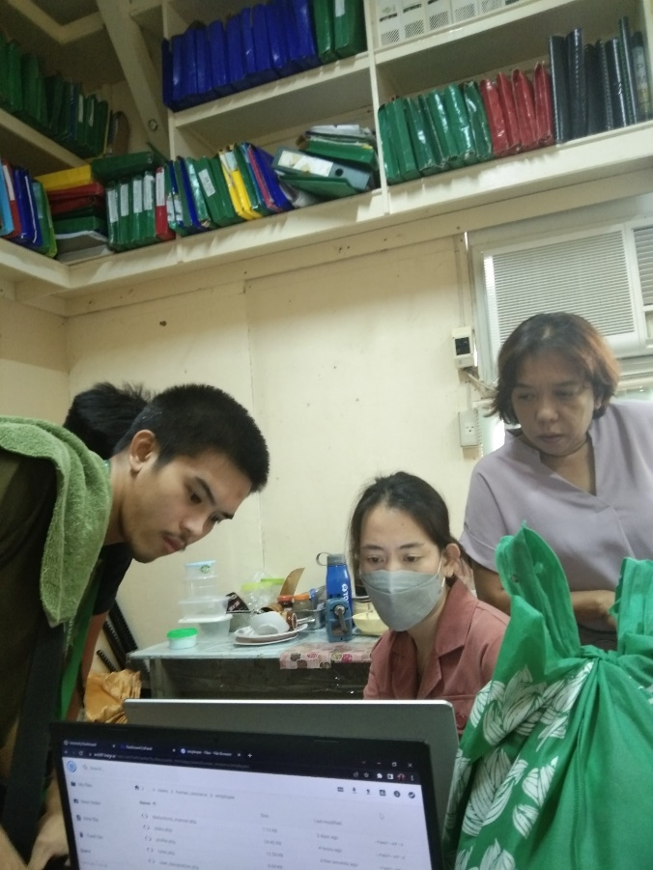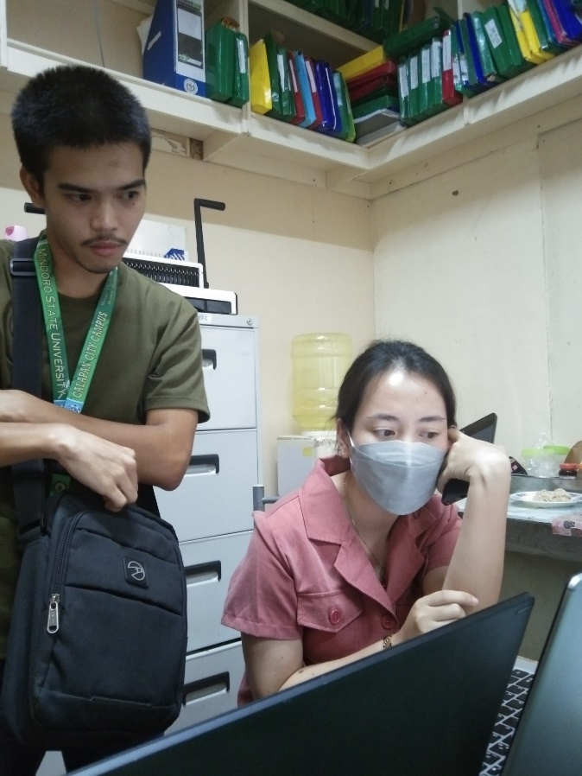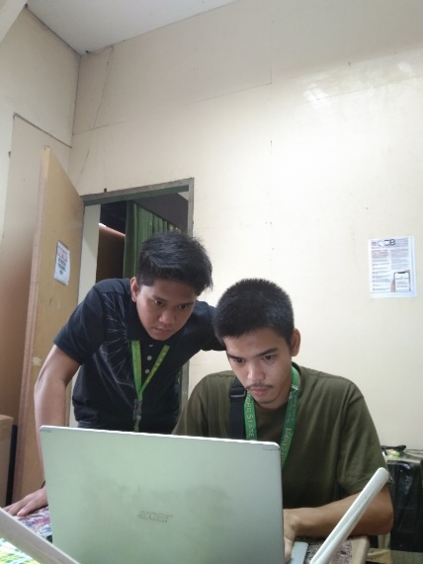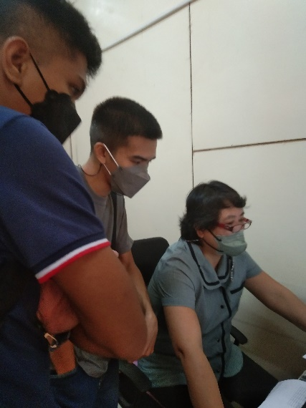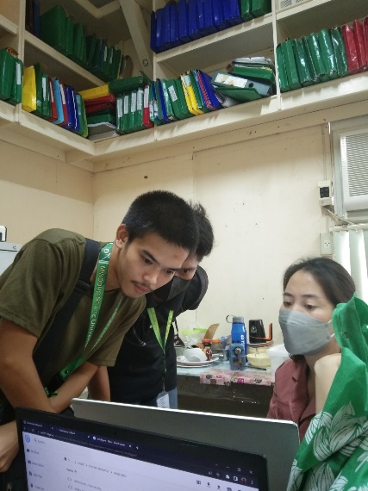The system development and deployment are depicted in the pictures below. In order to present the system's progress and work with the system's required processes, the researchers consulted their client, the HR of MinSU's Calapan City Campus. In order to provide information for the established project, the researchers registered each employee and collected data from the workplace during deployment.

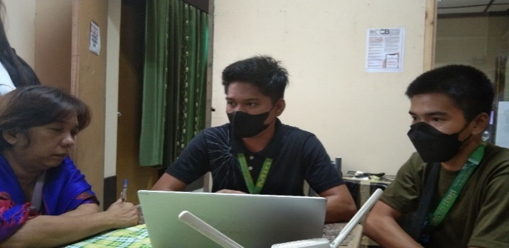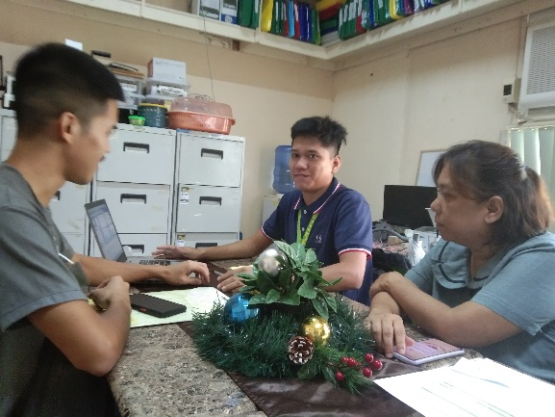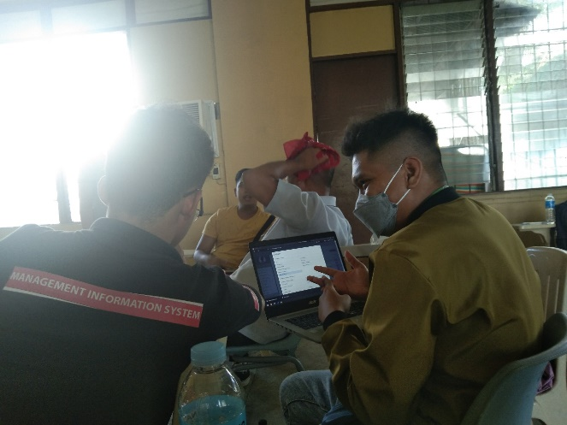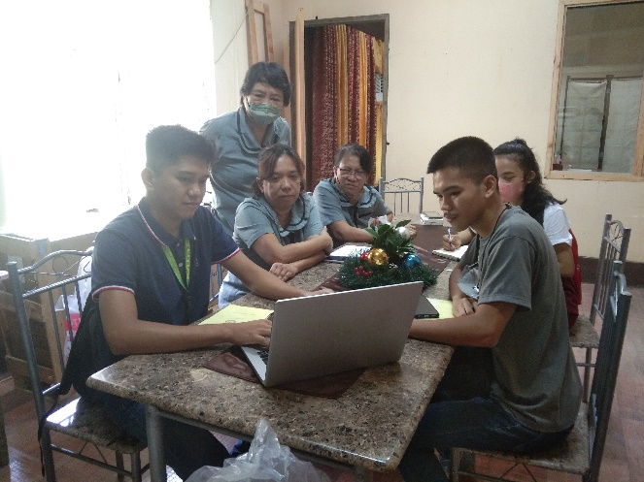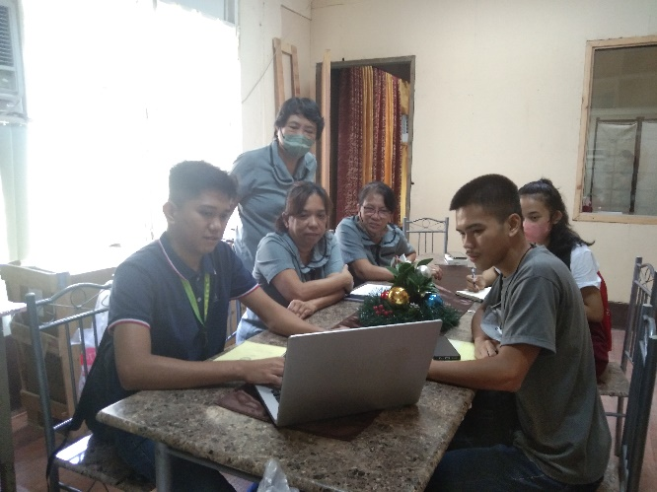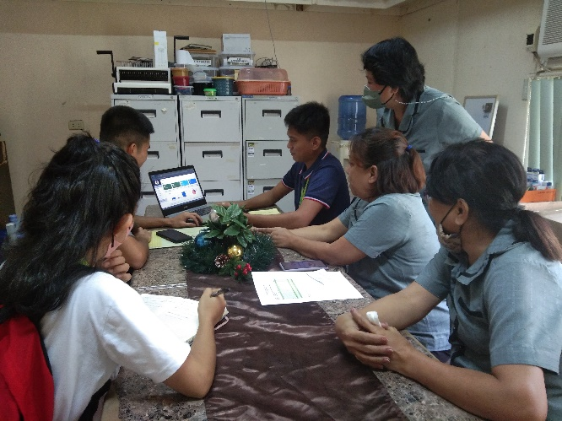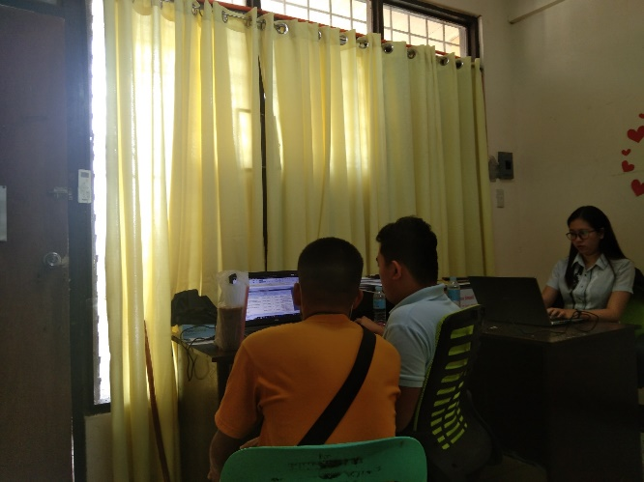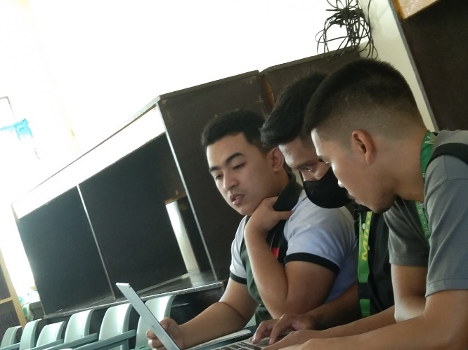

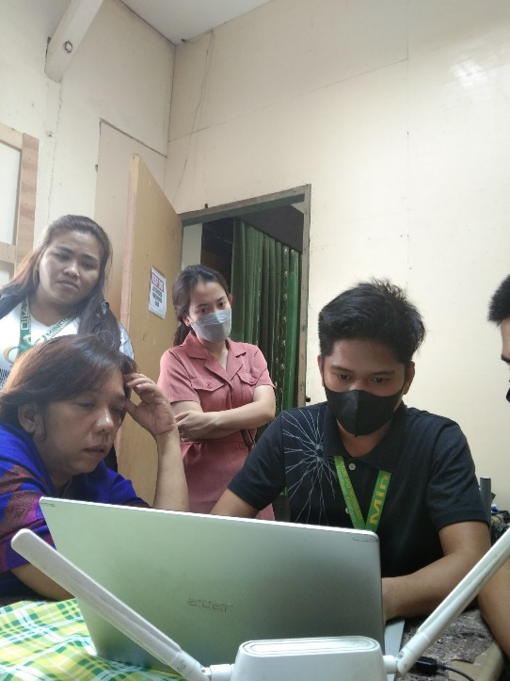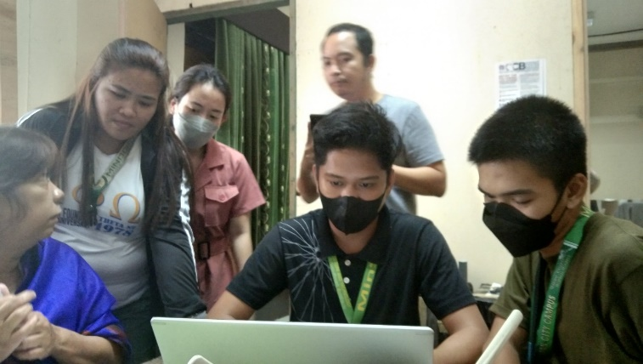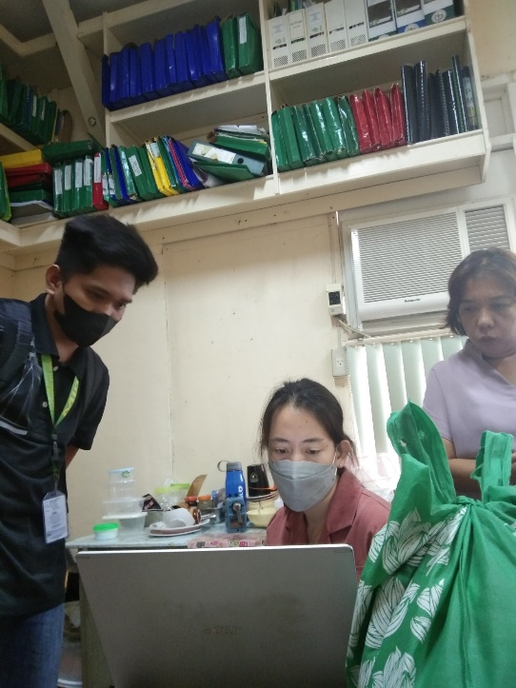

**APPENDIX K**

**Pictures during Final Defense**

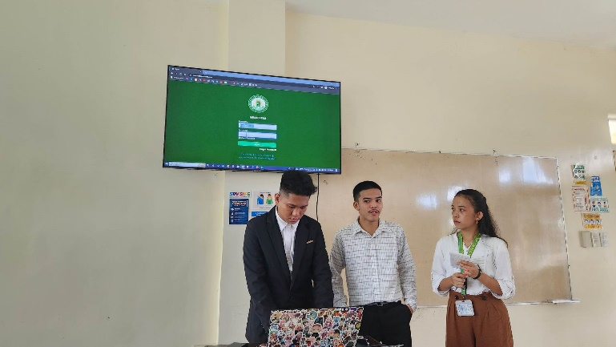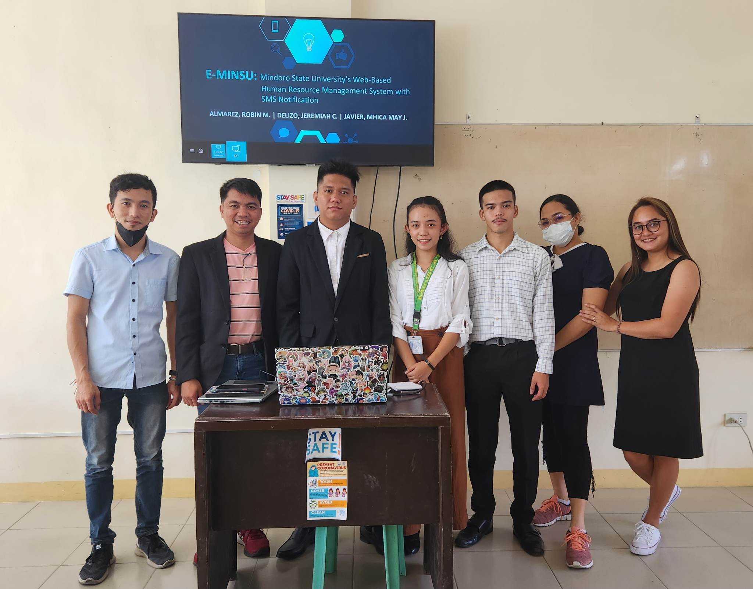The images below were captured at the capstone final defense, which took place on February 10, 2023. As seen in the picture, it consists of researchers, the panelist, as well as the research adviser

**APPENDIX L**

**Research/Capstone Project Waiver**

**RESEARCH/CAPSTONE PROJECT WAIVER**

We, **JEREMIAH C. DELIZO, MHICA MAY J. JAVIER** and **ROBIN M. ALMAREZ**, of legal ages, the sole proponent of the Research/Capstone Project entitled **“E-MINSU: A WEB-BASED HUMAN RESOURCE MANAGEMENT SYSTEM FOR MINDORO STATE UNIVERSITY WITH SMS NOTIFICATION”**, hereby authorize our Adviser, Course Facilitator and the College of Computer Studies – Research Unit to submit our Research/Capstone Project for paper presentation, publication and funding.

Whereas, if the research project will be accepted in any form of publication or presentation, the proponents shall be assisted by their Adviser, Course Facilitator and/or CCS Research Unit Head. However, if the sole proponents unable to attend, the Adviser, Course Facilitator and/or CCS Research Unit Head may represent the group.

Whereas, the Adviser, Course Facilitator and/or CCS Research Unit Head may improve the content of the manuscript in accordance with the requirements set forth by the conference and forum organizers. If improvement had been made by the Adviser, Course Facilitator and/or CCS Research Unit Head, they will be apart of the research group as Co-Authors. The original proponents shall be notified and included as one of the proponents of the Research/Capstone Project.

Whereas, our actions and decisions will be beneficial/advantageous for all of us, to the College of Computer Studies and its respective programs.

**JEREMIAH C. DELIZO MHICA MAY J. JAVIER ROBIN M. ALMAREZ**

Research Proponent Research Proponent Research Proponent

Date: __________ Date: __________ Date: __________

**APPENDIX M**

**Certificate of Oral Research Presentation**

**APPENDIX N**

**ACM Format**

**E-MINSU: A WEB-BASED HUMAN RESOURCE MANAGEMENT SYSTEM FOR MINDORO STATE UNIVERSITY WITH SMS NOTIFICATION**

|  |  |  |
| --- | --- | --- |
| Robin M. Almarez [1] | Jeremiah C. Delizo [2] | Mhica May J. Javier [3] |
| Mindoro State University | Mindoro State University | Mindoro State University |
| Masipit, Calapan City Oriental Mindoro | Masipit, Calapan City Oriental Mindoro | Masipit, Calapan City Oriental Mindoro |
| Bucayao, Calapan City Oriental Mindoro | Buhuan, Calapan City Oriental Mindoro | Dulangan 2, Baco Oriental Mindoro |
| 09950063183 | 09300005339 | 09510112180 |
| almarezrobin24662@gmail.com | jcdelizo14@gmail.com | javiermhicamay18@gmail.com |

**ABSTRACT**

The goal of this study is to establish a web-based human resource management system that electronically records information like Personal Data Sheets (PDS), which will be used by both employees and human resources administrators. This website also integrates SMS notification for the updates of the transactions. The employee may submit PDS, locator, and leave requests, and the administrator can manage transactions like leave, locator requests, service records, and NOSI. The evaluation's findings demonstrate the system's success because it operates in accordance with the suggested and proposed features. The created system can manage the virtual operations of the human resource office, including managing PDS, leave, and locator requests, creating service records and pay slips, electronically storing data, and managing employee accounts. Employees can submit PDS, leave, and locator requests and receive SMS notifications when their transactions have updates. This website can simplify and virtualize the HR office procedure, reducing walk-in and paper transactions while also offering data storage. According to the many views of the proponents, this website might be made more valuable by incorporating additional HR office processes, the reports they generate, and other papers that must be kept electronically. These extra features could expand the system's functionality and make it more beneficial for the office.

Keywords: PDS, NOSI, SMS, Locator, Leave, Service Record, Pay slip, electronic documents, web-based

**1**. **INTRODUCTION**

**1.1 Project Context**

In today’s world, the role of information is crucial and the ways that facilitate its processing are significant. There are concepts in economic designations about information civilization and information society (Kuś & Pypłacz, 2019). Setiyawati & Doktoralina (2019) discussed that utilizing information technology and applying good governance principles affects the quality of accounting information. Information Technology has been defined as the range of available technologies that benefit people and help them to be more efficient. It facilitates the exchange and delivery of data and information. Additionally, Zainab et al. (2018) implied that information technology systems have presented advantages as an essential tool for helping the country with the enhancement of the economy in both educational and industrial sectors.

Human Resource Management (HRM) and an organization’s digitalization is a combination of conceptual advancement. As a result, digital HRM represents a new evolutionary stage in the idea of technology based HRM (Strohmeier, 2020). However, despite the evident advantages of implementing electronic records management, some organizations still ignore the need to have one and stick with the manual ways of keeping the records, which could result in data loss. Information management is essential for the success of an organization while storing and keeping it is necessary so it will be accessible anytime it is needed. It is a difficult task to compile and traditionally keep records, so the researchers have come up with an idea to improve the current way of managing the records by implementing a web-based system that would allow an organization to store data and provide backup in times of unexpected phenomena.

This initiative known as E-MINSU was developed by the advocates to address the issue with the MinSU Calapan City Campus's human resources department. Since upon gathering the related studies, the researchers have discovered that the management of information is essential for the success of an organization. Storing and keeping the information is necessary so it will be accessible anytime it is needed. With the gathered problems from the previous related works, the researchers have come up with the decision to develop a web-based human resource management system with SMS notifications. The system will enable the mentioned organization to store and keep track of the records and information inside the workplace.

**2. REVIEW OF RELATED LITERATURE/SYSTEM**

Human Resource Management (HRM) and an organization’s digitalization is a combination of conceptual advancement. As a result, digital HRM represents a new evolutionary stage in the idea of technology-based HRM. (Strohmeier, 2020) Organizational strategists refer to the Human Resource Office as one of the most important aspects of company resources because this is responsible for work-related responsibilities such as recruiting, selecting, hiring, promoting, paying, and firing employees and contractors. The human resource office also oversees creating a good environment and productive employees for the organization, this office also works with documents, managing their data and pieces of information, building a cooperative team, together with mentoring them, and planting leadership in each employee.

**Literature/System**

The internet has grown to become the world's largest data repository. Overload of information is information explosion has made it more difficult for information retrieval systems to organize and retrieve information for the ordinary user efficiently and effectively (Luzon et al. 2022).

According to Grepon et al. (2022) automating school management data information system can help with effort reduction, time management, and the generation of timely and high-quality reports. To carry out their administrative and managerial duties correctly and efficiently, school administrators employ a variety of ICT tools and systems. Many people prefer to utilize technology to manage data and information since it is more trustworthy and efficient

Every institution and organization relies on information. Brombuela et al. (2021) claims that modern institution like universities have grown large and complex information needs that every institution must pay close attention to how information is gathered, stored, disseminated, and utilized. With the aid of modern technology, an institution can utilize using a system supporting them in handling the information within their institution. Information systems alleviate uncertainties and provide quicker support and almost automated decisions.

While according to Garcia et al. (2021), web technology has a rapid growth which also affects the educational system, he stated that the study about web-based learning has grown in importance because the portable devices such as cellphones, laptops, and personal digital assistants now have rapid access to web-based applications and learning environments thank to the internet. As a result, the needed information can be easily obtained via the internet. Furthermore, time and spatial constraints can be addressed to facilitate self-directed learning.

Additionally Buhain and Pulmano (2021) stated that managing, authorizing, and recording leave requests is generally the responsibility of the university's human resource development office and higher authorities. The university's human resource development office has been experiencing problems in their manual operations, such as difficulties in handling information due to traditional storage of information, and transparency issues because employees do not have direct access to their leave records, with an increasing number of employees earning leave and leave applications being filed monthly.

And Anwar and Abdullah (2021) discussed that planning, strategic recruiting, employee training, growth pay management, efficiency, worker relations, health care, employee satisfaction, and supply of employee services are all duties that fall under the umbrella of human resource management (HRM). Together with the rules and procedures designed to boost organizational efficiency, employee engagement, and job quality. The HRM’s practices such as revenue return, benefit, competitiveness, and market share will improve if the office practices good management.

Suwita et al. (2021) mentioned that web-based software’s simple to use and create nowadays, they are also usable in the business industry, businesses use web applications to carry out typical business planning, analysis, and techniques for data collection for the promotional effectiveness. The web also employed activities that are widely used by numerous firms as well as business problems to attract customers, and vendors and earn money.

The leave management and monitoring system automates the leave request process, making it easier for employees and managers to track and award leave Buhain & Pulmano, (2021). While Pengaruh PMA, PMDN, TK, (2020) stated that most institution uses the conventional method of requesting and managing leave. In this method, an employee is required to write and submit a leave application to the designated personnel such as the Head of the Department. The request is forwarded to the officer in charge of approving and rejecting leave. The current method is at risk of having an error, requires a lot of paperwork, tedious to manage, and consumes a lot of time.

Paderna et al. (2020) and Valencia-Inarda (2020) both mentioned that human resources have an essential position and important role in the success of an organization. Paderna et al. (2020) who conducted the research entitled “Improving Employee Experience in a Medium-sized Retail Chain through Quality Human Resource Management Practices: Does Bifurcation Bias in Family Firms Moderate the Nexus?” tackled that Human Resource Management (HRM) is an organizational function that focuses on the recruitment, management, and direction of a company's most valuable asset. This functional area provides an organization with the essential information, tools, training, administrative services, coaching, legal and management counsel, and talent management oversight to maximize performance quality. Employees are then given a set of goals to achieve using their talents and knowledge because of these resources. Human resource managers must be able to identify and meet employee needs through successful recruitment and selection, training and development, compensation administration, and employee-employer relations, in addition to what type of employment best suits an employee's skill set.

On the other hand, human resources are substantially related to organizational commitment based on the study by Valencia-Inarda (2020), the analysis of her study which is conducted in the Philippines highlighted four core areas of the human resource system and its relationship with the organizational commitment in the context of public organization. Human resource initiatives have been implemented at many levels in terms of RSP, L&D, PM, and R&R. People believe they have given all candidates an equal chance under the law. Even though L & D operations are carried out, this research does not focus on their effectiveness. On PM, primary sources suggested that data recording and storage may be improved. Personnel has been given R&R based on their excellent performance and achievements.

As stated by Jayoma et al. (2020), the process of converting paper-based data into a digital format, such as computer-generated electronic documents or digital images created by scanning or photography, is known as digitization. Data that has been digitized will be easier to preserve, access, and manage. Digitized data is stored and managed through a system such as a record management system. However, there are still some who still stick to the traditional way of keeping and managing their records which are stored in cabinets, filers, and folders.

In the teaching-learning process, a teacher's attendance is critical. The presence of teachers has a major impact on student learning, according to a study. When compared to their counterparts, teachers who had fewer absenteeism had kids who scored higher on achievement tests Naive, (2020).

On the other hand, Strohmeier (2020) who studied Digital Human Resource Management: A conceptual clarification said that there is a possibility that the digital HRM can be developed based on the general research that he conducted regarding the digital organization, terminology, and typology of digital HRM. The findings point to a perspective on technology based HRM that is not fundamentally different from earlier perspectives, but that embraces and expands on them.

Gonapinuwala (2020) discussed that in today's world, there are only manual procedures for dealing with teacher leaves, which are more time consuming due to the numerous paper works, such as filling out applications. Because the clearance process involves multiple types of employees, it takes longer to acquire approval for some special leaves, such as study leaves and foreign leaves. All records of leave taken by an employee in accordance with the company's leave policy are kept by leave management. In a large firm, having an effective leave management system is critical. And Afsana, 2018 further explained that a leave management system is an automated online stage that tracks all forms of leave applications and requests, as well as a method to track different types of leaves. This system can be used to automate the process of submitting and accepting leave applications. It is a simple and easy to use technology that eliminates paperwork and saves time and money.

Most institutional authorities are bothered by the inconvenient method of manually tracking their employees' attendance. The manual process of signing on a piece of paper is time-consuming and insecure. At such locations, an effective attendance monitoring system must be implemented. (Setiyawati & Doktoralina, 2019)

According to Reddy et al. (2019), the monitoring of attendance in all organizations for checking the performance of students is a challenging task. It is time-consuming to call the names of students to see whether they are present or not. In businesses, calling the registered numbers or names of the employees is also a prolonged task. Attendance is manually taken in all organizations by calling their register numbers or names and recorded in attendance registers issued by department heads as proof, and in some organizations, students want to sign in these sheets, which are stored for future reference. This technique is repetitive, complex work that leads to errors because few pupils sign for their students or tell surrogate attendance of the missing students regularly. This method also able to track all the students' attendance more difficult, as well as monitoring individual student attendance in a large classroom setting. An attendance Monitoring System needs to be implemented to make the task easier and effortless.

As explained by Balbino J. et al. (2019), filing for leave is exhausting because it requires going through various departments or employees to get approval, just like filing for reimbursement expenses. While Plata & Calpito, (2020) discussed that leave management is one of the simplest yet crucial HR activities that often consumes a significant portion of the HR personnel’s time. Organizations must recognize the need for employees not to report from their work, taking time away to consider and fulfill personal, family, social obligations, and other necessities thus may file different leave privileges. Taking annual leave is a right of an employee but subject to the right of the head of the office to schedule the time at which leave may be made. While a leave of absence is a right granted to employees not to report to work with or without pay, leave policies must be complied with or provided by the law. The HR personnel must see to it that there are always available sufficient workers and that employees are satisfied with the working environment.

Kuliah and Kuliah (2019), elaborated on the role of information management and cluster to innovate the development of regions and operational management. It plays a vital role in addressing significant issues and structural entities. Through it, the level of life of the most population is being raised and news products and services are being created.

Information is significant in today's economic realities; it is fundamental to recognize that the 21st-century society can be considered a mass data community in which information is very valuable and needed as a determinant of action. The information allows people to take action and enhance the current state. Furthermore, in the view of an organization, accessing the right information at the right time is much more necessary to its people than any large assets and revenue (Kuś & Pypłacz, 2019).

According to Aladejebi and Oladimeji (2019), in business management meticulous record keeping are required. Identification, classification, summarizing, storage, protection, communication, retention, and disposal of records for the creation of financial statements are all part of record keeping. Policies, systems, procedures, operations, and individuals all play a role in record keeping. A record of financial inflows and outflows in connection to the respective asset, liability, income, and expense is called an account. The importance of reliable financial information being available to owners and managers for performance measurement cannot be overstated. Owners of businesses, the government, creditors, potential investors, and others are all users of accounts.

While according to Mukred et al. (2019), records management improves the quality of public service delivery, and it also assists organizations to acquire quality certification. Records management has a direct relationship with transparency, productivity, and accountability inside an organization. However, as perceived from the professional aspect, there are still some who don’t understand the importance of this program.

Human resources are an organization's most precious asset. A company's Human Resources department performs an important function. It has the ability to manage an organization's most important and valuable assets. Without a properly operating human resources department, a firm will struggle to achieve high levels of efficiency and labor management. Recruitment and selection, salary management, performance management, organization development, employee engagement, and employee leave management are all responsibilities of Human Resource Management (HRM) (Afsana, 2018).

World Wide Web’s (www) growth and evolution has grown rapidly in the previous 10 years, owing primarily to factors such as social media and mobile technology. This expansion, which necessitates the pleasure of millions of users accessing Web applications with sufficient service quality, necessitates ongoing infrastructure upgrades to improve user experience or meet new needs (Curiel & Pont, 2018).

Web-based applications allow the gathered information to be accessed and processed remotely. And this kind of software is created to ensure secure and real-time access to the data, the backend is programmed via PHP Hypertext Pre-Processor while the user-interactive front-end is written or programmed using Javascript to generate Dynamic HTML together with the stored and maintained data in a MySQL database (Capraro et al., 2018).

This paper aims to demonstrate how policy can facilitate the incorporation of disclosure requirements into the project life cycle of documentation (transparency by design) to prevent the occurrence of any corruption risk associated with the management of information created by a public administration (missing or disappearance of information, lack of evidence, modification of documents, etc.) It has been shown that organizing information can facilitate the occurrences inside an organization (Casadesús et al., 2018).

Aziz and Yusof (2018), conducted a study regarding Electronic Document and Records Management System (EDRMS), which is a system that is responsible for managing digital information. It could merge both document management and records management to increase the efficacy of a business and attain better accountability. The study has revealed that some organization is not ready to implement EDRMS in their workplace. The required knowledge and skills, as well as the lack of policy and procedure in place, are contributing factors to this. In the findings of the study, it is shown that developing proper policies and procedures while taking appropriate actions could help to resolve the issue of implementing a records management system in the workplace.

Mukred and Yusof (2018), stated that records are key to organizing the goals and attaining knowledge for the process of decision-making and problem-solving. Businesses rely on information and communications technology to run and conduct operations which resulted in the generation of e-records in large volumes. Therefore, it is important to retain the records and keep evidence that a certain activity has been carried out.

Furthermore, Zainab et al. (2018), several government organizations, as well as educational institutions, still depend on manually checking attendance in a paper-based approach. The said approach has presented disadvantages such as wastage of environmental resources and is a time-consuming task. There is a must to change these traditional and old methods of recording attendance and change them with more productive ones. A system must be implemented to disclose those disadvantages and achieve a much more effective approach.

As stated by Khim (2018), there is waste of time while the leave process approval is being processed and records are being retrieved. The existing manual system has several shortcomings. Because the entire system is maintained by hand, the process of storing, maintaining, and retrieving information is time-consuming and labor-intensive.

**3. METHODOLOGY**

**3.1 System Architecture**

**Figure 1. System Architecture**

Figure 1 above shows the system architecture of the proposed project. The main features mainly revolve between the employee and the HR. The HR mainly manages the essential document with concern to the employees such as PDS. The modules are restricted to the designated users.

* 1. A black screen with white text

     Description automatically generated with low confidence**Case Diagram**

**Figure 2. Use Case Diagram**

In this figure 2 above, the case diagram shows the connection of the system between the actors. Human Resource is mainly the one who manages almost all the transactions on the system especially approval or rejection of Personal Data Sheet (PDS) updates, leave, locator applications and manages other documents related to the employees

Employees also have their own module which they have the functionalities to interact with other modules mainly with the Human resource module. An employee can apply for leave using the system, request PDS updates, and fill up a locator slip

* 1. **A picture containing text, diagram, graphics, logo

     Description automatically generatedAgile Model**

**Figure 3. Agile Model**

E-MINSU will be developed using the agile model. There are six phases in this model which are defined below.

**1. Requirements.** In this stage, the requirements are gathered that are needed to create a solution. Interviews on designated personnel are conducted to gather the information needed as well as viewing some document and forms that is involved into the system. The information collected would be analyzed to fulfill the system requirements.

**2. Design.** In this stage, designing of the system undergoes. The design would include the different diagrams such as data flow diagram, context diagram, use case diagram and other diagrams that will help the developers with developing the project.

**3. Development**. During this stage, the proposed system would be developed. The HR module would develop first then followed by the Employee’s module. The proposed project will be developed using HTML, CSS, JS, and LavaLust framework.

**4. Testing**. Once the development phase is done, testing will be conducted for the developers to identify if there are some issues and bugs occurring on different functionality.

**5. Deployment**. In this stage, the system will be deployed on the client. The actors involve in the deployment are the HR, cashier and the employees. They will be assigned on their respective modules with different sets of functions and features. The client must test and used the functions to see if it meets the requirement.

**6. Review**. During this stage, all the feedbacks about the system are written. These feedbacks will be used for further improvement of the system. After the review, the developer must enhance the system based on the review.

**4. RESULTS AND DISCUSSION**

**4.1 Results and Discussion**

Using ISO 25010, an evaluation of the website's quality standard was done as part of the implementation plan to check for things like functional suitability, reliability, performance efficiency, usability, security, compatibility, maintainability and portability. This was assessed by IT professionals, a representative from the Human Resource Office, and employees of the Mindoro State University campus in Calapan City.

**4.2 Summary of Results**

**Table 1. Summary Results of the Evaluation**

Table 1 shows the results of the implementation results of the website ISO 25010. The table 1 shows that the website has Functional Suitability of (A=4.52), Performance Efficiency (A=4.67), Compatibility (A=4.6), Usability (A=4.68), Reliability (A=4.52) Security (A=4.65), Maintainability (A=4.4), and Portability (A=4.55) as “Strongly Agree”, which has the general average of “4.57” of which all mean is equivalent for each characteristic as “Strongly Agree”.

**5. SUMMARY, CONCLUSION AND RECOMMENDATION**

* 1. **Summary**

The primary goal of this study is to create a web-based human resource management system with SMS notification that will electronically store organizational data. The system administrator can control the transactions, and users or employees can submit PDS, leave and locator requests. The study concentrated on creating a user-friendly environment so that users can easily engage with the website and on the features that the user requires to manage a human resource. Additionally, the technical operation of the entire system was tested during the construction of this system using ISO 25010.

Going by the evaluated data from the respondents, the functional suitability is effectively checked and according to the gathered data, “4.52” is the overall mean which describes as “strongly agree”, performance efficiency with overall mean of “4.67” and describes as “strongly agree”, compatibility with overall mean of “4.6” and describes as “strongly agree”, usability with overall mean of “4.68” and describes as “strongly agree”, reliability with overall mean of “4.52” and describes as “strongly agree”, security with overall mean of “4.65” and describes as “strongly agree”, maintainability with overall mean of “4.4” and describes as “agree” and portability with overall mean of “4.55” and describes as “strongly agree”. The system completes stated tasks and objectives without exhibiting any errors and operates in accordance with user requirements. Overall, the system is functional, beneficial for the office's data management, and convenient for the staff, which shows that it can run flawlessly in accordance with its goals.

Additionally, that was supported by the information acquired and system usage where the Mindoro State University (MinSU) Calapan City Campus personnel successfully registered and submitted PDS, leave, and locator requests. The admin, who works in the human resources department at the MinSU Calapan City Campus, effectively managed the system's other features as well as the requests to approve and deny employees' accounts.

* 1. **Conclusions**

As the proponents complete the development and study of E-MINSU: Mindoro State University’s Web-Based Human Resource Management System with SMS Notification, the researchers have come to several conclusions and observations. These are the following:

1. The web-based system functions to store the employees’ data securely and can generate different reports for human resource office needs.
2. The system allows the employees to file their leave and locator requests virtually, produce service records, and pay slips.
3. The system integrates SMS notification to notify employees about the progress of their request.
4. The system meets the user requirements in terms of Functional Suitability, Performance Efficiency, Compatibility, Useability, Reliability, Security, Maintainability and Portability as the respondents gave a high rating performance; and
5. The system is fully implemented by Mindoro State University – Human Resource Office.

**5.3 Recommendations**

The researchers make the following recommendations based on the data presented in this study which are obtained during deployment period:

1. To future researchers and web developers, for the website's human resource management system to be complete, they should include additional offices as users.
2. To future web developers, they should include the other documents that the human resource needs to process.
3. To future developers, they should improve the user interface (UI) and user experience (UX) of the system.
4. To future researchers, they must look for additional functions that are necessary for human resources to fully convert their operations to electronic ones.
5. To future developers, they must improve the system's interactivity and responsiveness to mobile devices.
6. To future researchers, they must continue to make upgrades and advances to keep up with developing technologies.

**REFERENCES**

Ab Aziz, A., Mohammad Yusof, Z., Mokhtar, U. A., & Jambari, D. I. (2018). Electronic document and records management system implementation in Malaysia: A preliminary study of issues embracing the initiative. In Lecture Notes in Computer Science (including subseries Lecture Notes in Artificial Intelligence and Lecture Notes in Bioinformatics): Vol. 10766 LNCS. Springer International Publishing. https://doi.org/10.1007/978-3-319-78105-1_65

Afsana, H. (2018). Employee leave Management System in MetLife Bangladesh. 38. http://hdl.handle.net/10361/9854

Aladejebi, D. O., & Oladimeji, D. J. A. (2019). The Impact of Record Keeping On the Performance of Selected Small and Medium Enterprises in Lagos Metropolis. Journal of Small Business and Entrepreneurship Development, 7(1). https://doi.org/10.15640/jsbed.v7n1a3

Amora, E. N. O., Romero, K. V, & Romero, A. M. J. (2021). Digital Attendance and Accomplishment Report Monitoring System (Digiatt). Ioer International Multidisciplinary Research Journal, 3(2), 123–133.

Anwar, G., & Abdullah, N. N. (2021). The impact of Human resource management practice on Organizational performance. International Journal of Engineering, Business and Management, 5(1), 35–47. https://doi.org/10.22161/ijebm.5.1.4

Brombuela, G. B., Estacio, A. D. L., Jingco, F. G. A., & Cabrera, W. (2021). The Impact of Management Information System on Teachers of an HEI in City of The Impact of Management Information System on Teachers of an HEI in City of Malolos , Bulacan , Philippines Abstract : September.

Buhain, J.-A. C., & Pulmano, C. E. (2021). Development of a Leave Management and Monitoring System for the Cavite State University Campus Network. International Journal of Business and Technology Management, 3(3), 124–135. https://myjms.mohe.gov.my/index.php/ijbtm/article/view/16022

Capraro, F., Tosetti, S., Rossomando, F., Mut, V., & Serman, F. V. (2018). Web-based system for the remote monitoring and management of precision irrigation: A case study in an arid region of Argentina. Sensors (Switzerland), 18(11). https://doi.org/10.3390/s18113847

Casadesús, A., Mingo, D., & Cerrillo-i-martínez, A. (2018). International Journal of Information Management Improving records management to promote transparency and prevent corruption. International Journal of Information Management, 38(1), 256–261. https://doi.org/10.1016/j.ijinfomgt.2017.09.005

Curiel, M., & Pont, A. (2018). Workload Generators for Web-Based Systems: Characteristics, Current Status, and Challenges. IEEE Communications Surveys and Tutorials, 20(2), 1526–1546. https://doi.org/10.1109/COMST.2018.2798641

Garcia, J. G., Gangan, M. G. T., Tolentino, M. N., Ligas, M., Moraga, S. D., & Pasilan, A. A. (2021). Canvas Adoption Assessment and Acceptance of the Learning Management System on a Web-Based Platform. ArXiv: Computers and Society, 12(1), 24–38. https://128.84.21.199/abs/2101.12344

Gonapinuwala, D. S. D. (2020). Leave Management System for Sri Lanka Teachers’ Service. http://dl.ucsc.cmb.ac.lk/jspui/handle/123456789/4488

Grepon, B. G., Baran, N., Gumonan, K. M. V., Martinez, A. L., & Lacsa, M. L. (2022). Designing and Implementing e-School Systems: An Information Systems Approach to School Management of a Community College in Northern Mindanao, Philippines. International Journal of Computing Sciences Research, 6, 792–808. https://doi.org/10.25147/ijcsr.2017.001.1.74

Jayoma, J. M., Moyon, E. S., & Morales, E. M. O. (2020). OCR Based Document Archiving and Indexing Using PyTesseract: A Record Management System for DSWD Caraga, Philippines. 2020 IEEE 12th International Conference on Humanoid, Nanotechnology, Information Technology, Communication and Control, Environment, and Management, HNICEM 2020. https://doi.org/10.1109/HNICEM51456.2020.9400000

Khim, C. Y. (2018). Leave Management System (LMS).

Kuś, A., & Pypłacz, P. (2019). The importance of information management in the context of Industry 4.0: Evidence from the Kuyavian-Pomeranian Forbes Diamonds. Social Sciences, 8(6), 1–13. https://doi.org/10.3390/socsci8060169

Luzon, C., Lacatan, L., Bangalisan, H., & Osapdin, J. (2022). Web-Based File Clustering and Indexing for Mindoro State University. International Journal of Computing Sciences Research, 6, 951–961. https://doi.org/10.25147/ijcsr.2017.001.1.82

Mukred, M., Yusof, Z. M., & Alotaibi, F. M. (2019). Ensuring the productivity of higher learning institutions through electronic records management system (ERMS). IEEE Access, 7, 97343–97364. https://doi.org/10.1109/ACCESS.2019.2927614

Naive, A. F. E. (2020). Design and implementation of faculty class attendance monitoring system using BLE beacons. Indian Journal of Science and Technology, 13(40), 4234–4243. https://doi.org/10.17485/ijst/v13i40.1527

Paderna, R. D., Guiveses, M. L., Ong, S. J., & Tsai, J. L. (2020). Improving Employee Experience in a Medium-sized Retail Chain through Quality Human Resource Management Practices: Does Bifurcation Bias in Family Firms Moderate the Nexus? Review of Integrative Business and Economics Research, 9(1), 62–79. http://buscompress.com/journal-home.html

Pengaruh PMA, PMDN, TK, dan I. (2020). EMPLOYEE LEAVE MANAGEMENT SYSTEM. 2507(February), 1–9.

Plata, I. T., & Calpito, J. L. (2020). Application of time-based one time password (TOTP) algorithm for human resource e-leave tracking web app. International Journal of Scientific and Technology Research, 9(3), 4070–4077.

Praveen. T, Vetrivel. HM, & Arumugasamy. B. (2020). Online Leave Management System. International Journal of Advanced Science and Technology, 29(7), 2785–2791. http://sersc.org/journals/index.php/IJAST/article/view/18155

Reddy, K. P. N., Alekhya, T., T, S. M., & Rashmi, K. (2019). AI-Based Attendance Monitoring System. International Journal of Innovative Technology and Exploring Engineering, 9(2S), 592–597. https://doi.org/10.35940/ijitee.b1057.1292s19

Satria, D., Zulfan, Z., Munawir, M., & Mulyati, D. (2019). Final Project Consultation Information System Integrated Notification System Based on Sms Gateway. Cyberspace: Jurnal Pendidikan Teknologi Informasi, 2(2), 135. https://doi.org/10.22373/cj.v2i2.4002

Setiyawati, H., & Doktoralina, C. M. (2019). The importance of quality accounting information management in regional governments in Indonesia. Management Science Letters, 9(12), 2083–2092. https://doi.org/10.5267/j.msl.2019.6.025

Strohmeier, S. (2020). Digital human resource management: A conceptual clarification. German Journal of Human Resource Management, 34(3), 345–365. https://doi.org/10.1177/2397002220921131

Suwita, F. S., Sholihat, S. A., & Dewi, N. P. (2021). Web-based information system sales. Journal of Physics: Conference Series, 1764(1). https://doi.org/10.1088/1742-6596/1764/1/012189

Valencia-Inarda, A. (2020). Exploring Prime-Human Resource Management and Organizational Commitment: A Perspective. PalArch’s Journal of Archaeology of Egypt …, 17(2), 501–517. https://www.archives.palarch.nl/index.php/jae/article/view/2534

Zainab Hussein Arif, Nabeel Salih Ali, Nurul Azma Zakaria, M. N. A.-M. (2018). Attendance Management System for Educational Sector: Critical Review . International Journal of Computer Science and Mobile Computing, 7(8), 60–66.

**APPENDIX 0**

**Curriculum Vitae**

**PERSONAL INFORMATION**

**Name :** Robin M. Almarez

**Email Address :** almarezrobin24662@gmail.com

**Contact Number :** 09950063183

**Address :** Bucayao, Calapan City Oriental Mindoro

**Age :** 21 yrs. old

**Birthday :** May 01, 2001

**Father :** Binancio E. Almarez

**Mother :** Rose M. Almarez

**Tertiary:** Mindoro State University

Masipit Calapan City Oriental Mindoro

Present

**Secondary:** **St. Anthony College of Calapan**

Bayanan I, Calapan City, Oriental Mindoro

S.Y: 2017 – 2019

**Elementary**:Managpi Elementary School

Managpi Calapan City, Oriental Mindoro

S.Y: 2012 - 2013

**EDUCATIONAL ATTAINMENT**

**PERSONAL INFORMATION**

**Name :** Jeremiah C. Delizo

**Email Address :** jcdelizo14@gmail.com

**Contact Number :** 09300005339

**Address :** Buhuan, Calapan City Oriental Mindoro

**Age :** 22 yrs. old

**Birthday :** November 25, 2000

**Father :** Javier M. Delizo

**Mother :** Annaliza C. Delizo

**EDUCATIONAL ATTAINMENT**

**Tertiary:** Mindoro State University

Masipit Calapan City Oriental Mindoro

Present

**Secondary:** **St. Anthony College of Calapan**

Bayanan I, Calapan City, Oriental Mindoro

S.Y: 2017 – 2019

**Elementary**:Sampaguita Elementary School

Sampaguita, Naujan, Oriental Mindoro

S.Y: 2012 - 2013

**PERSONAL INFORMATION**

**Name :** Mhica May J. Javier

**Email Address :** javiermhicamay18@gmail.com

**Contact Number :** 09510112180

**Address :** Dulangan II Baco, Oriental Mindoro

**Age :** 21 yrs. old

**Birthday :** May 18, 2001

**Father :** Florante A. Javier

**Mother :** Emelita J. Javier

**Tertiary:** Mindoro State University

Masipit Calapan City Oriental Mindoro

Present

**Secondary**: Anastacio Dela Chica High School

Dulangan II, Baco Oriental Mindoro

S.Y: 2017 – 2019

**Elementary**:Dulangan II Elementary School

Dulangan II, Baco Oriental Mindoro

S.Y: 2012 - 2013

**EDUCATIONAL ATTAINMENT**